**EIPA 0.2:2021**

EIPA CoC

Date: 2021-09-30

**JP-PINT**

**Peppol international invoice**

- Part 3 –

Core invoice usage specification

Draft stage

© EIPA 2021

All rights reserved. Unless otherwise specified, or required in the context of its implementation, no part of this publication may be reproduced or utilized otherwise in any form or by any means, electronic or mechanical, including photocopying, or posting on the internet or an intranet, without prior written permission. Permission can be requested from either EIPA at the address below.

EIPA E-Invoice Promotion Association

Email: info@eipa.jp

Website: www.eipa.jp

Published in Japan

電子インボイス推進協議会 事務局

〒107-0052 東京都港区赤坂 1-3-6 赤坂グレースビル 4F (一般社団法人ソフトウェア協会内)

**Contents**

1 Introduction 6

1.1 General 6

1.2 Objective 6

1.3 Peppol BIS Billing 3.0 6

1.4 Peppol International Invoice (PINT) 6

2 Normative reference 8

3 Terms and definitions 9

4 Verbal form 11

5 PINT specification 12

5.1 Overview 12

5.2 Parties and roles 14

5.2.1 General 14

5.2.2 Parties 15

5.2.3 Roles 15

5.2.4 Business process requirements supported 15

5.3 Invoicing functionality supported 16

5.3.1 General 16

5.3.2 Accounting 16

5.3.3 Invoice verification 17

5.3.4 Auditing 20

5.3.5 Tax Reporting 21

5.3.6 Payment 22

5.4 Standard invoicing process 23

5.5 Delivery Note process 24

5.5.1 General 24

5.5.2 Document used in this process 25

5.6 Summary invoicing process 25

5.6.1 General 25

5.6.2 Documents used in process. 27

5.6.3 Processing patterns 27

5.6.4 Standard invoice 29

5.6.5 Payment advice pretending to be a summarised invoice (1-A, 2-A) 29

5.6.6 Summerised Invoice (Pattern 1-C) 33

5.6.7 Summerised Invoice (Pattern 2-C) 38

5.7 Payment advice (Statement) 42

5.7.1 General 42

5.7.2 Statement business process 42

5.8 Negative invoices and credit notes 51

5.8.1 General 51

5.8.2 When crediting by means of credit note 55

5.8.3 When crediting by means of negative invoice 58

5.9 Credit Note 60

5.10 The Peppol international invoice model in relation to other documents 60

5.10.1 General 60

5.10.2 Open Peppol BIS version 3.0 60

6 Consumption tax 62

6.1 Overview 62

6.2 invoices with classified descriptions 63

6.3 Overview of Qualified Invoice Based method in Japan 64

6.4 The difference of requirements to apply input tax credit 65

6.5 Line CT Information 67

6.6 Document level allowance or charge 67

6.7 CT Breakdown 67

6.8 Invoice total CT amount 67

7 Rounding 68

7.1 Overview 68

7.2 PINT rule 68

7.3 JP-PINT rule 68

8 Calculation 69

8.1 Calculation on line level 69

8.1.1 Item net price 69

8.1.2 Invoice line net amount 70

8.1.3 Example calculation on line level (informative) 72

8.2 Calculation of allowance/charge amount 74

8.3 Calculation of CT 77

8.4 Document total 80

8.5 UBL syntax calculation formula for document total 81

8.6 Example of Tax breakdown and document total (informative) 81

9 Payment means 86

9.1 Usage in Japan 86

9.2 Business terms used to specify a payment means 86

9.3 Example 88

10.1 EN 16931-1 Business rules 91

10.1.1 Integrity constraints 91

10.1.2 Conditions 93

10.1.3 VAT Rules [SOURCE: EN 16931-1 6.4.3 VAT rules] 95

10.1.3.1 Introduction 95

10.1.3.2 Specification of VAT category codes 96

10.1.4 VAT is levied through the Invoice [SOURCE: EN 16931-1 6.4.3.3] 97

10.1.4.1 Standard rate and reduced rate items 97

10.1.4.2 Business rules statements 97

10.2 Model rule for PINT 98

10.3 Rules for BIS Billing 3.0 99

10.4 Shared rule for PINT 104

10.5 Rules for Japanese Standard Commercial Invoice (Aligned) 107

10.6 Rules requested by Japanese Digital Agency on September 21st 109

8.1.1.1.1 Although following rule exists, we need to add a rule by Schematron. 111

8.1.1.1.2 ibr-co-26 (fatal) 111

10.7 Basic idea of our proposal on October 5th 113

10.8 Our proposals 113

11 Code list and identifier 120

11.1 Overview 120

11.2 Shared code list 120

11.2.1 Document type 120

11.2.2 Country code 121

11.2.3 Currency code 122

11.2.4 Unit of measure 122

11.2.5 Allowance reason codes 123

11.2.6 Charge reason codes 123

11.2.7 Mime codes 123

11.2.8 Code lists for identifier schemes 123

11.2.8.1 General 123

11.2.8.2 Electronic address identifier scheme 123

11.2.8.3 Party identifiers and party legal registration identifier scheme 124

11.2.8.4 Invoiced object identifier scheme 124

11.2.8.5 Item standard identifier scheme 124

11.2.8.6 Item classification identifier 124

11.2.8.7 Peppol Identifiers 124

11.3 Aligned code list 125

11.3.1 Payment means type code 125

11.3.2 TAX category codes 125

11.3.3 TAX type 125

11.3.4 TAX exemption reason code 126

11.3.5 Value added tax point date code 126

11 Peppol Identifiers 128

11.1 Overview 128

11.2 Profiles and messages 128

11.3 Japanese standard invoice 128

11.4 Japanese summarised invoice 128

12 Applying the PINT: Examples of selected parts of the transaction (informative) 129

12.1 General 129

12.2 Party 129

12.2.1 Overview 129

12.2.2 Seller 129

12.2.3 Buyer 129

12.2.4 Payee 129

12.2.5 UBL example for party information 129

12.3 Delivery Details (Date and Location) 131

12.4 References 133

12.4.1 Overview 133

12.4.2 Purchase order and sales order reference 133

12.4.3 Buyer reference 134

12.4.4 Invoiced object identifier 134

12.4.5 Contract reference 135

12.4.6 Despatch and receipt advice references 135

12.4.7 Tender reference 136

12.4.8 Project reference 136

12.4.9 Preceding invoice references 137

12.5 Allowances and Charges 138

12.5.1 The document level 138

12.5.2 The line level 139

12.5.3 The line level Price information 141

12.6 Item information 142

12.6.1 Item identifiers 142

12.6.2 Item classification 143

# 

# Introduction

## General

[SOURCE: PINT DRAFT 0.08]

The Peppol International Invoicing Model (PINT) is a semantic data model that defines a set of business terms in an invoice to be used in an international context. PINT also provides syntactic mapping to ISO/IEC 19845:2015 (UBL 2.1) and examples of how to define and use these data models in business processes.

The semantic definition of those business terms is shared between compliant users of the model.

## Objective

[SOURCE: PINT DRAFT 0.08]

The objective of this specification is to define an invoice data model that enables international exchange of electronic invoices between domains in different parts of the world while at the same time enabling them to support regional requirements.

The primary objective of the international model is to develop a shared part that fosters interoperability. Enabling support for specific requirements will be attempted where possible but is secondary.

[SOURCE EN 16931-1 7.4 Documentation of core invoice usage specifications]

A CIUS shall always be documented with clear reference to the core invoice model. It may be documented either as changes only, or as a full specification. If documented as a full specification, it shall be clear in what way the specification differs from its underlying specification and represents a further specification within the core invoice model.

Core invoice usage specifications should be documented in an appropriate repository for retrieval and sharing. The availability of such a repository is expected to foster convergence over time.

Agreement between Buyers and Sellers on using a core invoice usage specification should be part of the commercial contract between them.

## Peppol BIS Billing 3.0

[SOURCE: PINT DRAFT 0.08]

The Peppol BIS Billing 3.0 is a compliant CIUS on the EN 16931 European eInvoice standard. Consequently, those who can receive and process the Peppol BIS 3.0 are compliant to the Directive 2014/55 on eInvoicing in the European Public sector.

The EN 16931 eInvoicing standard is designed to support EN directives and legislation on invoicing, most importantly the EU Directive 112/2006 or VAT. As result the EN 16931 is in some areas too restrictive to be used by countries outside of the European Union. This is most relevant for tax related issues and payment means. In these the EN 16931 is focused on EU directives and the SEPA payment area, neither of which apply outside of the EU.

## Peppol International Invoice (PINT)

[SOURCE: PINT DRAFT 0.08]

The design principle for the PINT is to follow the Peppol BIS Billing 3.0 as closely as possible, to take advantage of the investment by service providers and end-users to establish requirements and implement solutions. Where necessary the PINT will extend the semantic definition of business terms in the data model or add business terms, to enable support for non-EU requirements.

Since the PINT is an extension on the Peppol BIS Billing 3.0 then the BIS Billing is by default a compliant restriction on the PINT. Electronic invoice specifications in other countries and regions must be compliant to the PINT model. **Figure 1** shows relationship among PINT and electronic invoice specifications in other countries and regions.

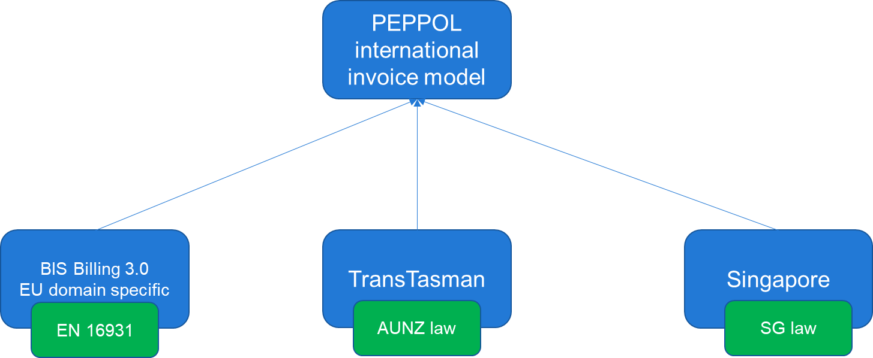

**Figure 1— Peppol international invoice**

# 

# Normative reference

[EIPA]

The following documents are referred to in the text in such a way that some or all of their content constitutes requirements of this document. For dated references, only the edition cited applies. For undated references, the latest edition of the referenced document (including any amendments) applies.

EN 16931-1, *Electronic invoicing — Part 1: Semantic data model of the core elements of an electronic invoice*

CEN/TS 16931-3-1:2017, *Electronic invoicing — Part 3-1: Methodology for syntax bindings of the core elements of an electronic invoice*

CEN/TS 16931-3-2:2017 *Electronic invoicing — Part 3-2: Syntax binding for ISO/IEC 19845*

*(UBL 2.1) invoice and credit note*

EN 16931-5:2017, *Electronic invoicing — Part 5: Guidelines on the use of sector or country extensions in conjunction with EN 16931-1, methodology to be applied in the real environment*

CWA 5678 part 113, *BII Profile 21 – Statement*

ISO 8601:2004, *Data elements and interchange formats — Information interchange — Representation of dates and times*

ISO 4217 :2015*, Codes for the representation of currencies*

ISO 3166-1:2020*, Codes for the representation of names of countries and their subdivisions — Part 1: Country code*

ISO/IEC 6523-1:1998*, Information technology — Structure for the identification of organizations and organization parts — Part 1: Identification of organization identification schemes*

ISO 15000-5:2014*, Electronic Business Extensible Markup Language (ebXML)  — Part 5: Core Component Specification (CCS)*

ISO/IEC 19845:2015 *Information technology — Universal business language version 2.1 (UBL v2.1)*

ISO/IEC 19757-3 :2020, *Information technology — Document Schema Definition Languages (DSDL) — Part 3: Rule-based validation using Schematron*

ISO/IEC Directives, Part 2 *— Rules for the structure and drafting of International Standards*

Extensible Markup Language (XML) 1.0 (Second Edition), *W3C Recommendation 6 October 2000*

XML Schema Part 1: Structures. Second Edition*. W3C Recommendation 28 October 2004*

XML Schema Part 2: Datatypes. Second Edition. *W3C Recommendation 28 October 2004*

XSL Transformations (XSLT) Version 1.0, *W3C Recommendation 16 November 1999*

XML Path Language (XPath) 2.0 (Second Edition), *W3C Recommendation 14 December 2010 (Link errors corrected 3 January 2011; Status updated October 2016)*

PINT Peppol international invoicing model Specification — POAC *DRAFT 0.08 2020-12-21 Final working group copy*

PEPPOL BIS Billing *OpenPEPPOL AISBL, Post-Award Coordinating Community Version 3.0.10 https://docs.peppol.eu/poacc/billing/3.0/bis/*

Japanese Peppol BIS Documentation *https://test-docs.peppol.eu/poacc/billing-japan/*

# 

# Terms and definitions

[SOURCE: PINT DRAFT 0.08 modified by EIPA]

**3.1**

**semantic data model**

structured set of logically interrelated information elements

[SOURCE: EN 16931-1,3.2]

**3.2**

**business term**

label assigned to a given information element which is used as a primary reference

[SOURCE: EN 16931-1,3.6]

**3.3**

**electronic invoice**

invoice that has been issued, transmitted, and received in a structured electronic format which allows for its automatic and electronic processing.

[SOURCE: EN 16931-1,3.1]

**3.4**

**syntax**

machine-readable language or dialect used to represent the information elements contained in an electronic document (e.g. an electronic invoice)

[SOURCE: EN 16931-1,3.5]

**3.5**

**invoicing domain**

a country or a region that share specific business and legal requirements

**3.6**

**shared business term**

business term which definition and rules are the same in all specifications that is compliant to the international invoicing model

**3.7**

**aligned business term**

business term that have a generalized definition that can be specialized (restricted) to support requirements in specific invoicing domains

**3.8**

**distinct business term**

business term that is added in specific invoicing domains

**3.9**

**tax**

tax that is applied to item at the time of sale, such as Value Added Tax (VAT), Goods and Service Tax (GST), Consumption tax, Sales tax

Note 1 to entry: the Peppol international invoice model supports international tax that does not fall under Directive 2014/55/EU.

**3.10**

**identifier**

character string used to establish the identity of, and distinguish uniquely, one instance of an object within an identification scheme from all other objects within the same scheme

[SOURCE: EN 16931-1,3.9]

**3.11**

**identification scheme**

collection of identifiers applicable for a given type of object governed under a common set of rules

[SOURCE: EN 16931-1,3.10]

**3.12**

**compliant**

some or all features of the Peppol international invoice model are used, and all rules of the Peppol international invoice model are respected

Note 1 to entry: Changed core invoice model to the Peppol international invoice model.

[SOURCE: EN 16931-1, 3.11, modified – Note 1 to entry has been added.]

**3.13**

**conformant**

all rules of the Peppol international invoice model are respected, and some additional features not defined in the Peppol international invoice model are also used

Note 1 to entry: Changed core invoice model to the Peppol international invoice model.

[SOURCE: EN 16931-1, 3.12, modified – Note 1 to entry has been added.]

Nobu: ISO DP2 Clause 16 Terms and definition says "Terms shall in general be presented in their basic grammatical form., i.e. nouns in the singular, verbs in the infinitive. The definition shall be written in such a form that it can replace the term in its content. it shall not start with an article ("the", "a") nor end with a full stop. A definition shall not take the form of, or contain, a requirement"

# 

# Verbal form

[EIPA]

The user of the document shall be able to identify the requirements he/she is obliged to satisfy in order to claim conformance to a document. The user shall also be able to distinguish these requirements from other types of provision (recommendations, permissions, possibilities and capabilities).

It is essential to follow rules for the use of verbal forms so that a clear distinction can be made between requirements, recommendations, permissions, possibilities and capabilities. To avoid risk of misinterpretation, verbal forms that are not defined in ISO/IEC Directives, Part 2 Clause 7 Verbal forms for expressions of provisions shall not be used for the expression of provisions.

**Table 1** lists these preferred verbal forms defined in ISO/IEC Directives, Part 2.

**Table 1 — Verbal forms for provision**

|  |  |
| --- | --- |
| **Type of provision** | **Preferred verbal form** |
| Requirement | shall, shall not |
| Recommendation | should, should not |
| Permission | may, may not |
| Possibility and capability | can, cannot |
| External constraint | must |

# 

# PINT specification

## Overview

The Peppol international invoice is expected to be applied in different invoicing domains through domain specific specification that are compliant to the PINT. It is technically possible to use the PINT directly but that assumes that there are no domain specific regulations that need to be supported.

ISO/IEC 19845:2015 (UBL 2.1) provides many kinds of documents related to the business processes defined **Figure 2**, which is taken from ISO/IEC 19845:2015 (UBL 2.1) Figure 1. UN 16931-1 defines semantic data model of core invoice and CEN/TS 16931-3-2 specifies syntax binding this semantic model to ISO/IEC 19845:2015 (UBL 2.1). Open Peppol also provides documents other than invoices based on ISO/IEC 19845:2015 (UBL 2.1).

Tendering is the case where a contracting authority (the Originator) initiates a procurement project to buy goods, services, or works during a specified period. [SOURCE: ISO/IEC 19845:2015 (UBL 2.1) Clause 2.3]

The term post award is taken from tendering business process and invoice documents is key documents in billing business process shown in **Figure 2**.

Open Peppol BIS Billing business process is a pert of the tendering process. **Figure 3** shows the tendering process defined in OASIS ISO/IEC 19845:2015 (UBL 2.1) Figure 6.

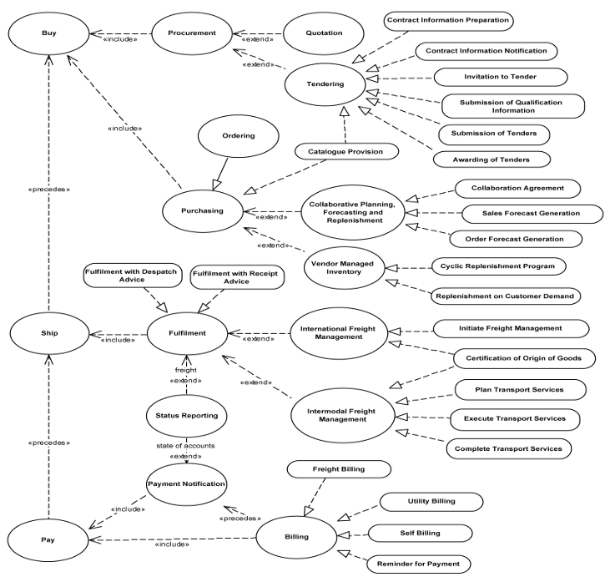

**Figure 2 — UBL 2.1 Use Case [SOURCE: ISO/IEC 19845:2015 (UBL 2.1)]**

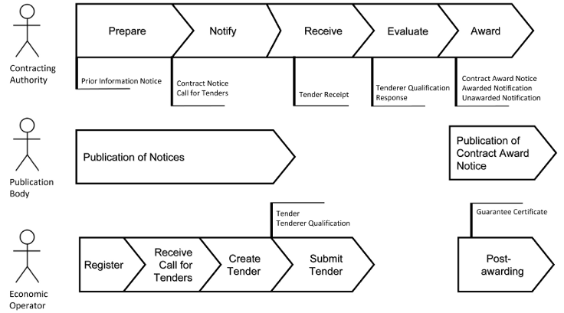

**Figure 3 — The Tendering Process [SOURCE: ISO/IEC 19845:2015 (UBL 2.1)]**

## Parties and roles

### General

The Peppol international invoice model uses the business parties and their roles specified in EN 16931-1. Error! Reference source not found. **Figure 4** shows the roles involved in the invoice and credit note transactions. The customer and invoice receiver is the same entity, as is the supplier and the invoice sender. Following [SOURCE: PINT DRAFT 0.08]

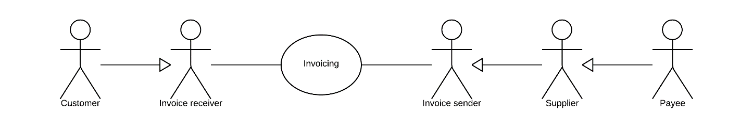

**Figure 4 — Parties and roles [SOURCE: PINT DRAFT 0.08]**

**Figure 5** is a partial extract of Figure 5 from EN 16931-1. Billing is a partial activity in purchase-to-pay of buyer side and order-to cash of seller side.

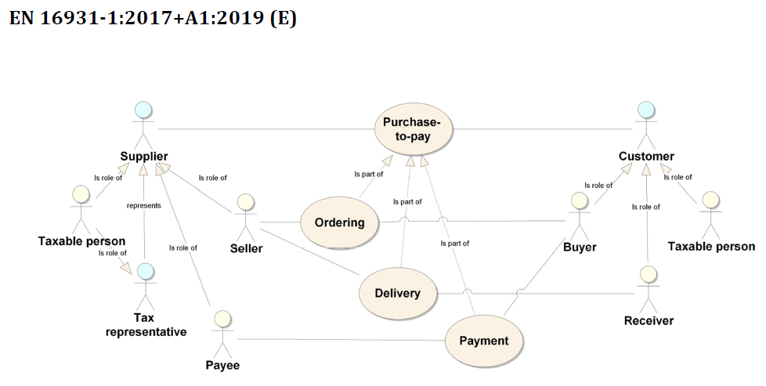

**Figure 5— Parties and roles [SOURCE: EN 16931-1]**

### Parties

[SOURCE: PINT DRAFT 0.08]

* Customer

The customer is the legal person or organisation who is in demand of a product or service. Examples of customer roles: buyer, consignee, debtor, contracting authority.

* Supplier

The supplier is the legal person or organisation who provides a product or service.

### Roles

[SOURCE: PINT DRAFT 0.08]

* Creditor

One to whom a debt is owe. The party that claims the payment and is responsible for resolving billing issues and arranging settlement. The party that sends the invoice or credit note. Also known as invoice issuer, accounts receivable or seller.

* Debtor

One who owes debt. The party responsible for making settlement relating to a purchase. The party that receives the invoice or credit note. Also known as invoices, accounts payable, or buyer.

### Business process requirements supported

The Peppol international invoice model supports the business process specified in EN 16931-1.

The Peppol international invoice model shall include elements that allow the trading parties to represent any invoice transaction used internationally and should support the following types of business processes:

— P1: Invoicing of deliveries of goods and services against purchase orders, based on a

contract;

— P2: Invoicing deliveries of goods and services based on a contract;

— P3: Invoicing the delivery of an incidental purchase order;

— P4: Pre-payment;

— P5: Spot payment;

— P6: Payment in advance of delivery;

— P7: Invoices with references to a despatch advice;

— P8: Invoices with references to a despatch advice and a receiving advice;

— P9: Credit notes or invoices with negative amounts, issued for a variety of reasons including

the return of empty packaging;

— P10: Corrective invoicing (cancellation/correction of an invoice);

— P11: Partial and final invoicing;

— P12: Self billing.

Other processes are not explicitly supported, but the core invoice model may still be applicable.

In more complex or advanced processes, however, extensions to the information content of the

core invoice model may be needed.

## Invoicing functionality supported

### General

[SOURCE: Peppol BIS Billing 3.0]

The Poppol international invoice model support the functions specified in EN 16931-1.

An invoice may support functions related to a number of related (internal) business processes. This Peppol BIS shall support the following functions:

* Accounting
* Invoice verification against the contract, the purchase order and the goods and service delivered
* Tax reporting
* Auditing
* Payment

In the following chapters an assessment is made of what information is needed for each of the functions listed above and whether it is in scope or out of scope for this Peppol BIS.

Explicit support for the following functions (but not limited to) is out of scope:

* Inventory management
* Delivery processes
* Customs clearance
* Marketing
* Reporting

### Accounting

[SOURCE: Peppol BIS Billing 3.0]

Recording a business transaction into the financial accounts of an organization is one of the main objectives of the invoice. According to financial accounting best practice and CT rules every Taxable person shall keep accounts in sufficient detail for CT to be applied and its application checked by the tax authorities. For that reason, an invoice shall provide for the information at document and line level that enables booking on both the debit and the credit side.

[SOURCE: EN 16931-1 5.3.2 Accounting]

Recording a business transaction into the financial accounts of an organization is one of the main objectives of the invoice. According to financial accounting best practice and VAT rules every Taxable person shall keep accounts in sufficient detail for VAT to be applied and its application checked by the tax authorities. For that reason, an invoice shall provide for the information at document and line level that enables booking on both the debit and the credit side.

In scope for the core invoice model:

R1 information at document level that enables the identification of the Payee, if different from the Seller (all processes, except P9);

R2 information at document level that enables booking on both the debit and the credit side (all processes);

R3 information at invoice line level that enables booking on the debit side (all processes);

R4 Buyer-specific booking information (account numbers) (all processes).

Out of scope for the core invoice model:

— invoice sub-lines;

— booking information at sub-line level.

to a delivery at invoice line level.

### Invoice verification

[SOURCE: Peppol BIS Billing 3.0]

This process forms part of the Buyer’s internal business controls. The invoice shall refer to an authentic commercial transaction. Support for invoice verification is a key function of an invoice. The invoice should provide sufficient information to look up relevant existing documentation, electronic or paper, for example, and as applicable:

* the relevant purchase order
* the contract
* the call for tenders, that was the basis for the contract
* the Buyer’s reference
* the confirmed receipt of the goods or services
* delivery information

An invoice should also contain sufficient information that allows the received invoice to be transferred to a responsible authority, person or department, for verification and approval.

[SOURCE: 5.3.3 Invoice verification]

This process forms part of the Buyer’s internal business controls. The invoice shall refer to an authentic commercial transaction. Support for invoice verification is a key function of an invoice.

The invoice should provide sufficient information to look up relevant existing documentation, electronic or paper, for example, and as applicable to the models detailed above:

— the relevant purchase order;

— the contract;

— the call for tenders, that was the basis for the contract;

— the Buyer’s reference;

— the confirmed receipt of the goods or services.

An invoice should also contain sufficient information that allows the received invoice to be transferred to a responsible authority, person or department, for verification and approval.

In scope for the core invoice model:

R5 information to trace to a single related purchase order from the document level (all processes, except P2 and P5);

R6 information to trace to a single related purchase order line from the invoice line (all processes, except P2 and P5);

R7 information to trace to a single contract and the underlying call for tenders from the document level (all processes, except P3 and P5);

R8 a reference supplied by the Buyer at document level (all processes);

R9 information to trace to a single despatch advice from the document level (processes P7 and P8);

R10 information to trace to a single receiving advice from the document level (process P8);

R11 information to trace to a related invoice to be corrected from the document level (process P10);

R12 reference to multiple part-invoices from a final invoice (process P12);

R13 information to allow an invoice and related documents to be transferred to a responsible authority, entity, person or department, for verification and approval (all processes);

R14 information about net price and the quantity on which the price is based at invoice line level, additional information such as gross price and price discount may be added (all processes);

R15 descriptive and coded information about allowances and charges at both document level and at invoice line level (all processes);

R16 information about charges, (non-VAT-)taxes, duties and levies, with their VAT information, that are not included in the line amounts at document level (all processes);

R17 information about charges, (non-VAT-)taxes, duties and levies that compose the taxable amount and are not included in the unit price at separate invoice lines, with a proper identification and/or description (all processes);

R18 information about charges at invoice line level as part of the line amount (all processes);

R19 the amounts of allowances and charges at document and invoice line level (all processes);

R20 textual descriptions of invoiced goods and services at invoice line level (all processes);

R21 identification of invoiced goods and services by means of a Seller's item number at invoice line level (all processes);

R22 identification of invoiced goods and services by means of a Buyer's item number at invoice line level (all processes);

R23 identification of invoiced goods and services by means of a qualified general item identifier at invoice line level as agreed by the Buyer and the Seller (all processes);

R24 classification of invoiced goods and services by means of applicable classification identifiers and schema reference as agreed between the Seller and the Buyer at invoice line level (all processes);

R25 information about returned and credited returnable assets or packages, such as pallets, and package charges, stated as normal invoice lines (all processes);

R26 information about returnable asset charges, stated as normal invoice lines (all processes);

R27 information about returned goods, stated as normal invoice lines (all processes);

R28 descriptive information about attributes of goods and services at invoice line level (all processes);

R29 information about the country of origin of goods and services at invoice line level (all processes);

R30 an invoice line period at invoice line level (process P2, P11);

R31 one delivery date at document level (all processes);

R32 one delivery location or address at document level (all processes);

R33 identification of the invoiced object at document and line level (process P2);

R34 a delivery/invoice period at document level (process P2, P11);

R35 attached documents of a limited set of file types (all processes);

R36 multiple attached or referenced documents at document level (all processes);

R37 a VAT category and rate at invoice line level (all processes);

R38 VAT totals per category at document level (all processes);

R39 a quantity and a net amount (exclusive of VAT) at invoice line level (all processes);

R40 all amounts at document and invoice line level that make up the invoice total amount and the amount due for payment (all processes);

R41 Reference to a sales order, issued by the Seller at document level (all processes);

R42 Allowance/charge percentage and base amount at document and invoice line level (all processes);

R44 Information to allow automated validation of a received electronic invoice (all processes).

Out of scope for the core invoice model:

— reference to multiple related purchase orders;

— reference to one or more related purchase order lines on header level;

— reference to multiple related purchase order lines on line level;

— reference to multiple contracts;

— reference to one or more price lists;

— reference to more than one despatch advice or shipping note;

— reference to the exact time of delivery;

— reference to one or more delivery notes, shipping notices or despatch advices or -lines at invoice line level;

— reference to more than one receiving advice;

— reference to one or more receiving advice lines at invoice line level;

— reference to supporting documents at invoice line level;

— reference to one or more consumption reports or performance records;

— reference to one or more invoices for payment in advance;

— reference to multiple sales orders (issued by the Seller);

— sub-lines of allowances and charges;

— delivered quantities of goods and services if different from invoiced quantities;

— ordered quantities of goods and services if different from invoiced quantities;

— back-ordered quantities of goods and services if different from invoiced quantities;

— coded attributes of goods and services;

— specific coded quality information of goods or services;

— structured metered values;

— lot numbers of goods and services (except in free text);

— serial numbers or other identification numbers (e.g. of the person rendering the services) (except in free text);

— reference to multiple deliveries;

— reference

### Auditing

[SOURCE: Peppol BIS Billing 3.0]

Companies audit themselves as means of internal control or they may be audited by external parties as part of a legal obligation. Accounting is a regular, ongoing process whereas an audit is a separate review process to ensure that the accounting has been carried out correctly. The auditing process places certain information requirements on an invoice. These requirements are mainly related to enable verification of authenticity and integrity of the accounting transaction.

Invoices, conformant to this Peppol BIS support the auditing process by providing sufficient information for:

* identification of the relevant Buyer and Seller
* identification of the products and services traded, including description, value and quantity
* information for connecting the invoice to its payment
* information for connecting the invoice to relevant documents such as a contract and a purchase order

[SOURCE: EN 16931-1 5.3.5 Auditing]

Companies audit themselves as means of internal control or they may be audited by external parties as part of a legal obligation. Accounting is a regular, ongoing process whereas an audit is a separate review process to ensure that the accounting has been carried out correctly. The auditing process places certain information requirements on an invoice. These requirements are mainly related to enable verification of authenticity and integrity of the accounting transaction.

Auditing requirements apply to all of the above processes.

Invoices, conformant to the core invoice model support the auditing process by providing sufficient information for:

— identification of the relevant Buyer and Seller;

— identification of the products and services traded, including description, value and quantity;

— information for connecting the invoice to its payment;

— information for connecting the invoice to relevant documents such as a contract and a purchase order.

In scope for the core invoice model:

R56 sufficient information to support the auditing process with regard to:

— identification of the invoice;

— identification of the date of issue of the invoice;

— identification of the products and services traded, including their description, value and quantity;

— information for relating the invoice to its settlement;

— information for relating the invoice to relevant documents such as a contract, a purchase order and a despatch advice;

— information about the reason for invoice correction (process P10);

R57 identification of the parties that fulfil the following roles at the invoice level, including their legal name and address:

— the Seller (including the Seller's trade name);

— the Buyer;

— the Deliver to party (if different from the Buyer);

— the Payee (if different from the Seller);

— the Tax representative of the Supplier;

Out of scope for the core invoice model:

— identification of:

— the carrier;

— the creditor (if different from Payee);

— the debtor (if different from Buyer);

— the identification of the service or business unit of the Seller, issued by the Buyer;

— subtotals for part of the lines.

### Tax Reporting

[SOURCE: Peppol BIS Billing 3.0]

The invoice is used to carry Tax related information from the Seller to the Buyer to enable the Buyer and Seller to correctly handle Tax booking and reporting. An invoice should contain sufficient information to enable the Buyer and any auditor to determine whether the invoice is correct from a Tax point of view.

The invoice shall allow the determination of the Tax regime, the calculation and description of the tax, in accordance with the {Tax-dir} and subsequent amendments.

[SOURCE: EN 16931-1 5.3.4 VAT reporting]

The invoice is used to carry VAT related information from the Seller to the Buyer to enable the Buyer and Seller to correctly handle VAT booking and reporting. An invoice should contain sufficient information to enable the Buyer and any auditor to determine whether the invoice is correct from a VAT point of view.

The invoice shall allow the determination of the VAT regime, the calculation and description of the tax, in accordance with the European Directive 2006/112/EC [2] and subsequent amendments. VAT reporting applies to all processes.

In scope for the core invoice model:

R45 information to determine the requirements of the applicable VAT legislation in force and the calculation and reporting thereof;

R46 information on the date the VAT is liable at document level;

R47 the necessary elements for national legal VAT requirements that apply for invoices issued to national and foreign Buyers, such as the legal registration status of the Seller;

R48 information to support the following VAT use cases:

— Invoices for supplies for which VAT is charged;

— Invoices for supplies for which VAT is not charged based on an exemption reason;

— Invoices for supplies for which the Seller’s goods and services are exempt from VAT at line level;

— Invoices for supplies that are issued under reverse charge;

— Invoices for exempt intra-community supplies for which an intra-community acquisition has to be done;

— Invoices for supplies outside the scope of the Directive 2006/112/EC [2] (non-VAT invoices);

R49 the total VAT amount at document level;

R50 total taxable amount per VAT rate at document level;

R51 any additional information required to support the exemption evidence in case VAT is not charged based on an exemption reason at document and at invoice line level;

R52 the legal registration number and the VAT registration number of the Seller and Buyer and the VAT registration number of the Tax representative of the Supplier;

R53 the official postal address of the Buyer, Seller and Tax representative of the Supplier and their place of business and registered office;

R54 the invoice currency and the VAT accounting currency at document level if different from the invoice currency;

R55 codes for exemption reasons at document and invoice line level.

Out of scope for the core invoice model:

— refund applications (Directive 2008/9/EC [5]);

— structured information that is commonly provided in page footnote of business documents,

such as:

— share Capital Amount of the Seller;

— legal form of the Seller.

### Payment

[SOURCE: Peppol BIS Billing 3.0]

An invoice represents a claim for payment. The issuance of an invoice may take place either before or after the payment is carried out. When an invoice is issued before payment it represents a request to the Buyer to pay, in which case the invoice commonly contains information that enables the Buyer, in the role of a debtor, to correctly initiate the transfer of the payment, unless that information is already agreed in prior contracts or by means of payment instructions separately lodged with the Buyer.

If an invoice is issued after payment, such as when the order process included payment instructions or when paying with a credit card, online or telephonic purchases, the invoice may contain information about the payment made in order to facilitate invoice to payment reconciliation on the Buyer side. An invoice may be partially paid before issuing such as when a pre-payment is made to confirm an order.

Invoices, conformant with this specification should identify the means of payment for settlement of the invoice and clearly state what payment amount is requested. They should provide necessary details to support bank transfers. Payments by means of Credit Transfer, Direct debit, and Payment Card are in scope.

[SOURCE: EN 16931-1 5.3.6 Payment]

An invoice represents a claim for payment. The issuance of an invoice may take place either before or after the payment is carried out. When an invoice is issued before payment it represents a request to the Buyer to pay, in which case the invoice commonly contains information that enables the Buyer, in the role of a debtor, to correctly initiate the transfer of the payment, unless that information is already agreed in prior contracts or by means of payment instructions separately lodged with the Buyer.

If an invoice is issued after payment, such as when the order process included payment instructions or when paying with a credit card, online or telephonic purchases, the invoice may contain information about the payment made in order to facilitate invoice to payment reconciliation on the Buyer side. An invoice may be partially paid before issuing such as when a pre-payment is made to confirm an order.

Invoices, conformant with the core invoice model should identify the means of payment for settlement of the invoice and clearly state what payment amount is requested. They should provide necessary details to support bank transfers in accordance with the Single Euro Payments Area (SEPA) for payments in Euro and the relevant national payment practices for other currencies. Payments by means of Credit Transfer, Direct debit, and Payment Card are in scope for making payments of invoices conformant with the core invoice model.

Payment information is needed in all processes.

In scope for the core invoice model:

R58 identification of the means of settlement;

R59 the requested amount due for payment;

R60 the date on which payment is due;

R61 necessary details to support bank transfers in accordance with SEPA and national systems;

R62 a reference number and any additional reference data to be included in the payment;

R63 reference number and any additional reference data to be included in the payment, in order to relate the payment to the invoice;

R64 information for relating an invoice to a payment card used for settlement;

R65 basic information to support national payment systems for use in domestic trade;

R66 information about the amount that was pre-paid;

R67 invoices that have a total amount of zero;

R68 invoices that have an amount to pay of zero;

R69 necessary details to support direct debits.

R70 pre-payment invoices

Out of scope for the core invoice model:

— instalments;

— references to pre-payments;

— early-payment allowances in a structured way;

— late-payment penalty schemes in a structured way;

— quoted or referenced structured payment terms.

## Standard invoicing process

[SOURCE: Japanese Peppol BIS Documentation]

The invoicing process includes issuing and sending the invoice and the credit note from the supplier to the customer and the reception and handling of the same at the customer’s site.

The invoicing process is shown in this work flow:

* A supplier issues and sends an invoice to a customer. The invoice refers to one order and a specification of delivered goods and services.

An invoice may also refer to a contract or a frame agreement. The invoice may specify articles (goods and services) with article number or article description.

* The customer receives the invoice and processes it in the invoice control system leading to one of the following results:

1. The customer fully approves the invoice, posts it in the accounting system and passes it on to be paid.
2. The customer completely rejects the invoice, contacts the supplier and requests a credit note.
3. The customer disputes parts of the invoice, contacts the supplier and requests a credit note and a new invoice.

**Figure 6** shows the basic invoicing process with the use of this PEPPOL BIS profile. This process assumes that both the invoice and the credit note are exchanged electronically.

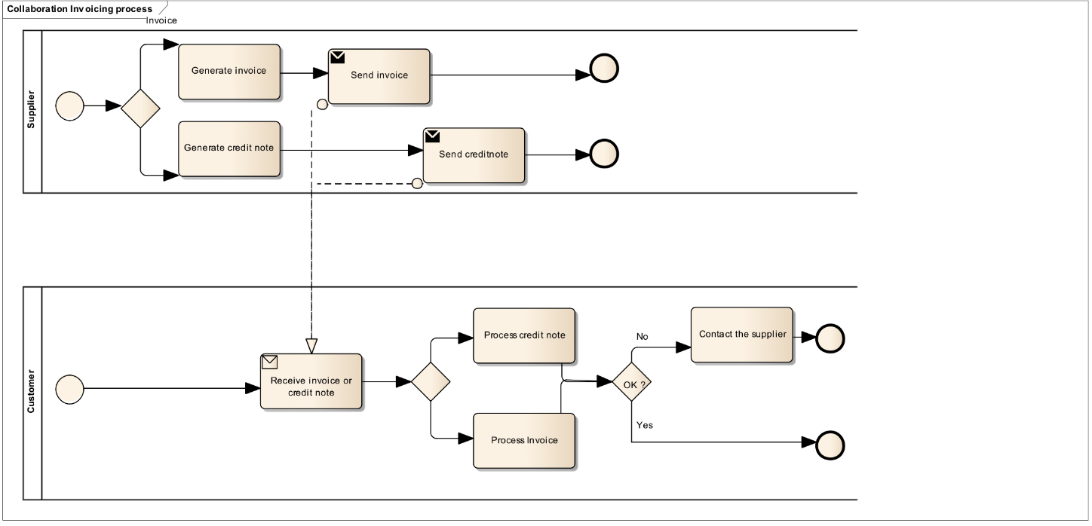

**Figure 6 — Standard invoice process [SOURCE: EN 16931-1]**

This profile covers the following invoice processes:

|  |  |
| --- | --- |
| **P1** | Invoicing of deliveries of goods and services against purchase orders, based on a contract |
| **P2** | Invoicing deliveries of goods and services based on a contract |
| **P3** | Invoicing the delivery of an incidental purchase order |
| **P4** | Pre-payment |
| **P5** | Spot payment |
| **P6** | Payment in advance of delivery |
| **P7** | Invoices with references to a despatch advice |
| **P8** | Invoices with references to a despatch advice and a receiving advice |
| **P9** | Credit notes or invoices with negative amounts, issued for a variety of reasons including the return of empty packaging |
| **P10** | Corrective invoicing (cancellation/correction of an invoice) |
| **P11** | Partial and final invoicing |
| **P12** | Self billing. |

## Delivery Note process

[SOURCE: Japanese Peppol BIS Documentation]

### General

In the delivery note process, the supplier sends a delivery note to the buyer with each delivery and the buyer uses the information in the delivery note to verify the reception of the items. The delivery note is focused on providing information about the items that are being delivered.

The invoicing process is shown in this work flow:

* A supplier can send one or more delivery note along with the deliveries of items. The delivery note refers to the order and provides information about the items and their quantities. The customer can use the delivery note to control the reception of the items.

**Figure 7** shows the delivery note process. This process assumes the delivery notes are exchanged electronically.

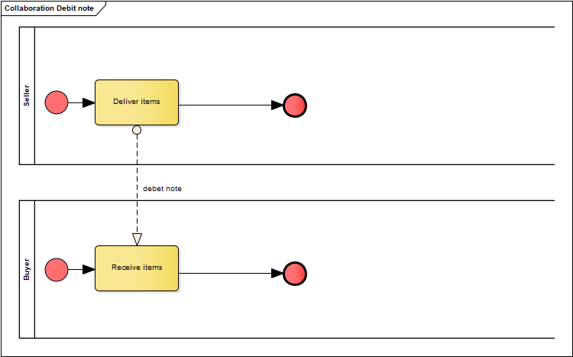

**Figure 7 — Debit Note process [SOURCE: Japanese Peppol BIS Documentation]**

### Document used in this process

[EIPA]

The Delivery Note process requires the use of the following document:

1. Delivery Note (Debit Note)

The delivery note uses the same data model as the Japanese standard invoice with the difference that document type code is 383 (Debit Note), terminology is adjusted from invoice to delivery note and rules are reduced.

NOTE 1: ISO 19845 defines Debit Note as a document used in billing business process to specify debits incurred by the Debtor and a submitter is a customer and a receiver is a supplier.

NOTE 2: ISO 19845 defines Despatch Advice and Open Peppol supports this document. This document is used in Fulfilment business process and used to describe the despatch or delivery of goods and services. A submitter role is Despatch and Receiver role is Delivery. Japanese Delivery Note is used in billing business process as a carbon copy of an invoice.

## Summary invoicing process

### General

[SOURCE: Japanese Peppol BIS Documentation]

In the summary invoicing process, the supplier sends a Delivery Note to the buyer with each delivery and the buyer uses the information in the Delivery Note to verify the reception of the items. The Delivery Note is focused on providing information about the items that are being delivered. At the end of a period (usually a month) the supplier sends a single invoice that summarises the items that were send during that period. The invoice contains represents a claim for payment and contains the necessary tax information.

The invoicing process is shown in this work flow:

* A supplier can send one or more Delivery Note along with the deliveries of items. The Delivery Note refers to the order and provides information about the items and their quantities. The customer can use the Delivery Note to control the reception of the items.
* A the end of a period a supplier issues and sends an invoice to a customer. The invoice summarizes all the items delivered during the period and references the Delivery Notes.
* The customer receives the invoice and processes it in the invoice control system leading to one of the following results:
* The customer fully approves the invoice, posts it in the accounting system and passes it on to be paid.
* The customer completely rejects the invoice, contacts the supplier and requests a credit note.
* The customer disputes parts of the invoice, contacts the supplier and requests a credit note and a new invoice.

**Figure 8** shows the basic invoicing process with the use of this PEPPOL Japan summary invoice BIS profile. This process assumes that both the invoice and the credit note are exchanged electronically.

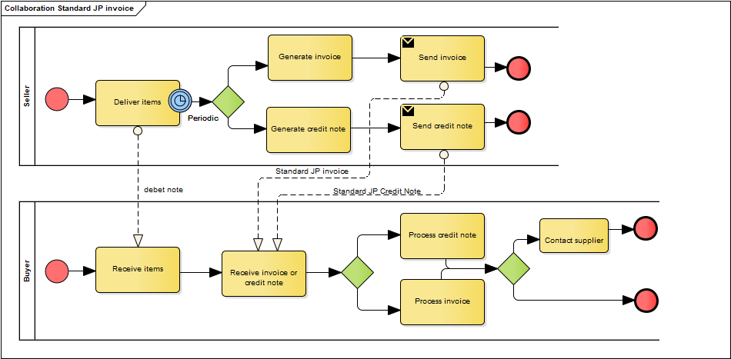

**Figure 8 — Summary invoice [SOURCE: Japanese Peppol BIS Documentation ]**

This profile covers the following invoice processes: [EIPA]

|  |  |
| --- | --- |
| **P1** | Invoicing of deliveries of goods and services against purchase orders, based on a contract |
| **P2** | Invoicing deliveries of goods and services based on a contract |
| **P3** | Invoicing the delivery of an incidental purchase order |
| **P4** | Pre-payment |
| **P5** | Spot payment |
| **P6** | Payment in advance of delivery |
| **P7** | Invoices with references to a despatch advice |
| **P8** | Invoices with references to a despatch advice and a receiving advice |
| **P9** | Credit notes or invoices with negative amounts, issued for a variety of reasons including the return of empty packaging |
| **P10** | Corrective invoicing (cancellation/correction of an invoice) |
| **P11** | Partial and final invoicing |
| **P12** | Self billing. |

### Documents used in process.

[SOURCE: Japanese Peppol BIS Documentation]

The Summarized Invoiced process requires the use of the following documents:

* Standard Japanese Invoice
* Delivery Note

1. Standard Japanese Invoice

The invoice used in this process is the same data model as specified for the Standard Japanese Invoice process, but with additional rules.

Additional rules are the following:

* A reference to a Delivery Note is required for each invoice line.

1. Delivery Note

The Delivery Note used in this process is the same as specified for the stand alone Delivery Note process.

### Processing patterns

[EIPA]

**Table 2** lists processing patterns and tax amount calculation..

**Table 2 — Processing patterns and tax amount**

|  |  |  |  |  |  |  |
| --- | --- | --- | --- | --- | --- | --- |
| **Pattern** | **Delivery Note** | | | **Summarized Invoice** | | |
| **Line item** | **TAX amount** |  | **Line item** | **Tax amount** |  |
| 1-A | ✓ | ✓ | Delivery note (if the mandatory items to be stated are satisfied by delivery note only.) or Combination of delivery note and summarized invoice (if the mandatory items to be stated are not satisfied by delivery note only.) | ✓ | ✓ | Aggregation of tax amount stated on delivery note |
| 1-B | ✓ | ✓ | -- (because of a non-compliant and non-qualified way, not applicable) | ✓ | ✓ | Recalculation of tax amount on summarized invoice (document level) |
| 1-C | ✓ |  | Summarized Invoice | ✓ | ✓ | Calculation of tax amount on summarized invoice (document level) |
| 2-A | ✓ | ✓ | Delivery note (if the mandatory items to be stated are satisfied by delivery note only.) or Combination of delivery note and summarized invoice (if the mandatory items to be stated are not satisfied by delivery note only.) |  | ✓ | Aggregation of tax amount stated on delivery note |
| 2-B | ✓ | ✓ | -- (because of a non-compliant and non-qualified way, not applicable) |  | ✓ | Recalculation of tax amount on summarized invoice (document level) |
| 2-C | ✓ |  | Combination of delivery note and summarized invoice (= Satisfy the mandatory items to be stated by both Delivery Note and summarized invoice) |  | ✓ | Calculation of tax amount on summarized invoice (document level) |

**Table** 3 lists Processing patterns from legal and business perspectives.

**Table 3 — Processing patterns from legal and business perspectives**

|  |  |  |  |
| --- | --- | --- | --- |
| **Pattern** | **From a legal perspective** | **From a business process perspective** | **Direction [in e-Invocing]** |
| 1-A | △ Aggregated result of tax amount stated on delivery note = Tax amount on Summarized Invoice (document level) They are matched as amount. Tax amount stated on summarized invoice is treated as "graffiti" and it is invalid. | △ Be careful about what should be kept as qualified invoice | Summarized invoice in this pattern is positioned as "monthly-based convergent invoice" and it means "payment advice" in fact. Legal requirements should be satisfied by delivery note only and delivery note should be treated as qualified invoice. |
| 1-B | × Aggregated result of tax amount stated on delivery note ≠ Tax amount stated on Summarized Invoice (document level) Because the existence of two kinds of tax amount makes confusion, it is not allowed. | × There is a discrepancy between delivery note and summarized invoice (Unresolved issue) | × not allowed |
| 1-C | ◎ Only summarized invoice has tax amount. This is a compliant and qualified way with Consumption Tax Law. | ○ | ◎ What it should be as summarized invoice |
| 2-A | △ Aggregated result of tax amount stated on delivery note = Tax amount stated on Summarized Invoice (document level) They are matched as amount. Tax amount stated on summarized invoice is treated as "graffiti" and it is invalid. | △Be careful about what should be kept as qualified invoice | Summarized invoice in this pattern is positioned as "monthly-based convergent invoice" and it means "payment advice" in fact. Legal requirements should be satisfied by delivery note only and delivery note should be treated as qualified invoice. |
| 2-B | × Aggregated result of tax amount stated on delivery note ≠ Tax amount stated on Summarized Invoice (document level) Because the existence of two kinds of tax amount makes confusion, it is not allowed. | × There is a discrepancy between delivery note and summarized invoice (Unresolved issue) | × not allowed |
| 2-C | △ Aggregated result of tax amount stated on delivery note = Tax amount on Summarized Invoice (document level) They are matched as amount. Tax amount stated on summarized invoice is treated as "graffiti" and it is invalid. | ○ | ◎ What it should be as summarized invoice |

**Figure 9** to **Figure 12** shows summary of items to be held in either in a Summerised Invoice and a Delivery Note.

Not all items but key items are described; most are required by Tax Authority

Term 'Delivery Note' here is represented as 'Debit Note' in Peppol. It works as a copy of partial information of an invoice.

Each mark shows tax law qualification status; 〇=qualified, △= not qualified but allowed, X= not allowed

### Standard invoice

[EIPA]

**Figure 9** shows a standard invoice pattern. In case a Delivery Note is issued, it is just for delivery notice purpose. It is not recommended to have any amount mentioned. An Invoice works as Tax-Qualified Invoice. Some buyers book inventory/service for a Delivery Note receipt, while others book upon invoice for efficiency. Buyers book account payable for invoice receipt.

Rounding should be done at invoice level.

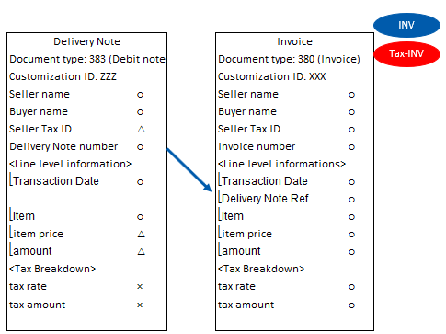

**Figure 9 — Standard invoice**

### Payment advice pretending to be a summarised invoice (1-A, 2-A)

[EIPA]

**Figure 10** shows pattern 1-A and 1-B. Delivery Note works as individual invoice. Delivery Note and individual Invoice' works as Tax-qualified invoice. Buyers book inventory/service for a 'Delivery Note and invoice' receipt. Buyers book account payable for 'Delivery Note and invoice' receipt. Conventional monthly Summerised invoice works as payment advice.

Rounding should be done a 'Delivery Note and invoice' level. Rounding won't be done per a monthly Summerised invoice just as payment advice.

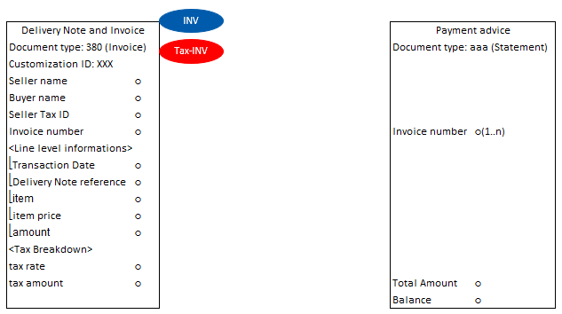

**Figure 10 — Payment advice pretending to be a Summerised invoice (1-A, 2-A)**

**Table 4** and **Table 5** lists example semantic contents of delivery note (Pattern 1-A, 2-A) above.

NOTE: All element names are inherited from Peppol International Invoicing (PINT) and naming use the term invoice, the same items are used in standard commercial invoice, summarised invoice and delivery note (debit note). The tag names are correct according to the ISO/IEC 19845:2015 (UBL 2.1) Invoice schema.

**Table 4 — Example semantic contents of Delivery note (Delivery Note#0011) (Pattern 1-A, 2-A)**

|  |  |  |  |  |  |  |  |  |  |
| --- | --- | --- | --- | --- | --- | --- | --- | --- | --- |
| **ID** | **Level** | **Card.** | **Business Term** | **Content** | **VAT S 10%** | **VAT AA 8%** | **Line 1** | **Line 2** | **Line 3** |
| ibt-001 | 1 | 1..1 | Invoice number | #0011 |  |  |  |  |  |
| ibt-002 | 1 | 1..1 | Invoice issue date | 2022-10-01 |  |  |  |  |  |
| ibt-003 | 1 | 1..1 | Invoice type code | 383 |  |  |  |  |  |
| ibt-005 | 1 | 1..1 | Invoice currency code | JPY |  |  |  |  |  |
| ibg-04 | 1 |  | SELLER | | | | | | |
| ibt-027 | 2 | 1..1 | Seller name | △△商事(株) |  |  |  |  |  |
| ibt-031 | 2 | 0..1 | Seller TAX identifier | T1234567890123 |  |  |  |  |  |
| ibg-07 | 1 | 1..1 | BUYER | | | | | | |
| ibt-044 | 2 | 1..1 | Buyer name | (株)〇〇 |  |  |  |  |  |
| ibg-13 | 1 | 0..1 | DELIVERY INFORMATION | | | | | | |
| ibg-14 | 2 | 0..1 | INVOICING PERIOD | | | | | | |
| ibt-073 | 3 | 0..1 | Invoicing period start date | 2022-10-01 |  |  |  |  |  |
| ibt-074 | 3 | 0..1 | Invoicing period end date | 2022-10-01 |  |  |  |  |  |
| ibg-22 | 1 | 1..1 | DOCUMENT TOTALS | | | | | | |
| ibt-106 | 2 | 1..1 | Sum of Invoice line net amount | 8000 |  |  |  |  |  |
| ibt-109 | 2 | 1..1 | Invoice total amount without TAX | 8000 |  |  |  |  |  |
| ibt-110 | 2 | 0..1 | Invoice total TAX amount | 660 |  |  |  |  |  |
| ibt-112 | 2 | 1..1 | Invoice total amount with TAX | 8660 |  |  |  |  |  |
| ibt-115 | 2 | 1..1 | Amount due for payment | 8660 |  |  |  |  |  |
| ibg-23 | 1 | 1..n | TAX BREAKDOWN | | | | | | |
| ibt-116 | 2 | 1..1 | TAX category taxable amount |  | 1000 | 7000 |  |  |  |
| ibt-117 | 2 | 1..1 | TAX category tax amount |  | 100 | 560 |  |  |  |
| ibt-118 | 2 | 1..1 | TAX category code |  | S | AA |  |  |  |
| ibt-118-1 | 3 | 0..1 | Tax Scheme |  | VAT | VAT |  |  |  |
| ibt-119 | 2 | 0..1 | TAX category rate |  | 10 | 8 |  |  |  |
| ibg-25 | 1 | 1..n | INVOICE LINE | | | | | | |
| ibt-126 | 2 | 1..1 | Invoice line identifier |  |  |  | 1 | 2 | 3 |
| ibt-129 | 2 | 1..1 | Invoiced quantity |  |  |  | 1 | 1 | 1 |
| ibt-130 | 2 | 1..1 | Invoiced quantity unit of measure code |  |  |  | C62 | C62 | C62 |
| ibt-131 | 2 | 1..1 | Invoice line net amount |  |  |  | 5000 | 2000 | 1000 |
| ibg-29 | 2 | 1..1 | PRICE DETAILS | | | | | | |
| ibt-146 | 3 | 1..1 | Item net price |  |  |  | 5000 | 2000 | 1000 |
| ibg-30 | 2 | 1..n | LINE TAX INFORMATION | | | | | | |
| ibt-151 | 3 | 1..1 | Invoiced item TAX category code |  |  |  | AA | AA | S |
| ibt-152 | 3 | 0..1 | Invoiced item TAX rate |  |  |  | 8 | 8 | 10 |
| ibg-31 | 2 | 1..1 | ITEM INFORMATION | | | | | | |
| ibt-153 | 3 | 1..1 | Item name |  |  |  | 牛肉 | じゃがいも | 割り箸 |

**Table 5 — Example semantic contents of Deliverly note (Delivery Note#0012) (Pattern 1-A, 2-A)**

|  |  |  |  |  |  |  |  |
| --- | --- | --- | --- | --- | --- | --- | --- |
| **ID** | **Level** | **Card.** | **Business Term** | **Content** | **VAT S 10%** | **VAT AA 8%** | **Line 1** |
| ibt-001 | 1 | 1..1 | Invoice number | #0012 |  |  |  |
| ibt-002 | 1 | 1..1 | Invoice issue date | 2022-10-29 |  |  |  |
| ibt-003 | 1 | 1..1 | Invoice type code | 383 |  |  |  |
| ibt-005 | 1 | 1..1 | Invoice currency code | JPY |  |  |  |
| ibg-04 | 1 |  | SELLER | | | | |
| ibt-027 | 2 | 1..1 | Seller name | △△商事(株) |  |  |  |
| ibt-031 | 2 | 0..1 | Seller TAX identifier | T1234567890123 |  |  |  |
| ibg-07 | 1 | 1..1 | BUYER | | | | |
| ibt-044 | 2 | 1..1 | Buyer name | (株)〇〇 |  |  |  |
| ibg-13 | 1 | 0..1 | DELIVERY INFORMATION | | | | |
| ibg-14 | 2 | 0..1 | INVOICING PERIOD | | | | |
| ibt-073 | 3 | 0..1 | Invoicing period start date | 2022-10-29 |  |  |  |
| ibt-074 | 3 | 0..1 | Invoicing period end date | 2022-10-29 |  |  |  |
| ibg-22 | 1 | 1..1 | DOCUMENT TOTALS | | | | |
| ibt-106 | 2 | 1..1 | Sum of Invoice line net amount | 5400 |  |  |  |
| ibt-109 | 2 | 1..1 | Invoice total amount without TAX | 5400 |  |  |  |
| ibt-110 | 2 | 0..1 | Invoice total TAX amount | 540 |  |  |  |
| ibt-112 | 2 | 1..1 | Invoice total amount with TAX | 5940 |  |  |  |
| ibt-115 | 2 | 1..1 | Amount due for payment | 5940 |  |  |  |
| ibg-23 | 1 | 1..n | TAX BREAKDOWN | | | | |
| ibt-116 | 2 | 1..1 | TAX category taxable amount |  | 5400 |  |  |
| ibt-117 | 2 | 1..1 | TAX category tax amount |  | 540 |  |  |
| ibt-118 | 2 | 1..1 | TAX category code |  | S |  |  |
| ibt-118-1 | 3 | 0..1 | Tax Scheme |  | VAT |  |  |
| ibt-119 | 2 | 0..1 | TAX category rate |  | 10 |  |  |
| ibg-25 | 1 | 1..n | INVOICE LINE | | | | |
| ibt-126 | 2 | 1..1 | Invoice line identifier |  |  |  | 1 |
| ibt-129 | 2 | 1..1 | Invoiced quantity |  |  |  | 1 |
| ibt-130 | 2 | 1..1 | Invoiced quantity unit of measure code |  |  |  | C62 |
| ibt-131 | 2 | 1..1 | Invoice line net amount |  |  |  | 5400 |
| ibg-29 | 2 | 1..1 | PRICE DETAILS | | | | |
| ibt-146 | 3 | 1..1 | Item net price |  |  |  | 5400 |
| ibg-30 | 2 | 1..n | LINE TAX INFORMATION | | | | |
| ibt-151 | 3 | 1..1 | Invoiced item TAX category code |  |  |  | S |
| ibt-152 | 3 | 0..1 | Invoiced item TAX rate |  |  |  | 10 |
| ibg-31 | 2 | 1..1 | ITEM INFORMATION | | | | |
| ibt-153 | 3 | 1..1 | Item name |  |  |  | ワイン |

**Table 6** lists example semantic contents of Payment advice (Pattern 1-A, 2-A) above.

**Table 6 — Example semantic contents of Payment advice (Pattern 1-A, 2-A)**

TBD

### Summerised Invoice (Pattern 1-C)

[EIPA]

**Figure 11** shows pattern 1-C. Delivery Note is just for goods receipt verification and better not to mention any amount. Summerised Invoice works as Tax-qualified invoice Some buyers book inventory / service for a Delivery Note receipt, while others book upon invoice for efficiency. Buyers book account payable for Summerised invoice receipt. Payment advice is additionally issued on occasion.

Rounding shall be done at Summerised invoice level.

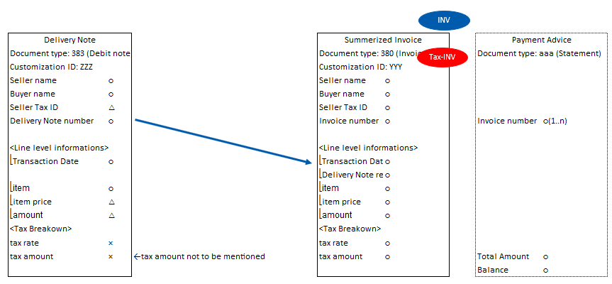

**Figure 11 — Summerised Invoice (Pattern 1-C)**

**Table 7** and **Table 8** lists example semantic contents of delivery note (Pattern 1-C) above.

NOTE: All element names are inherited from Peppol International Invoicing (PINT) and naming use the term invoice, the same items are used in standard commercial invoice, summarised invoice and delivery note (debit note). The tag names are correct according to the ISO/IEC 19845:2015 (UBL 2.1) Invoice schema.

**Table 7 — Example semantic contents of Delivery note (Delivery Note#0011) (Pattern 1-C)**

|  |  |  |  |  |  |  |  |
| --- | --- | --- | --- | --- | --- | --- | --- |
| **ID** | **Level** | **Card.** | **Business Term** | **Content** | **Line 1** | **Line 2** | **Line 3** |
| ibt-001 | 1 | 1..1 | Invoice number | #0011 |  |  |  |
| ibt-002 | 1 | 1..1 | Invoice issue date | 2022-10-01 |  |  |  |
| ibt-003 | 1 | 1..1 | Invoice type code | 383 |  |  |  |
| ibt-005 | 1 | 1..1 | Invoice currency code | JPY |  |  |  |
| ibg-04 | 1 |  | SELLER | | | | |
| ibt-027 | 2 | 1..1 | Seller name | △△商事(株) |  |  |  |
| ibg-07 | 1 | 1..1 | BUYER | | | | |
| ibt-044 | 2 | 1..1 | Buyer name | (株)〇〇 |  |  |  |
| ibg-13 | 1 | 0..1 | DELIVERY INFORMATION | | | | |
| ibg-14 | 2 | 0..1 | INVOICING PERIOD | | | | |
| ibt-073 | 3 | 0..1 | Invoicing period start date | 2022-10-01 |  |  |  |
| ibt-074 | 3 | 0..1 | Invoicing period end date | 2022-10-01 |  |  |  |
| ibg-25 | 1 | 1..n | INVOICE LINE | | | | |
| ibt-126 | 2 | 1..1 | Invoice line identifier |  | 1 | 2 | 3 |
| ibt-129 | 2 | 1..1 | Invoiced quantity |  | 1 | 1 | 1 |
| ibt-130 | 2 | 1..1 | Invoiced quantity unit of measure code |  | C62 | C62 | C62 |
| ibt-131 | 2 | 1..1 | Invoice line net amount |  | 5000 | 2000 | 1000 |
| ibg-29 | 2 | 1..1 | PRICE DETAILS | | | | |
| ibt-146 | 3 | 1..1 | Item net price |  | 5000 | 2000 | 1000 |
| ibg-31 | 2 | 1..1 | ITEM INFORMATION | | | | |
| ibt-153 | 3 | 1..1 | Item name |  | 牛肉 | じゃがいも | 割り箸 |

**Table 8 — Example semantic contents of Delivery note (Delivery Note#0012) (Pattern 1-C)**

|  |  |  |  |  |  |
| --- | --- | --- | --- | --- | --- |
| **ID** | **Level** | **Card.** | **Business Term** | **Content** | **Line 1** |
| ibt-001 | 1 | 1..1 | Invoice number | #0012 |  |
| ibt-002 | 1 | 1..1 | Invoice issue date | 2022-10-29 |  |
| ibt-003 | 1 | 1..1 | Invoice type code | 383 |  |
| ibt-005 | 1 | 1..1 | Invoice currency code | JPY |  |
| ibg-04 | 1 |  | SELLER | | |
| ibt-027 | 2 | 1..1 | Seller name | △△商事(株) |  |
| ibg-07 | 1 | 1..1 | BUYER | | |
| ibt-044 | 2 | 1..1 | Buyer name | (株)〇〇 |  |
| ibg-13 | 1 | 0..1 | DELIVERY INFORMATION | | |
| ibg-14 | 2 | 0..1 | INVOICING PERIOD | | |
| ibt-073 | 3 | 0..1 | Invoicing period start date | 2022-10-29 |  |
| ibt-074 | 3 | 0..1 | Invoicing period end date | 2022-10-29 |  |
| ibg-25 | 1 | 1..n | INVOICE LINE | | |
| ibt-126 | 2 | 1..1 | Invoice line identifier |  | 1 |
| ibt-129 | 2 | 1..1 | Invoiced quantity |  | 1 |
| ibt-130 | 2 | 1..1 | Invoiced quantity unit of measure code |  | C62 |
| ibt-131 | 2 | 1..1 | Invoice line net amount |  | 5400 |
| ibg-29 | 2 | 1..1 | PRICE DETAILS | | |
| ibt-146 | 3 | 1..1 | Item net price |  | 5400 |
| ibg-31 | 2 | 1..1 | ITEM INFORMATION | | |
| ibt-153 | 3 | 1..1 | Item name |  | ワイン |

**Table 9** lists example semantic contents of Summerised Invoice (Pattern 1-C) above.

**Table 9 — Example semantic contents of Summerised Invoice (Pattern 1-C)**

|  |  |  |  |  |  |  |  |  |  |  |
| --- | --- | --- | --- | --- | --- | --- | --- | --- | --- | --- |
| **ID** | **Level** | **Card.** | **Business Term** | **Content** | **VAT S 10%** | **VAT AA 8%** | **#0011.1** | **#0011.2** | **#0011.3** | **#0012.1** |
| ibt-001 | 1 | 1..1 | Invoice number | No.4321 |  |  |  |  |  |  |
| ibt-002 | 1 | 1..1 | Invoice issue date | 2022-11-01 |  |  |  |  |  |  |
| ibt-003 | 1 | 1..1 | Invoice type code | 380 |  |  |  |  |  |  |
| ibt-005 | 1 | 1..1 | Invoice currency code | JPY |  |  |  |  |  |  |
| ibg-01 | 1 | 0..n | INVOICE NOTE | | | | | | | |
| ibt-022 | 2 | 0..1 | Invoice note | 10月分 |  |  |  |  |  |  |
| ibg-04 | 1 |  | SELLER | | | | | | | |
| ibt-027 | 2 | 1..1 | Seller name | △△商事(株) |  |  |  |  |  |  |
| ibt-031 | 2 | 0..1 | Seller TAX identifier | T1234567890123 |  |  |  |  |  |  |
| ibg-07 | 1 | 1..1 | BUYER | | | | | | | |
| ibt-044 | 2 | 1..1 | Buyer name | (株)〇〇 |  |  |  |  |  |  |
| ibt-048 | 2 | 0..1 | Buyer TAX identifier |  |  |  |  |  |  |  |
| ibg-13 | 1 | 0..1 | DELIVERY INFORMATION | | | | | | | |
| ibg-14 | 2 | 0..1 | INVOICING PERIOD | | | | | | | |
| ibt-073 | 3 | 0..1 | Invoicing period start date | 2022-10-01 |  |  |  |  |  |  |
| ibt-074 | 3 | 0..1 | Invoicing period end date | 2022-10-31 |  |  |  |  |  |  |
| ibg-22 | 1 | 1..1 | DOCUMENT TOTALS | | | | | | | |
| ibt-106 | 2 | 1..1 | Sum of Invoice line net amount | 13400 |  |  |  |  |  |  |
| ibt-109 | 2 | 1..1 | Invoice total amount without TAX | 13400 |  |  |  |  |  |  |
| ibt-110 | 2 | 0..1 | Invoice total TAX amount | 1200 |  |  |  |  |  |  |
| ibt-112 | 2 | 1..1 | Invoice total amount with TAX | 14600 |  |  |  |  |  |  |
| ibt-115 | 2 | 1..1 | Amount due for payment | 14600 |  |  |  |  |  |  |
| ibg-23 | 1 | 1..n | TAX BREAKDOWN | | | | | | | |
| ibt-116 | 2 | 1..1 | TAX category taxable amount |  | 6400 | 7000 |  |  |  |  |
| ibt-117 | 2 | 1..1 | TAX category tax amount |  | 640 | 560 |  |  |  |  |
| ibt-118 | 2 | 1..1 | TAX category code |  | S | AA |  |  |  |  |
| ibt-118-1 | 3 | 0..1 | Tax Scheme |  | VAT | VAT |  |  |  |  |
| ibt-119 | 2 | 0..1 | TAX category rate |  | 10 | 8 |  |  |  |  |
| ibg-25 | 1 | 1..n | INVOICE LINE | | | | | | | |
| ibt-126 | 2 | 1..1 | Invoice line identifier |  |  |  | #0011.1 | #0011.2 | #0011.3 | #0012.1 |
| ibt-188 | 2 | 0..1 | Invoice line document identifier |  |  |  | #0011 | #0011 | #0011 | #0012 |
| ibt-189 | 2 | 0..1 | Document type code |  |  |  | 383 | 383 | 383 | 383 |
| ibt-129 | 2 | 1..1 | Invoiced quantity |  |  |  | 1 | 1 | 1 | 1 |
| ibt-130 | 2 | 1..1 | Invoiced quantity unit of measure code |  |  |  | C62 | C62 | C62 | C62 |
| ibt-131 | 2 | 1..1 | Invoice line net amount |  |  |  | 5000 | 2000 | 1000 | 5400 |
| ibg-26 | 2 | 0..1 | INVOICE LINE PERIOD | | | | | | | |
| ibt-134 | 3 | 0..1 | Invoice line period start date |  |  |  | 2022-10-01 | 2022-10-01 | 2022-10-01 | 2022-10-29 |
| ibt-135 | 3 | 0..1 | Invoice line period end date |  |  |  | 2022-10-01 | 2022-10-01 | 2022-10-01 | 2022-10-29 |
| ibg-29 | 2 | 1..1 | PRICE DETAILS | | | | | | | |
| ibt-146 | 3 | 1..1 | Item net price |  |  |  | 5000 | 2000 | 1000 | 5400 |
| ibg-30 | 2 | 1..n | LINE TAX INFORMATION | | | | | | | |
| ibt-151 | 3 | 1..1 | Invoiced item TAX category code |  |  |  | AA | AA | S | S |
| ibt-152 | 3 | 0..1 | Invoiced item TAX rate |  |  |  | 8 | 8 | 10 | 10 |
| ibg-31 | 2 | 1..1 | ITEM INFORMATION | | | | | | | |
| ibt-153 | 3 | 1..1 | Item name |  |  |  | 牛肉 | じゃがいも | 割り箸 | ワイン |
| ibg-32 | 3 | 0..n | ITEM ATTRIBUTES | | | | | | | |
| ibt-160 | 4 | 1..1 | Item attribute name |  |  |  | 明細行番号 | 明細行番号 | 明細行番号 | 明細行番号 |
| ibt-161 | 4 | 1..1 | Item attribute value |  |  |  | 1 | 2 | 3 | 1 |

**Table 10** lists example semantic contents of statement (Pattern 1-C) above.

**Table 10 — Example semantic contents of statement (Pattern 1-C)**

TBD

### Summerised Invoice (Pattern 2-C)

[EIPA]

**Figure 12** shows pattern 2-C. A Delivery Note needs amount since it works as a component of a Tax-Qualified Invoice in addition to goods receipt verification. A combination of Delivery Note(s) and a Summerised invoice works as a Tax-Qualified Invoice. Some buyers book inventory for a Delivery Note receipt, while others book upon invoice for efficiency. Buyers book account payable for Summerised invoice receipt. Payment advice is additionally issued on occasion.

Rounding shall be done at Summerised invoice level.

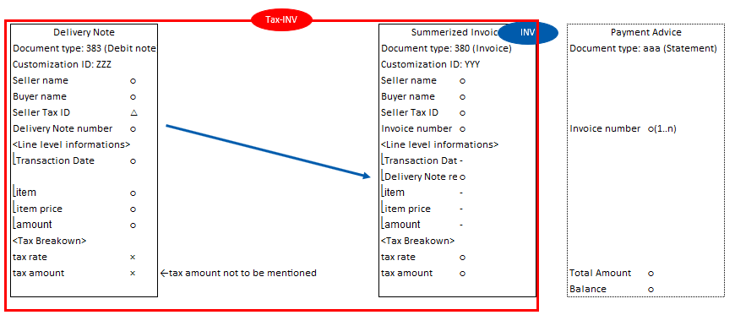

**Figure 12 — Summerised Invoice (Pattern 2-C)**

**Table 11** and **Table 12** lists example semantic contents of delivery note (Pattern 2-C) above. Contents are the same with Pattern 1-C.

NOTE: All element names are inherited from Peppol International Invoicing (PINT) and naming use the term invoice, the same items are used in standard commercial invoice, summarised invoice and delivery note (debit note). The tag names are correct according to the ISO/IEC 19845:2015 (UBL 2.1) Invoice schema.

**Table 11 — Example semantic contents of Delivery note (Delivery Note#0011) (Pattern 2-C)**

|  |  |  |  |  |  |  |  |
| --- | --- | --- | --- | --- | --- | --- | --- |
| **ID** | **Level** | **Card.** | **Business Term** | **Content** | **Line 1** | **Line 2** | **Line 3** |
| ibt-001 | 1 | 1..1 | Invoice number | #0011 |  |  |  |
| ibt-002 | 1 | 1..1 | Invoice issue date | 2022-10-01 |  |  |  |
| ibt-003 | 1 | 1..1 | Invoice type code | 383 |  |  |  |
| ibt-005 | 1 | 1..1 | Invoice currency code | JPY |  |  |  |
| ibg-04 | 1 |  | SELLER | | | | |
| ibt-027 | 2 | 1..1 | Seller name | △△商事(株) |  |  |  |
| ibg-07 | 1 | 1..1 | BUYER | | | | |
| ibt-044 | 2 | 1..1 | Buyer name | (株)〇〇 |  |  |  |
| ibg-13 | 1 | 0..1 | DELIVERY INFORMATION | | | | |
| ibg-14 | 2 | 0..1 | INVOICING PERIOD | | | | |
| ibt-073 | 3 | 0..1 | Invoicing period start date | 2022-10-01 |  |  |  |
| ibt-074 | 3 | 0..1 | Invoicing period end date | 2022-10-01 |  |  |  |
| ibg-25 | 1 | 1..n | INVOICE LINE | | | | |
| ibt-126 | 2 | 1..1 | Invoice line identifier |  | 1 | 2 | 3 |
| ibt-129 | 2 | 1..1 | Invoiced quantity |  | 1 | 1 | 1 |
| ibt-130 | 2 | 1..1 | Invoiced quantity unit of measure code |  | C62 | C62 | C62 |
| ibt-131 | 2 | 1..1 | Invoice line net amount |  | 5000 | 2000 | 1000 |
| ibg-29 | 2 | 1..1 | PRICE DETAILS | | | | |
| ibt-146 | 3 | 1..1 | Item net price |  | 5000 | 2000 | 1000 |
| ibg-31 | 2 | 1..1 | ITEM INFORMATION | | | | |
| ibt-153 | 3 | 1..1 | Item name |  | 牛肉 | じゃがいも | 割り箸 |

**Table 12 — Example semantic contents of Delivery note (Delivery Note#0012) (Pattern 2-C)**

|  |  |  |  |  |  |
| --- | --- | --- | --- | --- | --- |
| **ID** | **Level** | **Card.** | **Business Term** | **Content** | **Line 1** |
| ibt-001 | 1 | 1..1 | Invoice number | #0012 |  |
| ibt-002 | 1 | 1..1 | Invoice issue date | 2022-10-29 |  |
| ibt-003 | 1 | 1..1 | Invoice type code | 383 |  |
| ibt-005 | 1 | 1..1 | Invoice currency code | JPY |  |
| ibg-04 | 1 |  | SELLER | | |
| ibt-027 | 2 | 1..1 | Seller name | △△商事(株) |  |
| ibg-07 | 1 | 1..1 | BUYER | | |
| ibt-044 | 2 | 1..1 | Buyer name | (株)〇〇 |  |
| ibg-13 | 1 | 0..1 | DELIVERY INFORMATION | | |
| ibg-14 | 2 | 0..1 | INVOICING PERIOD | | |
| ibt-073 | 3 | 0..1 | Invoicing period start date | 2022-10-29 |  |
| ibt-074 | 3 | 0..1 | Invoicing period end date | 2022-10-29 |  |
| ibg-25 | 1 | 1..n | INVOICE LINE | | |
| ibt-126 | 2 | 1..1 | Invoice line identifier |  | 1 |
| ibt-129 | 2 | 1..1 | Invoiced quantity |  | 1 |
| ibt-130 | 2 | 1..1 | Invoiced quantity unit of measure code |  | C62 |
| ibt-131 | 2 | 1..1 | Invoice line net amount |  | 5400 |
| ibg-29 | 2 | 1..1 | PRICE DETAILS | | |
| ibt-146 | 3 | 1..1 | Item net price |  | 5400 |
| ibg-31 | 2 | 1..1 | ITEM INFORMATION | | |
| ibt-153 | 3 | 1..1 | Item name |  | ワイン |

**Table 13** lists example semantic contents of Summerised Invoice (Pattern 2-C) above. Instead of listing each line item, each line is summarised by delivery note, tax category, and tax rate in pattern 2.

**Table 13 — Example semantic contents of Summerised Invoice (Pattern 2-C)**

|  |  |  |  |  |  |  |  |  |  |
| --- | --- | --- | --- | --- | --- | --- | --- | --- | --- |
| **ID** | **Level** | **Card.** | **Business Term** | **Content** | **VAT S 10%** | **VAT AA 8%** | **#0011 AA 8%** | **#0011 S 10%** | **#0012 S 10%** |
| ibt-001 | 1 | 1..1 | Invoice number | No.4321 |  |  |  |  |  |
| ibt-002 | 1 | 1..1 | Invoice issue date | 2022-11-01 |  |  |  |  |  |
| ibt-003 | 1 | 1..1 | Invoice type code | 380 |  |  |  |  |  |
| ibt-005 | 1 | 1..1 | Invoice currency code | JPY |  |  |  |  |  |
| ibg-01 | 1 | 0..n | INVOICE NOTE | | | | | | |
| ibt-022 | 2 | 0..1 | Invoice note | 10月分 |  |  |  |  |  |
| ibg-04 | 1 |  | SELLER | | | | | | |
| ibt-027 | 2 | 1..1 | Seller name | △△商事(株) |  |  |  |  |  |
| ibt-031 | 2 | 0..1 | Seller TAX identifier | T1234567890123 |  |  |  |  |  |
| ibg-07 | 1 | 1..1 | BUYER | | | | | | |
| ibt-044 | 2 | 1..1 | Buyer name | (株)〇〇 |  |  |  |  |  |
| ibt-048 | 2 | 0..1 | Buyer TAX identifier |  |  |  |  |  |  |
| ibg-13 | 1 | 0..1 | DELIVERY INFORMATION | | | | | | |
| ibg-14 | 2 | 0..1 | INVOICING PERIOD | | | | | | |
| ibt-073 | 3 | 0..1 | Invoicing period start date | 2022-10-01 |  |  |  |  |  |
| ibt-074 | 3 | 0..1 | Invoicing period end date | 2022-10-31 |  |  |  |  |  |
| ibg-22 | 1 | 1..1 | DOCUMENT TOTALS | | | | | | |
| ibt-106 | 2 | 1..1 | Sum of Invoice line net amount | 13400 |  |  |  |  |  |
| ibt-109 | 2 | 1..1 | Invoice total amount without TAX | 13400 |  |  |  |  |  |
| ibt-110 | 2 | 0..1 | Invoice total TAX amount | 1200 |  |  |  |  |  |
| ibt-112 | 2 | 1..1 | Invoice total amount with TAX | 14600 |  |  |  |  |  |
| ibt-115 | 2 | 1..1 | Amount due for payment | 14600 |  |  |  |  |  |
| ibg-23 | 1 | 1..n | TAX BREAKDOWN | | | | | | |
| ibt-116 | 2 | 1..1 | TAX category taxable amount |  | 6400 | 7000 |  |  |  |
| ibt-117 | 2 | 1..1 | TAX category tax amount |  | 640 | 560 |  |  |  |
| ibt-118 | 2 | 1..1 | TAX category code |  | S | AA |  |  |  |
| ibt-118-1 | 3 | 0..1 | Tax Scheme |  | VAT | VAT |  |  |  |
| ibt-119 | 2 | 0..1 | TAX category rate |  | 10 | 8 |  |  |  |
| ibg-25 | 1 | 1..n | INVOICE LINE | | | | | | |
| ibt-188 | 2 | 0..1 | Invoice line document identifier |  |  |  | #0011 | #0011 | #0012 |
| ibt-189 | 2 | 0..1 | Document type code |  |  |  | 383 | 383 | 383 |
| ibt-129 | 2 | 1..1 | Invoiced quantity |  |  |  | 1 | 1 | 1 |
| ibt-130 | 2 | 1..1 | Invoiced quantity unit of measure code |  |  |  | C62 | C62 | C62 |
| ibt-131 | 2 | 1..1 | Invoice line net amount |  |  |  | 7000 | 1000 | 5400 |
| ibg-26 | 2 | 0..1 | INVOICE LINE PERIOD | | | | | | |
| ibt-134 | 3 | 0..1 | Invoice line period start date |  |  |  | 2022-10-01 | 2022-10-01 | 2022-10-29 |
| ibt-135 | 3 | 0..1 | Invoice line period end date |  |  |  | 2022-10-01 | 2022-10-01 | 2022-10-29 |
| ibg-29 | 2 | 1..1 | PRICE DETAILS | | | | | | |
| ibt-146 | 3 | 1..1 | Item net price |  |  |  | 7000 | 1000 | 5400 |
| ibg-30 | 2 | 1..n | LINE TAX INFORMATION | | | | | | |
| ibt-151 | 3 | 1..1 | Invoiced item TAX category code |  |  |  | AA | S | S |
| ibt-152 | 3 | 0..1 | Invoiced item TAX rate |  |  |  | 8 | 10 | 10 |
| ibg-31 | 2 | 1..1 | ITEM INFORMATION | | | | | | |
| ibt-153 | 3 | 1..1 | Item name |  |  |  | #0011.AA | #0011.S | #0012.S |

**Table 14** lists example semantic contents of statement (Pattern 2-C) above.

**Table 14 — Example semantic contents of statement (Pattern 2-C)**

TBD

## Payment advice (Statement)

[EIPA]

### General

CWA 5678 part 113 specifies Statement. **Table 15** and **Table 16** are taken from CWA 5678 part 113.

The following business partners participate in this profile, acting in the roles as defined below.

[SOURCE: CWA 5678 part 113]

**Table 15 — Business partners involved for the Statement [SOURCE: CWA 5678 part 113]**

|  |  |
| --- | --- |
| **Business partner** | **Description** |
| Customer | The Customer is the legal person or organization who is in demand of a product or service.  Examples of Customer roles: buyer, consignee, debtor, contracting authority. |
| Supplier | The Supplier is the legal person or organization who provides a product or service.  Examples of Supplier roles: seller, consignor, creditor, economic operator. |

**Table 16 — Roles involved for the Statement [SOURCE: CWA 5678 part 113]**

|  |  |
| --- | --- |
| **Role/actor** | **Description** |
| Creditor | One to whom a debt is owed. The Party that claims the payment and is responsible for resolving billing issues and arranging settlement. The Party that sends the invoice and/or statement.  Also known as statement Issuer, Accounts Receivable, Seller. |
| Debtor | One who owes debt. The Party responsible for making settlement relating to a purchase.  The Party that receives the Invoice or statement.  Also known as statement receiver, Accounts Payable, Buyer. |

**Figure 13 l**inks the business processes to the roles performed by the Business Partners.

[SOURCE: CWA 5678 part 113]

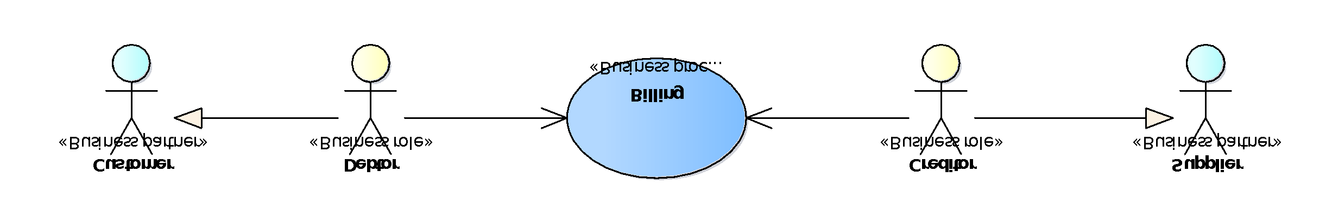

**Figure 13 — Role in the business process for the Statement[SOURCE: CWA 5678 part 113]**

### Statement business process

**Figure 14** is taken from CWA 5678 part 113. **Figure 14** shows the choreography of the business process implemented by the profile. The choreography of business collaborations defines the sequence of interactions when the profile is run within its context. [SOURCE: CWA 5678 part 113]

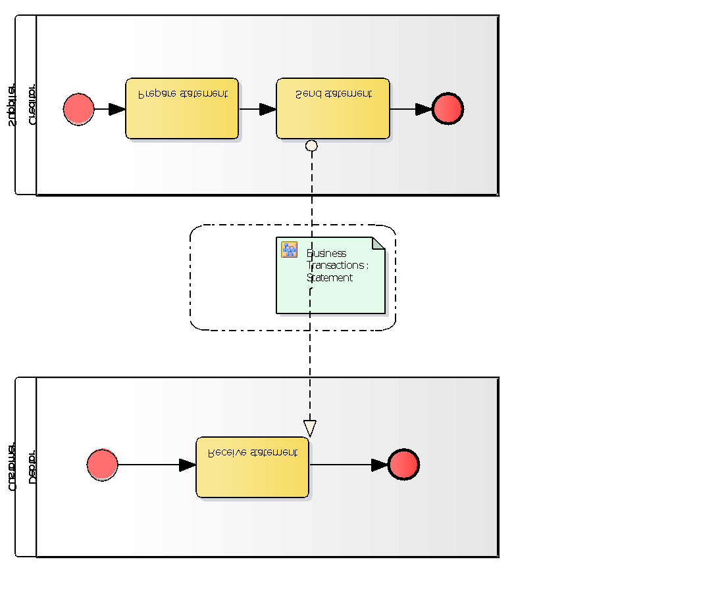

**Figure 14 — Statement business process [SOURCE: CWA 5678 part 113]**

**Table 17** is taken from CWA 5678 part 113.

**Table 17 — Statement business process description [SOURCE: CWA 5678 part 113]**

|  |  |
| --- | --- |
| **Categories** | **Description and Values** |
| Description | The Supplier sends an Invoice or a Credit Note to the customer.  There can be dispute scenarios of: overcharge, undercharge or incorrect information. The creditor corrects the disputed invoice either:  - By issuing a Credit Note,  - By an additional Corrective Invoice,  - By cancelling the original Invoice by means of a Credit Note and issuing a new Corrective Invoice.  - By providing additional documentation. |
| Pre-conditions | The Customer and the Supplier have identified each other.  The Customer has agreed to accept electronic invoices and electronic credit notes that use the profile.  Possibly Customer and Supplier have concluded a contract with general conditions and/or exchanged a Catalogue with product information and pricing. |
| Post-conditions | In the case of successful billing, the Customer is to pay the total invoiced amount under the conditions given. |
| Scenarios | *Invoice overcharge*. The Invoice was overcharged. The overcharged amount may be corrected by means of a Credit Note. Alternatively the total Invoice may be credited with a Credit Note and a new Corrective Invoice with the right amount may be issued.  *Invoice undercharge*. The Invoice was undercharged. The undercharged amount may be corrected by means of a Corrective Invoice. Alternatively the total Invoice may be credited with a Credit Note and a new Corrective Invoice with the right amount may be issued.  *Invoice contains wrong information*. The Invoice contains wrong information. The information may be corrected by means of a Corrective Invoice. Alternatively the total Invoice may be credited with a Credit Note and a new Corrective Invoice with the right information may be issued.  *Invoice missing supporting docs*. The Invoice is missing supporting documents. The supporting documents may be sent afterwards (not in scope of the profile). |
| Exceptions | The notification of invoice errors is handled externally. |
| Remarks | None |

**Table 18** lists Semantic model of Statement from CWA 5678 part 113. [modified table layout by EIPA]

**Table 18 — Semantic model of Statement [SOURCE: CWA 5678 part 113]**

|  |  |  |  |  |  |
| --- | --- | --- | --- | --- | --- |
| **ID** | **Level** | **Card** | **Business Term** | **Description** | **Datatype** |
|  | 0 |  | Statement |  |  |
| tir26-003 | 1 | 0..1 | Statement identifier | An identifier for the statement. | Text |
| tir26-004 | 1 | 0..1 | Statement issue date | The date on which the statement was issued. The date assigned by the Creditor on which the Statement was issued. | Date |
| tir26-005 | 1 | 1..1 | Statement currency | A code that identifies the currency in which the amounts in a statement are given unless otherwise stated for specific amounts. The default currency for the Statement. | Code |
| tir26-006 | 1 | 0..1 | Statement note | A free-text note that applies to the statement as a whole. Free-form text applying to the Statement. This element may contain notes or any other similar information that is not contained explicitly in another structure. | Text |
| tir26-007 | 1 | 0..1 | Statement total balance amount | The total amount for the statement equal to the sum of the statement line amounts. The total amount for the statement equal to the sum of the statement line amounts. | Amount |
|  | 1 | 1..1 | Process control | Information about the specification that apply to the transaction. |  |
| tir26-001 | 2 | 1..1 | Business process type identifier | Identifies the business process context in which the transaction appears. It enables the buyer to process the invoice in an appropriate way. | Identifier |
| tir26-002 | 2 | 1..1 | Specification identification | An identification of the specification containing the total set of rules regarding semantic content, cardinalities and business rules to which the data contained in the instance document conforms. This identifies the European invoice norm, as well as any extensions applied. The identification may include the version of the specification. | Code |
|  | 1 | 0..1 | Statement period | The period to which the statement applies. |  |
| tir26-008 | 2 | 0..1 | Period start date | The date when the period starts. The date is the first day of the period. | Date |
| tir26-009 | 2 | 0..1 | Period start time | The start time of the period. | Date |
| tir26-010 | 2 | 0..1 | Period end date | The date on which the period ends. The date is the last day of the period. | Date |
| tir26-011 | 2 | 0..1 | Period end time | The end time of the period. | Date |
|  | 1 | 1..1 | Supplier party | The business partner operates the account for which the statement is given. He is responsible for creating and sending the account statement and is the receiver of potential payments |  |
| tir26-012 | 2 | 0..1 | Supplier identifier | Identifies a party. | Identifier |
| tir26-013 | 2 | 0..1 | Supplier legal identifier | Identifies a company as registered with the company registration scheme. | Identifier |
| tir26-014 | 2 | 0..1 | Supplier name | The name of the party. | Text |
| tir26-015 | 2 | 0..1 | Supplier electronic address | Identifies the end point of the routing service. | Identifier |
|  | 2 | 0..1 | Postal address | Address information. |  |
| tir26-016 | 3 | 0..1 | Address line 1 | The main address line in an address. Usually the street name and number or post office box. | Text |
| tir26-017 | 3 | 0..1 | Address line 2 | An additional address line in an address that can be used to give further details supplementing the main line. | Text |
| tir26-018 | 3 | 0..1 | City | The common name of a city where the address is. | Text |
| tir26-019 | 3 | 0..1 | Post code | The identifier for an addressable group of properties according to the relevant postal service, such as a ZIP code or Post Code. | Text |
| tir26-020 | 3 | 0..1 | Country subdivision | The subdivision of a country such as region, county, state, province etc. | Text |
| tir26-021 | 3 | 0..1 | Country code | A code that identifies the country. The lists of valid countries are registered with the ISO 3166-1 Maintenance agency, "Codes for the representation of names of countries and their subdivisions". It is recommended to use the alpha-2 representation. | Code |
|  | 2 | 0..1 | Contacting details | Used to provide contacting information for a party in general or a person. |  |
| tir26-022 | 3 | 0..1 | Contact point | The name of the contact point. | Text |
| tir26-024 | 3 | 0..1 | Contact fax number | A fax number for the contact point. | Text |
| tir26-025 | 3 | 0..1 | Contact telephone number | A phone number for the contact point. | Text |
| tir26-026 | 3 | 0..1 | Contact email address | An e-mail address for the contact point. | Text |
|  | 1 | 1..1 | Customer party | The business partner who holds the account for which the statement is provided. He is the receiver of the account statement and is responsible for settling any potential payments. |  |
| tir26-027 | 2 | 0..1 | Customer identifier | Identifies a party. | Identifier |
| tir26-028 | 2 | 0..1 | Customer legal identifier | Identifies a company as registered with the company registration scheme. | Identifier |
| tir26-029 | 2 | 0..1 | Customer name | The name of the party. | Text |
| tir26-030 | 2 | 0..1 | Customer electronic address | Identifies the end point of the routing service. | Identifier |
|  | 1 | 0..1 | Seller party | The seller from which all transactions in the statement originate. Example is when a supplier issues a statement for an customer account at a specific branch or a suppliers division. |  |
| tir26-042 | 2 | 0..1 | Seller customer account identifier | A identifier for the seller that is issued by the party that sends the document in which the identifier is used. | Identifier |
| tir26-043 | 2 | 0..1 | Seller name | The full (formal) name by which the seller is registered in the national registry of legal entities or persons. | Text |
| tir26-066 | 2 | 0..1 | City | The common name of a city where the address is. The city where the party is located. | Text |
|  | 1 | 0..1 | Buyer party | A buyer who is responsible for all purchases and transactions for which the statement is given. Example is a customer's branch or other division. |  |
| tir26-044 | 2 | 0..1 | Buyer customer account identifier | A identifier for the buyer that is issued by the party that sends the document in which the identifier is used. | Identifier |
| tir26-045 | 2 | 0..1 | Buyer name | The full name of the buyer. | Text |
| tir26-067 | 2 | 0..1 | City | The common name of a city where the address is. The city where the party is located. | Text |
|  | 1 | 0..1 | Payment instructions | Instructions provided by the supplier on how the customer must settle the statement balance. When the supplier provides payment instructions it represents a claim that the customer settles the statement total balance amount. |  |
| tir26-046 | 2 | 1..1 | Payment means type code | The method, expressed as a code, for settling a payment. The code may be given by using the UN/ECE 4461 code list. A statement may contain an indication about how the payment should be handled. | Code |
| tir26-047 | 2 | 0..1 | Payment reference | A textual value used to establish a link between the payment and the invoice (e.g. transaction number). The reference helps the seller to assign an incoming payment to the relevant payment process. When specifying a payment reference, the receiving system should therefore indicate this reference when executing the payment. It must be possible to specify an identifier for the payment, issued by the supplier. A statement may contain an identifier for the payment, issued by the supplier as reference. Also known as end-to-end payment reference. | Text |
| tir26-048 | 2 | 0..1 | Statement due date | The date on or before which the total balance amount of the statement must be paid. A statement may contain the date on which payment that settles the statement balance is due. | Date |
| tir26-049 | 2 | 0..1 | Payment terms | A textual description of the payment terms that apply to the amount due for payment (Including description of possible penalties). | Text |
|  | 2 | 0..1 | Payment card identification | To provide information about the credit card used for payment that has been made. I.e. BII recommends that partners should not send payment instructions for credit cards inside the transactions. BII also recommends that only limited amount of credit card detail is provided such as only last 4 or 6 digits of the credit card number, sufficient for the receiver to recognize which of his cards was used for payment. |  |
| tir26-050 | 3 | 1..1 | Payment card primary account number | The Primary Account Number (PAN) of the card used for payment. In accordance with general requirements by financial institutions, an invoice should never include a full card primary account number but only the last 4 to 6 digits. The card number; the Primary Account Number (PAN).. BII strongly recommends putting only last digits of the card number, sufficient for the receiver to identify which of the cards he has on file is being reference. Generally last 4 or 6 digits. | Identifier |
| tir26-051 | 3 | 1..1 | Payment card network | The type of the card used for payment. E.g. VISA, MasterCard, etc. The card network provider. Used to provide information about the issuer of the card i.e. Visa, Mastercard, Diners club, Amex etc. | Text |
|  | 2 | 0..1 | Account identification | Information for identifying an financial account. |  |
| tir26-052 | 3 | 1..1 | Financial account identifier | A unique identifier of the financial account, such as IBAN, at a financial institution. The identifier for the account. Depending on circumstances the identifier can be in local format or standardized format such as IBAN. The identifier schema should be identified. | Identifier |
| tir26-053 | 3 | 0..1 | Financial institution identifier | An identifier for the financial institution, such as BIC, where a financial account is located. An identifier for the financial institution where the account is located, such as the BIC identifier (SWIFT code). | Identifier |
| tir26-054 | 3 | 0..1 | Financial institution branch identifier | An identifier for the branch or division of the financial organization. The identifier for a branch or division of an organization may, in some countries, be used to positively identify the location of the account or supplement the financial institution identifier. | Identifier |
|  | 1 | 1..n | Statement line | Individual transactions in the account for which the statement is given. |  |
| tir26-057 | 2 | 1..1 | Statement line identifier | An identifier for an individual statement line that is unique within a statement. Identifies the Statement Line. | Text |
| tir26-068 | 2 | 1..1 | Statement line date | The issuing date of the document that is reported in the statement line. The date when the transaction or document that the statement lines reports was carried out or issued. | Date |
| tir26-069 | 2 | 0..1 | Statement line time | The issuing time of the day of the document that is reported in the statement. The date when the transaction or document that the statement lines reports was carried out or issued. | Time |
| tir26-058 | 2 | 0..1 | Statement line note | A free-text note that applies to the statement line. Free-form text applying to the Statement Line. This element may contain notes or any other similar information that is not contained explicitly in another structure. | Text |
| tir26-059 | 2 | 1..1 | Statement line amount | The total amount of the statement line. The balance amount on the Statement Line. A positive amount indicates an increase in the amount owned by the supplier party and owed by the Customer party. As example, an invoice issued by the Supplier is registered as positive amount and a payment made by the Customer is a negative amount. | Amount |
| tir26-070 | 2 | 0..1 | Statement line exchange rate | The currency exchange rate that is used to convert the total amount of the statement line into the statement default currency. The exchange rate applied to the line amount when calculating the statement total balance amount. Exchange rate should be given so that line amount in document currency equals the line amount in the line currency multiplied by the exchange rate. | Numeric |
|  | 2 | 0..1 | Seller party | The seller that originates the particular statement line. |  |
| tir26-060 | 3 | 0..1 | Seller customer account identifier | A identifier for the seller that is issued by the party that sends the document in which the identifier is used. | Identifier |
| tir26-061 | 3 | 0..1 | Seller name | The full (formal) name by which the seller is registered in the national registry of legal entities or persons. | Text |
| tir26-071 | 3 | 0..1 | City | The common name of a city where the address is. | Text |
|  | 2 | 0..1 | Buyer party | The buyer to which the particular statement line relates. |  |
| tir26-062 | 3 | 0..1 | Buyer customer account identifier | A identifier for the buyer that is issued by the party that sends the document in which the identifier is used. | Identifier |
| tir26-063 | 3 | 0..1 | Buyer name | The full name of the buyer. | Text |
| tir26-072 | 3 | 0..1 | City | The common name of a city where the address is. | Text |
|  | 2 | 1..1 | Referenced documents | References to documents that are the bases for each statement line, such as invoices, credit notes, payments etc. |  |
| tir26-064 | 3 | 1..1 | Referenced document identifier | An identifier for the referenced document. An identifier for the document that is the basis for the statement line. | Text |
| tir26-065 | 3 | 1..1 | Referenced document type | The type of the referenced  document. The type of the document that is the basis for the statement line. | Code |

NOTE 1: Buyer postal address is required.

NOTE 2: ISO/IEC 19845:2015 (UBL 2.1) Statement has TotalDebitAmount, TotalCreditAmount, TotalBalanceAmount, and AllowanceCharge for document level.

**Table 19** lists Example semantic contents of Statement from CWA 5678 part 113.

**Table 19 — Example semantic contents of Statement [EIPA]**

|  |  |  |  |  |  |  |  |  |  |
| --- | --- | --- | --- | --- | --- | --- | --- | --- | --- |
| **ID** | **Level** | **Card** | **Business Term** | **Statement Content** | **Line 1** | **Line 2** | **Line 3** | **Line 4** | **Line 5** |
| tir26-003 | 1 | 0..1 | Statement identifier | 000002/No.001 |  |  |  |  |  |
| tir26-004 | 1 | 0..1 | Statement issue date | 2022-12-31 |  |  |  |  |  |
| tir26-005 | 1 | 1..1 | Statement currency | JPY |  |  |  |  |  |
| tir26-006 | 1 | 0..1 | Statement note | 請求書(控) |  |  |  |  |  |
| tir26-007 | 1 | 0..1 | Statement total balance amount | 1072302 |  |  |  |  |  |
|  | 1 | 1..1 | Process control |  |  |  |  |  |  |
| tir26-001 | 2 | 1..1 | Business process type identifier |  |  |  |  |  |  |
| tir26-002 | 2 | 1..1 | Specification identification |  |  |  |  |  |  |
|  | 1 | 0..1 | Statement period |  |  |  |  |  |  |
| tir26-008 | 2 | 0..1 | Period start date | 2021-12-01 |  |  |  |  |  |
| tir26-010 | 2 | 0..1 | Period end date | 2021-12-31 |  |  |  |  |  |
|  | 1 | 1..1 | Supplier party |  |  |  |  |  |  |
| tir26-012 | 2 | 0..1 | Supplier identifier | T123456789012 |  |  |  |  |  |
| tir26-013 | 2 | 0..1 | Supplier legal identifier |  |  |  |  |  |  |
| tir26-014 | 2 | 0..1 | Supplier name | 株式会社SCG印刷 |  |  |  |  |  |
| tir26-015 | 2 | 0..1 | Supplier electronic address | JP123456789012 |  |  |  |  |  |
|  | 2 | 0..1 | Postal address |  |  |  |  |  |  |
| tir26-016 | 3 | 0..1 | Address line 1 | 鳥島町111-1 |  |  |  |  |  |
| tir26-017 | 3 | 0..1 | Address line 2 |  |  |  |  |  |  |
| tir26-018 | 3 | 0..1 | City | 鹿沼市 |  |  |  |  |  |
| tir26-019 | 3 | 0..1 | Post code | 000-0000 |  |  |  |  |  |
| tir26-020 | 3 | 0..1 | Country subdivision | 栃木県 |  |  |  |  |  |
| tir26-021 | 3 | 0..1 | Country code | JP |  |  |  |  |  |
|  | 2 | 0..1 | Contacting details |  |  |  |  |  |  |
| tir26-022 | 3 | 0..1 | Contact point | 社長　野田　勝美 |  |  |  |  |  |
| tir26-024 | 3 | 0..1 | Contact fax number | 03-0000-0000 |  |  |  |  |  |
| tir26-025 | 3 | 0..1 | Contact telephone number | 03-0000-0000 |  |  |  |  |  |
| tir26-026 | 3 | 0..1 | Contact email address |  |  |  |  |  |  |
|  | 1 | 1..1 | Customer party |  |  |  |  |  |  |
| tir26-027 | 2 | 0..1 | Customer identifier | T3210987654321 |  |  |  |  |  |
| tir26-028 | 2 | 0..1 | Customer legal identifier |  |  |  |  |  |  |
| tir26-029 | 2 | 0..1 | Customer name | 株式会社伊勢企画西日暮里支店 |  |  |  |  |  |
| tir26-030 | 2 | 0..1 | Customer electronic address | JP3210987654321 |  |  |  |  |  |
|  | 2 | 0..1 | Postal address |  |  |  |  |  |  |
|  | 3 | 0..1 | Address line 1 | 日暮里横井町8-9 |  |  |  |  |  |
|  | 3 | 0..1 | Address line 2 |  |  |  |  |  |  |
|  | 3 | 0..1 | City | 荒川区 |  |  |  |  |  |
|  | 3 | 0..1 | Post code | 116-0013 |  |  |  |  |  |
|  | 3 | 0..1 | Country subdivision | 東京都 |  |  |  |  |  |
|  | 3 | 0..1 | Country code | JP |  |  |  |  |  |
|  | 1 | 0..1 | Seller party |  |  |  |  |  |  |
| tir26-042 | 2 | 0..1 | Seller customer account identifier |  |  |  |  |  |  |
| tir26-043 | 2 | 0..1 | Seller name |  |  |  |  |  |  |
| tir26-066 | 2 | 0..1 | City |  |  |  |  |  |  |
|  | 1 | 0..1 | Buyer party |  |  |  |  |  |  |
| tir26-044 | 2 | 0..1 | Buyer customer account identifier |  |  |  |  |  |  |
| tir26-045 | 2 | 0..1 | Buyer name |  |  |  |  |  |  |
| tir26-067 | 2 | 0..1 | City |  |  |  |  |  |  |
|  | 1 | 0..n | PAYMENT INSTRUCTIONS |  |  |  |  |  |  |
|  | 2 | 0..1 | Payment Instructions ID | AAA-BB-CC-123 |  |  |  |  |  |
|  | 2 | 1..1 | Payment means type code | 30 |  |  |  |  |  |
|  | 2 | 0..1 | Payment means text | Credit transfer |  |  |  |  |  |
|  | 2 | 0..n | Remittance information | Snippet1 |  |  |  |  |  |
|  | 1 | 1..n | Statement line |  |  |  |  |  |  |
| tir26-057 | 2 | 1..1 | Statement line identifier |  | Last time billed | Payment | Carryover | Purchase | Billing this time |
| tir26-068 | 2 | 1..1 | Statement line date |  | 2021-11-30 |  |  |  |  |
| tir26-058 | 2 | 0..1 | Statement line note |  | 前回ご請求高 | ご入金高 | 繰越高 | 今回お買上高 | 今回ご請求高 |
| tir26-059 | 2 | 1..1 | Statement line amount |  | 1206590 | 102000 | 180590 | 885712 | 1072302 |
|  | 2 | 1..1 | Referenced documents |  |  |  |  |  |  |
| tir26-064 | 3 | 1..1 | Referenced document identifier |  | ID of last time Statement |  |  | Standard invoice identifiers |  |
| tir26-065 | 3 | 1..1 | Referenced document type |  | ??? |  |  | 380 |  |

NOTE 1: Detail information of total amount of purchased item, allowance, charge, and tax can be specified using more lines.

NOTE 2: Need standardization of code that represents the contents of Statement line identifier for statement lines.

**Figure 17** shows an example payment advice.

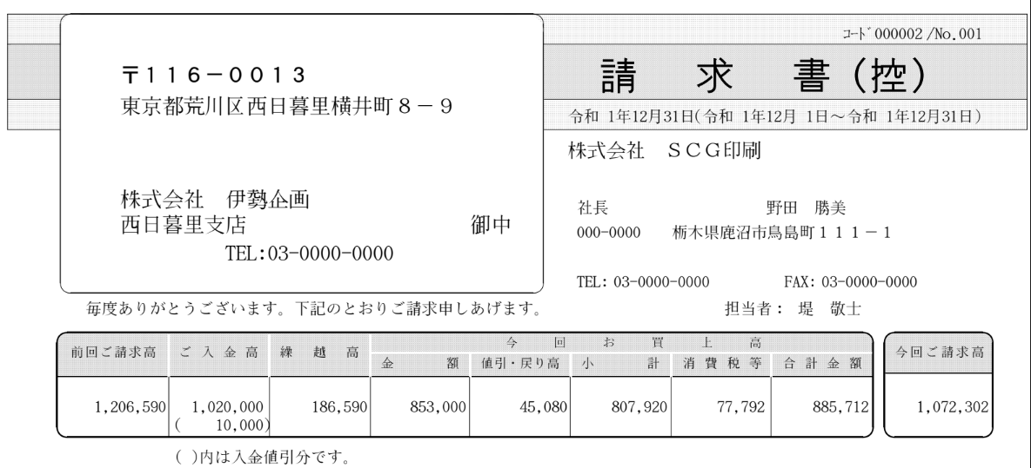

**Figure 15 — Example Statement**

## Negative invoices and credit notes

### General

**Figure 16** is take from EN 16931-1 Figure 10. EN 16931-1 defines business process for Credit Note or negative invoicing (P9).

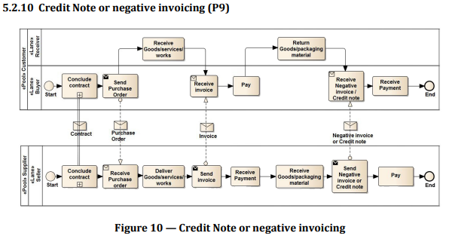

**Figure 16 — Business process P9 from EN 16931-1 [SOURCE: EN 16931-1]**

[SOURCE: Peppol BIS Billing 3.0]

This BIS supports negative grand totals.

The argument for negative invoices is to open up for a wider spectrum of invoicing processes.

Examples of such processes are

* Preliminary (estimated) consumption invoice that is balanced out in a later meter-based invoice;
* Pre-payment (with or without CT) is settled through a final invoice; and
* Some user communities prefer to use negative invoice rather than credit note when correcting transactions.

NOTE: Buyers who value automatic matching of e-invoices to orders or invoicing objects may wish to limit the areas and situations where complex transactions can be accepted and voice their requirements at time of procurement.

The decision has the following implications on the transaction format:

* The invoice (now with “negative invoice capacity”) can function as an alternative to the credit note. Invoice-generating systems may implement either option, while invoice-receiving systems have to support both of them.
* The transaction format for credit note has to be designed to accommodate for negative grand total, as well; this is because an entire negative invoice may have to be balanced out by means of a credit note.

Attention is drawn to the intrinsic differences between credit note and negative invoice when it comes to convey crediting information.

See 4.4.9 Preceding invoice references for referencing invoice to be corrected.

**Table 20** lists Example semantic contents of invoice to be corrected.[EIPA]

**Table 20 — Example semantic contents of invoice to be corrected**

|  |  |  |  |  |  |  |  |  |
| --- | --- | --- | --- | --- | --- | --- | --- | --- |
| **ID** | **Level** | **Card** | **Business Term** | **Invoice Content** | **VAT**  **Standaed**  **10%** | **VAT**  **Reduced**  **8%** | **Line 1** | **Line 2** |
| ibt-003 | 1 | 1..1 | Invoice type code | 380 |  |  |  |  |
| ibg-21 | 1 | 0..n | DOCUMENT LEVEL CHARGES |  |  |  |  |  |
| ibt-099 | 2 | 1..1 | Document level charge amount |  | 250 |  |  |  |
| ibt-102 | 2 | 1..1 | Document level charge TAX category code |  | S |  |  |  |
| ibt-103 | 2 | 0..1 | Document level charge TAX rate |  | 10 |  |  |  |
| ibt-103-1 | 3 | 0..1 | Tax Scheme |  | VAT |  |  |  |
| ibg-22 | 1 | 1..1 | DOCUMENT TOTALS |  |  |  |  |  |
| ibt-106 | 2 | 1..1 | Sum of Invoice line net amount | 1300 |  |  |  |  |
| ibt-108 | 2 | 0..1 | Sum of charges on document level | 250 |  |  |  |  |
| ibt-109 | 2 | 1..1 | Invoice total amount without TAX | 1550 |  |  |  |  |
| ibt-110 | 2 | 0..1 | Invoice total TAX amount | 155 |  |  |  |  |
| ibt-112 | 2 | 1..1 | Invoice total amount with TAX | 1705 |  |  |  |  |
| ibt-115 | 2 | 1..1 | Amount due for payment | 1705 |  |  |  |  |
| ibg-23 | 1 | 1..n | TAX BREAKDOWN |  |  |  |  |  |
| ibt-116 | 2 | 1..1 | TAX category taxable amount |  | 1550 |  |  |  |
| ibt-117 | 2 | 1..1 | TAX category tax amount |  | 155 |  |  |  |
| ibt-118 | 2 | 1..1 | TAX category code |  | S |  |  |  |
| ibt-118-1 | 3 | 0..1 | Tax Scheme |  | VAT |  |  |  |
| ibt-119 | 2 | 0..1 | TAX category rate |  | 10 |  |  |  |
| ibg-25 | 1 | 1..n | INVOICE LINE |  |  |  |  |  |
| ibt-126 | 2 | 1..1 | Invoice line identifier |  |  |  | 1 | 2 |
| ibt-129 | 2 | 1..1 | Invoiced quantity |  |  |  | 7 | -3 |
| ibt-130 | 2 | 1..1 | Invoiced quantity unit of measure code |  |  |  | DAY | DAY |
| ibt-131 | 2 | 1..1 | Invoice line net amount |  |  |  | 2800 | -1500 |
| ibg-29 | 2 | 1..1 | PRICE DETAILS |  |  |  |  |  |
| ibt-146 | 3 | 1..1 | Item net price |  |  |  | 400 | 500 |
| ibg-30 | 2 | 1..n | LINE TAX INFORMATION |  |  |  |  |  |
| ibt-151 | 3 | 1..1 | Invoiced item TAX category code |  |  |  | S | S |
| ibt-152 | 3 | 0..1 | Invoiced item TAX rate |  |  |  | 10 | 10 |
| ibt-167 | 3 | 0..1 | Tax Scheme |  |  |  | VAT | VAT |

EXAMPLE: UBL example of invoice to be corrected [EIPA]

<Invoice>

<cbc:InvoiceTypeCode>380</cbc:InvoiceTypeCode>

​<!-- Code omitted for clarity -->

​<cac:AllowanceCharge>

<cbc:ChargeIndicator>true</cbc:ChargeIndicator>

<cbc:AllowanceChargeReason>Insurance</cbc:AllowanceChargeReason>

<cbc:Amount currencyID="JPY">250</cbc:Amount> <!-- (1) -->

<cac:TaxCategory>

<cbc:ID>S</cbc:ID>

<cbc:Percent>10</cbc:Percent>

<cac:TaxScheme>

<cbc:ID>VAT</cbc:ID>

</cac:TaxScheme>

</cac:TaxCategory>

​</cac:AllowanceCharge>

<cac:TaxTotal>

<cbc:TaxAmount currencyID="JPY">155</cbc:TaxAmount>

<cac:TaxSubtotal>

<cbc:TaxableAmount currencyID="JPY">1550</cbc:TaxableAmount>

<cbc:TaxAmount currencyID="JPY">155</cbc:TaxAmount>

<cac:TaxCategory>

<cbc:ID>S</cbc:ID>

<cbc:Percent>10</cbc:Percent>

<cac:TaxScheme>

<cbc:ID>VAT</cbc:ID>

</cac:TaxScheme>

</cac:TaxCategory>

</cac:TaxSubtotal>

</cac:TaxTotal>

​<cac:LegalMonetaryTotal>

<cbc:LineExtensionAmount currencyID="JPY">1300</cbc:LineExtensionAmount>

<cbc:TaxExclusiveAmount currencyID="JPY">1550</cbc:TaxExclusiveAmount>

<cbc:TaxInclusiveAmount currencyID="JPY">1705</cbc:TaxInclusiveAmount>

<cbc:ChargeTotalAmount currencyID="JPY">250</cbc:ChargeTotalAmount>

<cbc:PayableAmount currencyID="JPY">1705</cbc:PayableAmount>

​</cac:LegalMonetaryTotal>

​<!-- Code omitted for clarity -->

<cac:InvoiceLine>

<cbc:ID>1</cbc:ID> <!-- (2) -->

<cbc:InvoicedQuantity unitCode="DAY">7</cbc:InvoicedQuantity>

<cbc:LineExtensionAmount currencyID= "JPY">2800</cbc:LineExtensionAmount>

<!-- Code omitted for clarity -->

<cac:Price>

<cbc:PriceAmount currencyID="JPY">400</cbc:PriceAmount>

</cac:Price>

<cac:TaxCategory>

<cbc:ID>S</cbc:ID>

<cbc:Percent>10</cbc:Percent>

<cac:TaxScheme>

<cbc:ID>VAT</cbc:ID>

</cac:TaxScheme>

</cac:TaxCategory>

<!-- Code omitted for clarity -->

</cac:InvoiceLine>

<cac:InvoiceLine>

<cbc:ID>2</cbc:ID> <!-- (3) -->

<cbc:InvoicedQuantity unitCode="DAY">-3</cbc:InvoicedQuantity>

<cbc:LineExtensionAmount currencyID="JPY">-1500</cbc:LineExtensionAmount>

<!-- Code omitted for clarity -->

<cac:Price>

<cbc:PriceAmount currencyID="JPY">500</cbc:PriceAmount>

</cac:Price>

<cac:TaxCategory>

<cbc:ID>S</cbc:ID>

<cbc:Percent>10</cbc:Percent>

<cac:TaxScheme>

<cbc:ID>VAT</cbc:ID>

</cac:TaxScheme>

</cac:TaxCategory>

<!-- Code omitted for clarity -->

</cac:InvoiceLine>

</Invoice>

(1) Charge amount

(2) Invoice line 1 with positive quantity and line amount

(3) Invoice line 2 with negative quantity and line amount

### When crediting by means of credit note

[SOURCE: Peppol BIS Billing 3.0]

The function of crediting or debiting is controlled merely by the business document type (e.g. 380 or 381) while the representation of the amount, including its sign, is not affected.

NOTE: All element names are inherited from Peppol International Invoicing (PINT) and naming use the term invoice, the same items are used in standard commercial invoice, summarised invoice and delivery note (debit note). The tag names are correct according to the ISO/IEC 19845:2015 (UBL 2.1) Invoice schema.

**Table 21** lists example semantic contents of credit note correcting the example invoice above. [EIPA]

**Table 21 — Example semantic contents of credit note correcting the example invoice above**

|  |  |  |  |  |  |  |  |  |
| --- | --- | --- | --- | --- | --- | --- | --- | --- |
| **ID** | **Level** | **Card** | **Business Term** | **Invoice Content** | **VAT**  **Standard**  **10%** | **VAT**  **Reduced**  **8%** | **Line 1** | **Line 2** |
| ibt-003 | 1 | 1..1 | Invoice type code | 381 |  |  |  |  |
| ibg-21 | 1 | 0..n | DOCUMENT LEVEL CHARGES | | | | | |
| ibt-099 | 2 | 1..1 | Document level charge amount |  | 250 |  |  |  |
| ibt-102 | 2 | 1..1 | Document level charge TAX category code |  | S |  |  |  |
| ibt-103 | 2 | 0..1 | Document level charge TAX rate |  | 10 |  |  |  |
| ibt-103-1 | 3 | 0..1 | Tax Scheme |  | VAT |  |  |  |
| ibg-22 | 1 | 1..1 | DOCUMENT TOTALS | | | | | |
| ibt-106 | 2 | 1..1 | Sum of Invoice line net amount | 1300 |  |  |  |  |
| ibt-108 | 2 | 0..1 | Sum of charges on document level | 250 |  |  |  |  |
| ibt-109 | 2 | 1..1 | Invoice total amount without TAX | 1550 |  |  |  |  |
| ibt-110 | 2 | 0..1 | Invoice total TAX amount | 155 |  |  |  |  |
| ibt-112 | 2 | 1..1 | Invoice total amount with TAX | 1705 |  |  |  |  |
| ibt-115 | 2 | 1..1 | Amount due for payment | 1705 |  |  |  |  |
| ibg-23 | 1 | 1..n | TAX BREAKDOWN | | | | | |
| ibt-116 | 2 | 1..1 | TAX category taxable amount |  | 1550 |  |  |  |
| ibt-117 | 2 | 1..1 | TAX category tax amount |  | 155 |  |  |  |
| ibt-118 | 2 | 1..1 | TAX category code |  | S |  |  |  |
| ibt-118-1 | 3 | 0..1 | Tax Scheme |  | VAT |  |  |  |
| ibt-119 | 2 | 0..1 | TAX category rate |  | 10 |  |  |  |
| ibg-25 | 1 | 1..n | INVOICE LINE | | | | | |
| ibt-126 | 2 | 1..1 | Invoice line identifier |  |  |  | 1 | 2 |
| ibt-129 | 2 | 1..1 | Invoiced quantity |  |  |  | 7 | -3 |
| ibt-130 | 2 | 1..1 | Invoiced quantity unit of measure code |  |  |  | DAY | DAY |
| ibt-131 | 2 | 1..1 | Invoice line net amount |  |  |  | 2800 | -1500 |
| ibg-29 | 2 | 1..1 | PRICE DETAILS | | | | | |
| ibt-146 | 3 | 1..1 | Item net price |  |  |  | 400 | 500 |
| ibg-30 | 2 | 1..n | LINE TAX INFORMATION | | | | | |
| ibt-151 | 3 | 1..1 | Invoiced item TAX category code |  |  |  | S | S |
| ibt-152 | 3 | 0..1 | Invoiced item TAX rate |  |  |  | 10 | 10 |
| ibt-167 | 3 | 0..1 | Tax Scheme |  |  |  | VAT | VAT |

EXAMPLE: UBL example of credit note correcting the example invoice above [EIPA]

<CreditNote>

<cbc:CreditNoteTypeCode>381/cbc:CreditNoteTypeCode> <!-- (1) -->

<!-- Code omitted for clarity -->

<cac:AllowanceCharge>

<cbc:ChargeIndicator>true</cbc:ChargeIndicator>

<cbc:AllowanceChargeReason>Insurance</cbc:AllowanceChargeReason>

<cbc:Amount currencyID="JPY">250</cbc:Amount> <!-- (2) -->

<cac:TaxCategory>

<cbc:ID>S</cbc:ID>

<cbc:Percent>10</cbc:Percent>

<cac:TaxScheme>

<cbc:ID>VAT</cbc:ID>

</cac:TaxScheme>

</cac:TaxCategory>

</cac:AllowanceCharge>

<cac:TaxTotal>

<cbc:TaxAmount currencyID="JPY">155</cbc:TaxAmount>

<cac:TaxSubtotal>

<cbc:TaxableAmount currencyID="JPY">1550</cbc:TaxableAmount>

<cbc:TaxAmount currencyID="JPY">155</cbc:TaxAmount>

<cac:TaxCategory>

<cbc:ID>S</cbc:ID>

<cbc:Percent>10</cbc:Percent>

<cac:TaxScheme>

<cbc:ID>VAT</cbc:ID>

</cac:TaxScheme>

</cac:TaxCategory>

</cac:TaxSubtotal>

</cac:TaxTotal>

<cac:LegalMonetaryTotal>

<cbc:LineExtensionAmount currencyID="JPY">1300</cbc:LineExtensionAmount>

<cbc:TaxExclusiveAmount currencyID="JPY">1550</cbc:TaxExclusiveAmount>

<cbc:TaxInclusiveAmount currencyID="JPY">1705</cbc:TaxInclusiveAmount>

<cbc:ChargeTotalAmount currencyID="JPY">250</cbc:ChargeTotalAmount>

<cbc:PayableAmount currencyID="JPY">1705</cbc:PayableAmount>

</cac:LegalMonetaryTotal>

<!-- Code omitted for clarity -->

<cac:CreditNoteLine>

<cbc:ID>1</cbc:ID> <!-- (3) -->

<cbc:CreditedQuantity unitCode="DAY">7</cbc:CreditedQuantity>

<cbc:LineExtensionAmount currencyID= "JPY">2800</cbc:LineExtensionAmount>

<!-- Code omitted for clarity -->

<cac:Price>

<cbc:PriceAmount currencyID="JPY">400</cbc:PriceAmount>

</cac:Price>

<cac:TaxCategory>

<cbc:ID>S</cbc:ID>

<cbc:Percent>10</cbc:Percent>

<cac:TaxScheme>

<cbc:ID>VAT</cbc:ID>

</cac:TaxScheme>

</cac:TaxCategory>

<!-- Code omitted for clarity -->

</cac:CreditNoteLine>

<cac:CreditNoteLine>

<cbc:ID>2</cbc:ID> <!-- (4) -->

<cbc:CreditedQuantity unitCode="DAY">-3</cbc:CreditedQuantity>

<cbc:LineExtensionAmount currencyID="JPY">-1500</cbc:LineExtensionAmount>

<!-- Code omitted for clarity -->

<cac:Price>

<cbc:PriceAmount currencyID="JPY">500</cbc:PriceAmount>

</cac:Price>

<cac:TaxCategory>

<cbc:ID>S</cbc:ID>

<cbc:Percent>10</cbc:Percent>

<cac:TaxScheme>

<cbc:ID>VAT</cbc:ID>

</cac:TaxScheme>

</cac:TaxCategory>

<!-- Code omitted for clarity -->

</cac:CreditNoteLine>

</CreditNote>

(1) Code 381 indicating a credit note

(2) Charge amount

(3) Invoice line 1 with positive quantity and line amount

(4) Invoice line 2 with negative quantity and line amount

### When crediting by means of negative invoice

[SOURCE: Peppol BIS Billing 3.0]

The function of crediting or debiting is controlled merely by the sign (i.e. plus sign or minus sign) of the amount concerned, while the business document type (e.g. 380) has no relevance on the operation (“to credit”) itself.

**Table 22** lists Example semantic contents of negative invoice correcting the example invoice above. [EIPA]

**Table 22 — Example semantic contents of negative invoice correcting the example invoice above**

|  |  |  |  |  |  |  |  |  |
| --- | --- | --- | --- | --- | --- | --- | --- | --- |
| **ID** | **Level** | **Card** | **Business Term** | **Invoice Content** | **VAT**  **Standard**  **10%** | **VAT**  **Reduced**  **8%** | **Line 1** | **Line 2** |
| ibt-003 | 1 | 1..1 | Invoice type code | 380 |  |  |  |  |
| ibg-21 | 1 | 0..n | DOCUMENT LEVEL CHARGES | | | | | |
| ibt-099 | 2 | 1..1 | Document level charge amount |  | -250 |  |  |  |
| ibt-102 | 2 | 1..1 | Document level charge TAX category code |  | S |  |  |  |
| ibt-103 | 2 | 0..1 | Document level charge TAX rate |  | 10 |  |  |  |
| ibt-103-1 | 3 | 0..1 | Tax Scheme |  | VAT |  |  |  |
| ibg-22 | 1 | 1..1 | DOCUMENT TOTALS | | | | | |
| ibt-106 | 2 | 1..1 | Sum of Invoice line net amount | -1300 |  |  |  |  |
| ibt-108 | 2 | 0..1 | Sum of charges on document level | -250 |  |  |  |  |
| ibt-109 | 2 | 1..1 | Invoice total amount without TAX | -1550 |  |  |  |  |
| ibt-110 | 2 | 0..1 | Invoice total TAX amount | -155 |  |  |  |  |
| ibt-112 | 2 | 1..1 | Invoice total amount with TAX | -1705 |  |  |  |  |
| ibt-115 | 2 | 1..1 | Amount due for payment | -1705 |  |  |  |  |
| ibg-23 | 1 | 1..n | TAX BREAKDOWN | | | | | |
| ibt-116 | 2 | 1..1 | TAX category taxable amount |  | -1550 |  |  |  |
| ibt-117 | 2 | 1..1 | TAX category tax amount |  | -155 |  |  |  |
| ibt-118 | 2 | 1..1 | TAX category code |  | S |  |  |  |
| ibt-118-1 | 3 | 0..1 | Tax Scheme |  | VAT |  |  |  |
| ibt-119 | 2 | 0..1 | TAX category rate |  | 10 |  |  |  |
| ibg-25 | 1 | 1..n | INVOICE LINE | | | | | |
| ibt-126 | 2 | 1..1 | Invoice line identifier |  |  |  | 1 | 2 |
| ibt-129 | 2 | 1..1 | Invoiced quantity |  |  |  | -7 | 3 |
| ibt-130 | 2 | 1..1 | Invoiced quantity unit of measure code |  |  |  | DAY | DAY |
| ibt-131 | 2 | 1..1 | Invoice line net amount |  |  |  | -2800 | 1500 |
| ibg-29 | 2 | 1..1 | PRICE DETAILS | | | | | |
| ibt-146 | 3 | 1..1 | Item net price |  |  |  | 400 | 500 |
| ibg-30 | 2 | 1..n | LINE TAX INFORMATION | | | | | |
| ibt-151 | 3 | 1..1 | Invoiced item TAX category code |  |  |  | S | S |
| ibt-152 | 3 | 0..1 | Invoiced item TAX rate |  |  |  | 10 | 10 |
| ibt-167 | 3 | 0..1 | Tax Scheme |  |  |  | VAT | VAT |

EXAMPLE: UBL example of negative invoice correcting the example invoice above [EIPA]

<Invoice>

<cbc:InvoiceTypeCode>380</cbc:InvoiceTypeCode> <!-- (1) -->

​<!-- Code omitted for clarity -->

​<cac:AllowanceCharge>

<cbc:ChargeIndicator>true</cbc:ChargeIndicator>

<cbc:AllowanceChargeReason>Insurance</cbc:AllowanceChargeReason>

<cbc:Amount currencyID="JPY">-250</cbc:Amount> <!-- (2) -->

<cac:TaxCategory>

<cbc:ID>S</cbc:ID>

<cbc:Percent>10</cbc:Percent>

<cac:TaxScheme>

<cbc:ID>VAT</cbc:ID>

</cac:TaxScheme>

</cac:TaxCategory>

​</cac:AllowanceCharge>

<cac:TaxTotal> <!-- (3) -->

<cbc:TaxAmount currencyID="JPY">-155</cbc:TaxAmount>

<cac:TaxSubtotal>

<cbc:TaxableAmount currencyID="JPY">-1550</cbc:TaxableAmount>

<cbc:TaxAmount currencyID="JPY">-155</cbc:TaxAmount>

<cac:TaxCategory>

<cbc:ID>S</cbc:ID>

<cbc:Percent>10</cbc:Percent>

<cac:TaxScheme>

<cbc:ID>VAT</cbc:ID>

</cac:TaxScheme>

</cac:TaxCategory>

</cac:TaxSubtotal>

</cac:TaxTotal>

​<cac:LegalMonetaryTotal> <!-- (4) -->

<cbc:LineExtensionAmount currencyID="JPY">-1300</cbc:LineExtensionAmount>

<cbc:TaxExclusiveAmount currencyID="JPY">-1550</cbc:TaxExclusiveAmount>

<cbc:TaxInclusiveAmount currencyID="JPY">-1705</cbc:TaxInclusiveAmount>

<cbc:ChargeTotalAmount currencyID="JPY">-250</cbc:ChargeTotalAmount>

<cbc:PayableAmount currencyID="JPY">-1705</cbc:PayableAmount>

​</cac:LegalMonetaryTotal>

​<!-- Code omitted for clarity -->

<cac:InvoiceLine>

<cbc:ID>1</cbc:ID> <!-- (5) -->

<cbc:InvoicedQuantity unitCode="DAY">7</cbc:InvoicedQuantity>

<cbc:LineExtensionAmount currencyID= "JPY">2800</cbc:LineExtensionAmount>

<!-- Code omitted for clarity -->

<cac:Price> <!-- (6) -->

<cbc:PriceAmount currencyID="JPY">400</cbc:PriceAmount>

</cac:Price>

<cac:TaxCategory>

<cbc:ID>S</cbc:ID>

<cbc:Percent>10</cbc:Percent>

<cac:TaxScheme>

<cbc:ID>VAT</cbc:ID>

</cac:TaxScheme>

</cac:TaxCategory>

<!-- Code omitted for clarity -->

</cac:InvoiceLine>

<cac:InvoiceLine>

<cbc:ID>2</cbc:ID> <!-- (7) -->

<cbc:InvoicedQuantity unitCode="DAY">-3</cbc:InvoicedQuantity>

<cbc:LineExtensionAmount currencyID="JPY">-1500</cbc:LineExtensionAmount>

<!-- Code omitted for clarity -->

<cac:Price>

<cbc:PriceAmount currencyID="JPY">500</cbc:PriceAmount>

</cac:Price>

<cac:TaxCategory>

<cbc:ID>S</cbc:ID>

<cbc:Percent>10</cbc:Percent>

<cac:TaxScheme>

<cbc:ID>VAT</cbc:ID>

</cac:TaxScheme>

</cac:TaxCategory>

<!-- Code omitted for clarity -->

</cac:InvoiceLine>

</Invoice>

(1) Code 380 indicating an invoice

(2) Charge amount is negative to correct the original invoice

(3) Tax amounts are negative

(4) All document level amounts are negative

(5) Invoice line 1 with originally positive quantity and line amount, now both negative

(6) Price amount must always be positive, and is not changed

(7) Invoice line 2 with originally negative quantity and line amount, now positive

## Credit Note

TBD

## The Peppol international invoice model in relation to other documents

[SOURCE: <https://peppol.eu/downloads/post-award/>]

[SOURCE: <https://docs.peppol.eu/poacc/upgrade-3/> ]

### General

[EIPA]

For automatic processing of invoices, however, usually explicit, qualified references are needed. The Peppol international invoice model specifies relationship to other documents as specified in EN 16931-1. See **17.4**.

### Open Peppol BIS version 3.0

[EIPA]

The following Peppol BIS 3.0.7 documents are published, together with the migration plan.

Peppol BIS Order only 3.2  
Peppol BIS Ordering 3.2  
Peppol BIS Catalogue only with Response 3.1  
Peppol BIS Despatch Advice 3.1  
Peppol BIS Punch Out 3.1  
Peppol BIS Order Agreement 3.0  
Peppol BIS Message Level Response 3.0  
Peppol BIS Invoice Response 3.1  
Peppol BIS Catalogue Without Response 3.1

# 

# Consumption tax

## Overview

[SOURCE: Japanese Peppol BIS Documentation]

The chapters below describe the different Consumption tax (CT) information that can be provided in a Japanese PEPPOL invoice or credit note.

Please also see [CT category codes] for details on the CT category code list, and Calculation of CT for detailed explanation and examples on how to perform the calculations for CT Breakdown.

[SOURCE: 2019 National Tax Agency ReportEfforts to Enhance Services for Taxpayers Ⅱ and to Boost Efficiency of Tax Administration https://www.nta.go.jp/english/Report_pdf/2019e_05.pdf ]

Table 23 is taken from a report by NTA and lists changes in required information as a eligible invoice.

Entry in ledgers, description on invoices and the storing of these documents

⑴ A business operator generating sales of, or purchasing, any items subject to the reduced tax rate is to issue an invoice, etc. and perform accounting such as book entries (separate accounting) adding tax rate-based separations to existing statement items.

⑵ A requirement for purchase tax credit is currently “storing ledgers, invoices, etc.” After the reduced tax rate system is implemented (2019), business operators will be required to store ledgers, invoices, etc. in accordance with the separate accounting (the method of storing invoices with classified descriptions).

⑶ Starting October of 2023, the method of storing eligible invoices (so-called invoice system) will be introduced. Preservation of invoice such as “eligible invoices[1],” will become the requirement for purchase tax credit, instead of “storage of separate statement invoices, etc.” (the method of storing eligible invoices).

**Table 23 — Entry in ledgers and descriptions on invoices**

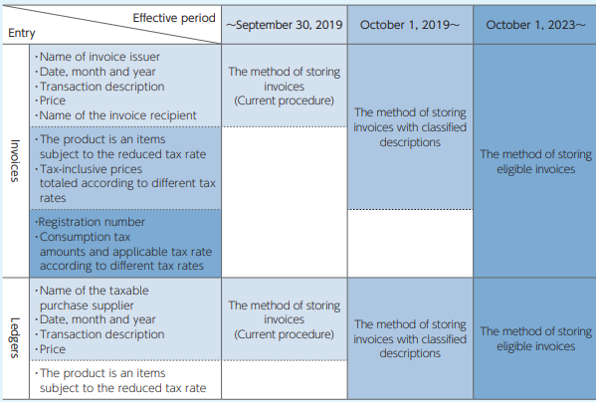

Following information are required as an eligible invoice.

* Registration number
* Consumption tax amounts and applicable tax rate according to different tax rate

NOTE: TAX category tax amount (ibt-117) in JPY is mandatory information.

[EIPA]

About ibt-117 TAX category tax amount (ibg-23 TAX BREAKDOWN):

In Japan, the tax amount must be calculated, declared and paid in JPY (Japanese yen). It is a mandatory legal requirement.

Japanese Consumption Tax Law requires the total tax amount per "tax category & tax rate" to be stated at the document level in invoice, in order for buyers to get able to claim tax on purchase as deductible. It is also a mandatory legal requirement.

Hence, in invoice, the total tax amount per "tax category and tax rate" at the document level must be stated always in JPY, regardless of invoice currency.

The crucial points are (1) per "tax category & tax rate" (not invoice total) and (2) in JPY.

ibt-111 Invoice total TAX amount in accounting currency cannot achieve this legal requirement because it is not the total tax amount per "tax category & tax rate".

ibt-117 TAX category tax amount is represented in invoice currency, and it seems that ibt-117 could achieve this legal requirement, however, we have to say that invoice currency is not always JPY. If invoice currency is any other currencies than JPY, ibt-117 TAX category tax amount cannot be represented in JPY under the current data model and the rules.

## invoices with classified descriptions

[EIPA]

The method of storing invoices with classified descriptions requires following information.

* Name of invoice issuer
* Date, month and year
* Transaction description
* Price
* Name of the invoice recipient
* The product is an item subject to the reduced tax rate
* Tax-inclusive prices totalled according to different tax rates

This type of invoice is also issued by an unregistered seller who has no TAX identifier (registration number "T"+13digits).

## Overview of Qualified Invoice Based method in Japan

[SOURCE: October 5, 2021 Japan Peppol Project Team (Digital Agency and EIPA)]

《Document issued by a supplier to be retained for tax credit purpose 》

○ 　Japan has not adopted Invoice Based method for tax credit purpose.

○ 　To claim of Consumption Tax paid (input Consumption Tax), a taxable business is required to retain an

accounting book and a Document issued by a supplier with specific description.

○ 　Not only a taxable business but also an exempt business can issue the Document. So, “Seller’s

Identification number for tax purpose”, ”Tax rate“ and “Tax amount per tax 　rate” are not required on the

Document.

○ Therefore, under the current system, even a taxable transaction with an exempt business would be subject to tax credit (This seems to be unique).

○ However, from October 1st ,2023, the new system “a Qualified Invoice Based method” will be implemented for tax credit purpose instead of the current system.

○ So, the Transitional rule will be applicable for the designated period (from October 1st , 2023 to September 30th , 2029). During that period, a taxable business is allowed to recover a certain percentage of input Consumption Tax by retaining the Document (≠ a Qualified Invoice) and an accounting book.

《Qualified Invoice 》

○ 　The Qualified Invoice Based method is a tax credit system, which will be implemented from

October 1, 2023. This is almost the same as “Input VAT credit system” in European Countries.

○ 　Under the method, in principle, a Qualified Invoice issued by a registered taxable business (=a

taxable business with the Registration number) should be retained for claiming credits of input

Consumption Tax.

○ 　Only a registered taxable business is allowed to issue a Qualified Invoice. This means that a

taxable business without the Registration number and an exempt business aren’t allowed to issue a

Qualified Invoice.

○ 　In addition to that, Consumption Tax law stipulates a way to calculate “Tax amount per tax rate”

required on a Qualified Invoice. It should be calculated in the following way.

Taxable amount (Consumption Tax exclusive) per tax rate x tax rate applied

○ 　The “Tax amount per tax rate” required on a Qualified Invoice should be between the amount

rounded down to integer values as floor and the amount rounded up to integer values as ceiling.

## The difference of requirements to apply input tax credit

[SOURCE: October 5, 2021 Japan Peppol Project Team (Digital Agency and EIPA)]

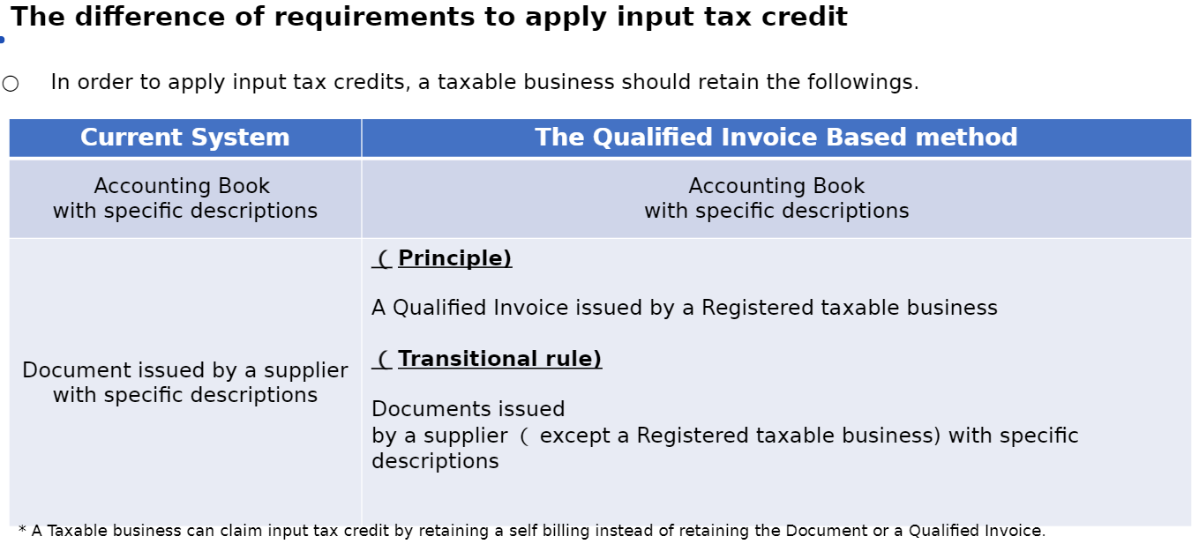

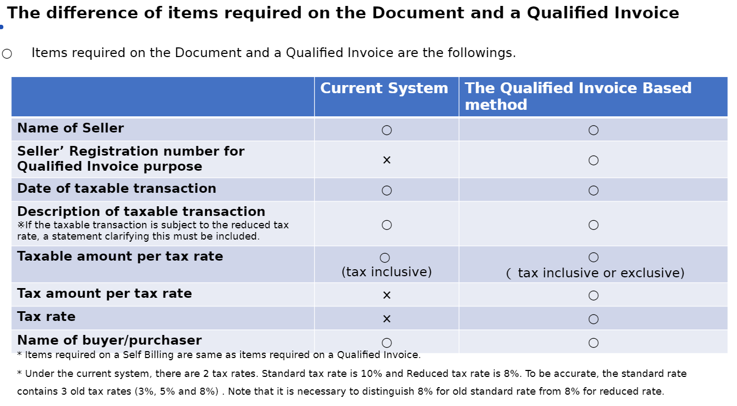

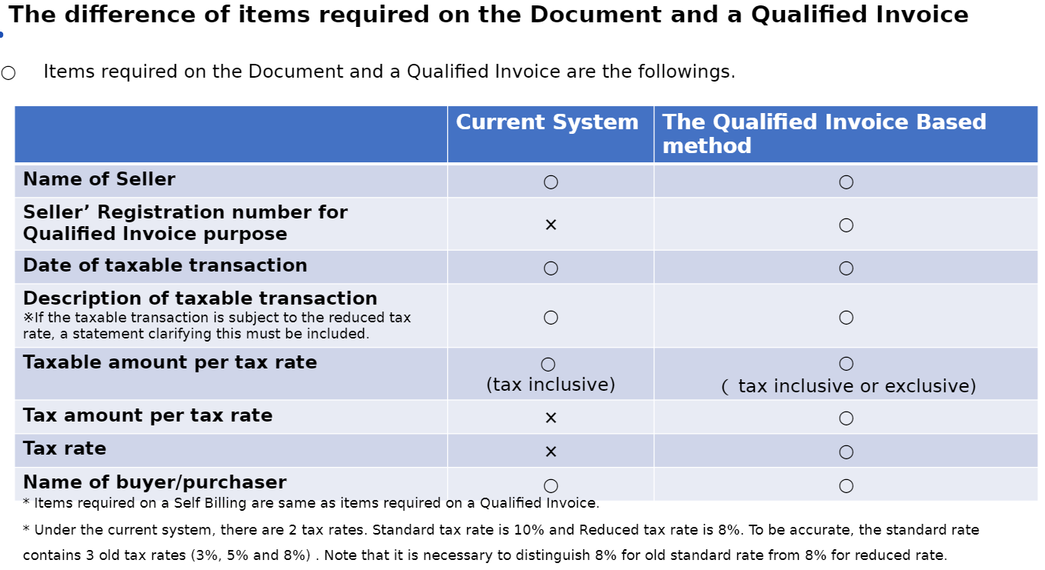

《 Invoice to correct an error or a mistake 》

○ If there is an error or a mistake on a Qualified Invoice issued, Consumption Tax law requires the issuer (a

registered taxable business) to correct it.

○ The law doesn’t stipulate the way to correct. Therefore, in practice, “issuing a correction document” and

“Issuing a new Qualified Invoice” would be options.

※Note that “issuing a new Qualified Invoice” to rectify the preceding invoice shall be ruled as Japan rule.

《Qualified Invoice for return 》

○ For example, when a registered taxable business makes an allowance or returns sales (sales

return), it is required to issue a Qualified Invoice for return.

○ Items required on a Qualified Invoice for return are the following.

　　・ Name of seller

　　・ Seller’s Registration number for Qualified Invoice purpose

　　・ Date of sales return

　　・ Date of taxable transaction returned

　　・ Description of taxable transaction returned

　　 ※ If the taxable transaction is subject to the reduced tax rate, a statement clarifying this must be included.

　　･ Taxable amount of sales return per tax rate

　　・ Tax amount of sales return per tax rate

　　・ Tax rate

## Line CT Information

[SOURCE: Japanese Peppol BIS Documentation]

Each invoice line shall have the invoiced item CT category code (ibt-151), and for all CT categories except "Not subject to CT" (O), the CT rate shall be provided.

## Document level allowance or charge

[SOURCE: Japanese Peppol BIS Documentation]

Each document level charge or allowance must have the Document level allowance or charge CT category code (ibt-095 and ibt-102), and for all CT categories except "Not subject to CT" (O), the CT rate shall be provided.

## CT Breakdown

[SOURCE: Japanese Peppol BIS Documentation]

One CT Breakdown shall be provided for each distinct combination of CT category code and CT rate found in either the line CT information or the Document level allowance or charges. For some CT categories, the CT rate shall be zero, and hence the rate is not needed in order to group the CT Breakdown for these.

For the CT rate, only significant decimals shall be considered, i.e any difference in trailing zeros shall not result in different CT breakdowns.

EXAMPLE

Invoice line 1 has category code = S and CT rate = 25

Invoice line 2 has category code = S and CT rate = 25.00

This shall result in only one CT Breakdown.

## Invoice total CT amount

[SOURCE: Japanese Peppol BIS Documentation]

The invoice total CT amount (ibt-110) is the sum of all CT Category CT amounts (ibt-117).

# Rounding

## Overview

[SOURCE: Japanese Peppol BIS Documentation]

To minimize the risk of differences due to rounding there are no rounding requirements in the PINT except that the amount due for payment must be rounded to maximum two digits.

The following rule requires the calculation result to be rounded.

The VAT category tax amount(ibt-117) in a VAT breakdown(ibg-23) shall equal the VAT category taxable amount(BT-116) multiplied by the VAT category rate (BT-119).

TAX category tax amount(ibt-117) =

TAX category taxable amount(ibt-116) × (TAX rate(ibt-119) ÷ 100)

To minimize the risk of differences due to rounding, the following rules apply:

* If Invoice currency code(ibt-005) is "JPY", all document level amounts shall have no decimals for accounting.
* If Invoice currency code(ibt-005) is "JPY", invoice line net amount shall be rounded.

Results from calculations involving already rounded amounts are not subject to rounding, like payable amounts and total amounts included CT.

Please also see **8** Calculation for details on how to calculate the different amounts.

## PINT rule

[EIPA]

The rounded amount is up to two decimal places.

(

TAX category tax amount(ibt-117) – 1 <

round(TAX category taxable amount(ibt-116) × (TAX rate(ibt-119) ÷ 100)×100) ÷ 100

) and (

TAX category tax amount(ibt-117) + 1 >

round(TAX category taxable amount(ibt-116) × (TAX rate(ibt-119) ÷ 100)×100) ÷ 100

)

## JP-PINT rule

[EIPA]

The rounded amount is an integer and the number of digits after the decimal point is zero. The National Tax Agency of Japan allows rounding down, rounding up, and rounding of calculation results.

(

floor(TAX category taxable amount(ibt-116) × (TAX rate(ibt-119) ÷ 100)) <

TAX category tax amount(ibt-117)

) and (

TAX category tax amount(ibt-117) <

ceil(TAX category taxable amount(ibt-116) × (TAX rate(ibt-119) ÷ 100))

)

# 

# Calculation

## Calculation on line level

[EIPA]

### Item net price

If gross price and discount exist, the Item net price has to equal with the item gross price less the item price discount.

The following calculation is applied to the PINT invoice line

Item net price(ibt-146) = Item gross price(ibt-148) - Item price discount(ibt-147)

**Table 24** lists example contents of semantic elements of item net price.

NOTE: In the table below, the leading "/(Invoice | CreditNote)/cac:InvoiceLine/" in the XPath has been removed and the XPath now contains spaces for readability. Be sure to add the leading "/(Invoice | CreditNote)/cac:InvoiceLine/" and remove the spaces before using it.

**Table 24 — Example of item net price**

|  |  |  |  |  |  |
| --- | --- | --- | --- | --- | --- |
| **ID** | **Level** | **Card** | **Business Term** | **Content** | **UBL syntax XPath** |
| ibt-129 | 2 | 1..1 | Invoiced quantity | 10 | cbc:InvoicedQuantity |
| ibt-131 | 2 | 1..1 | Invoice line net amount | 4100 | cbc:LineExtensionAmount |
| ibg-29 | 2 | 1..1 | PRICE DETAILS |  | cac:Price |
| ibt-146 | 3 | 1..1 | Item net price (3) | 410 | cac:Price/ cbc:PriceAmount |
| ibt-147 | 3 | 0..1 | Item price discount (2) | 40 | cac:Price/ cac:AllowanceCharge[cbc:ChargeIndicator = false()]/ cbc:Amount |
| ibt-148 | 3 | 0..1 | Item gross price (1) | 450 | cac:Price/ cac:AllowanceCharge[cbc:ChargeIndicator = false()]/ cbc:BaseAmount |
| ibt-149 | 3 | 0..1 | Item price base quantity | 1 | cac:Price/ cbc:BaseQuantity |
| ibt-150 | 3 | 0..1 | Item price base quantity unit of measure code | C62 | cac:Price/ cbc:BaseQuantity/ @unitCode |

EXAMPLE: UBL example of item net price

<cbc:InvoicedQuantity unitCode="C62">10</cbc:InvoicedQuantity>

<cbc:LineExtensionAmount currencyID="JPY">4100</cbc:LineExtensionAmount>

<cac:Price>

<cbc:PriceAmount currencyID="JPY">410</cbc:PriceAmount> <!-- (3) -->

<cbc:BaseQuantity unitCode="C62">1</cbc:BaseQuantity>

<cac:AllowanceCharge>

<cbc:ChargeIndicator>false</cbc:ChargeIndicator>

<cbc:Amount currencyID="JPY">40</cbc:Amount> <!-- (2) -->

<cbc:BaseAmount currencyID="JPY">450</cbc:BaseAmount> <!-- (1) -->

</cac:AllowanceCharge>

</cac:Price>

(1) Item gross price

(2) Item price discount

(3) Item price net amount = Item gross price − Item price discount

### Invoice line net amount

[EIPA]

The invoice line net amount (ibt-131) is as the name implies the net amount without CT, and inclusive of line level allowance and charges.

The following calculation is applied to the PINT invoice line

Invoice line net amount(ibt-131) =

Item net price(ibt-146)×(Invoiced quantity(ibt-129)÷Item price base quantity(ibt-149))

+ Invoice line charge amount(ibt-141)

- Invoice line allowance amount(ibt-136)

NOTE: As the line net amount must be rounded to no decimals, please note that the different parts of the calculation must be rounded separately. I.e the result of Item line net amount must be rounded to no decimals, and the allowance/charge amounts are also rounded separately.

**Table 25** lists example contents of semantic elements of line net price.

NOTE: In the table below, the leading "/(Invoice | CreditNote)/cac:InvoiceLine/" in the XPath has been removed and the XPath now contains spaces for readability. Be sure to add the leading "/(Invoice | CreditNote)/cac:InvoiceLine/" and remove the spaces before using it.

**Table 25 — Example of line net price**

|  |  |  |  |  |  |
| --- | --- | --- | --- | --- | --- |
| **ID** | **Level** | **Card** | **Business Term** | **Content** | **UBL syntax XPath** |
| ibt-129 | 2 | 1..1 | Invoiced quantity (3) | 10 | cbc:InvoicedQuantity |
| ibt-131 | 2 | 1..1 | Invoice line net amount (4) | 10000 | cbc:LineExtensionAmount |
| ibg-29 | 2 | 1..1 | PRICE DETAILS |  | cac:Price |
| ibt-146 | 3 | 1..1 | Item net price (1) | 2000 | cac:Price/ cbc:PriceAmount |
| ibt-149 | 3 | 0..1 | Item price base quantity (2) | 2 | cac:Price/ cbc:BaseQuantity |

EXAMPLE: UBL example of invoice line net amount where no line allowance/charge exist

<cbc:InvoicedQuantity unitCode="C62">10</cbc:InvoicedQuantity> <!-- (3) -->

<cbc:LineExtensionAmount currencyID="JPY">10000</cbc:LineExtensionAmount> <!-- (4) -->

<!-- Code omitted for clarity-->

<cac:Price>

<cbc:PriceAmount currencyID="JPY">2000</cbc:PriceAmount> <!-- (1) -->

<cbc:BaseQuantity unitCode="C62">2</cbc:BaseQuantity> <!-- (2) -->

</cac:Price>

(1) Item net price

(2) Item price base quantity

(3) Invoiced quantity

(4) Invoice line net amount=((Item net price÷Item price base quantity) (Invoiced Quantity)

**Table 26** lists example contents of semantic elements of line level price and tax.

NOTE: In the table below, the leading "/(Invoice | CreditNote)/cac:InvoiceLine/" in the XPath has been removed and the XPath now contains spaces for readability. Be sure to add the leading "/(Invoice | CreditNote)/cac:InvoiceLine/" and remove the spaces before using it.

**Table 26 — Example of line tax information**

|  |  |  |  |  |  |
| --- | --- | --- | --- | --- | --- |
| **ID** | **Level** | **Card** | **Business Term** | **Content** | **UBL syntax XPath** |
| ibt-129 | 2 | 1..1 | Invoiced quantity (4) | 10 | cbc:InvoicedQuantity |
| ibt-131 | 2 | 1..1 | Invoice line net amount (5) | 90000 | cbc:LineExtensionAmount |
| ibg-27 | 2 | 0..n | INVOICE LINE ALLOWANCES |  | cac:AllowanceCharge[cbc:ChargeIndicator = false()] |
| ibt-136 | 3 | 1..1 | Invoice line allowance amount (3) | 100 | cac:AllowanceCharge[cbc:ChargeIndicator = false()]/ cbc:Amount |
| ibt-139 | 3 | 0..1 | Invoice line allowance reason | Discount | cac:AllowanceCharge[cbc:ChargeIndicator = false()]/ cbc:AllowanceChargeReason |
| ibt-140 | 3 | 0..1 | Invoice line allowance reason code | 95 | cac:AllowanceCharge[cbc:ChargeIndicator = false()]/ cbc:AllowanceChargeReasonCode |
| ibg-28 | 2 | 0..n | INVOICE LINE CHARGES |  | cac:AllowanceCharge[cbc:ChargeIndicator = true()] |
| ibt-141 | 3 | 1..1 | Invoice line charge amount | 100 | cac:AllowanceCharge[cbc:ChargeIndicator = true()]/ cbc:Amount |
| ibt-142 | 3 | 0..1 | Invoice line charge base amount | 10000 | cac:AllowanceCharge[cbc:ChargeIndicator = true()]/ cbc:BaseAmount |
| ibt-143 | 3 | 0..1 | Invoice line charge percentage (2) | 1 | cac:AllowanceCharge[cbc:ChargeIndicator = true()]/ cbc:MultiplierFactorNumeric |
| ibt-144 | 3 | 0..1 | Invoice line charge reason | Charge | cac:AllowanceCharge[cbc:ChargeIndicator = true()]/ cbc:AllowanceChargeReason |
| ibt-145 | 3 | 0..1 | Invoice line charge reason code | CG | cac:AllowanceCharge[cbc:ChargeIndicator = true()]/ cbc:AllowanceChargeReasonCode |
| ibg-29 | 2 | 1..1 | PRICE DETAILS |  | cac:Price |
| ibt-146 | 3 | 1..1 | Item net price (1) | 10000 | cac:Price/ cbc:PriceAmount |

EXAMPLE: UBL example of invoice line net amount where line allowance and charge exist

<cbc:InvoicedQuantity unitCode="C62">10</cbc:InvoicedQuantity> <!-- (4) -->

<cbc:LineExtensionAmount currencyID="JPY">90000</cbc:LineExtensionAmount> <!-- (5) -->

<!-- Code omitted for clarity-->

<cac:AllowanceCharge>

<cbc:ChargeIndicator>false</cbc:ChargeIndicator>

<cbc:AllowanceChargeReasonCode>95</cbc:AllowanceChargeReasonCode>

<cbc:AllowanceChargeReason>Discount</cbc:AllowanceChargeReason>

<cbc:Amount currencyID="JPY">100</cbc:Amount> <!-- (3) -->

</cac:AllowanceCharge>

<cac:AllowanceCharge>

<cbc:ChargeIndicator>true</cbc:ChargeIndicator>

<cbc:AllowanceChargeReasonCode>CG</cbc:AllowanceChargeReasonCode>

<cbc:AllowanceChargeReason>Charge</cbc:AllowanceChargeReason>

<cbc:MultiplierFactorNumeric>1</cbc:MultiplierFactorNumeric>

<cbc:Amount currencyID="JPY">100</cbc:Amount> <!-- (2) -->

<cbc:BaseAmount currencyID="JPY">10000</cbc:BaseAmount>

</cac:AllowanceCharge>

<!-- Code omitted for clarity-->

<cac:Price>

<cbc:PriceAmount currencyID="JPY">10000</cbc:PriceAmount> <!-- (1) -->

</cac:Price>

(1) Item net price

(2) Line charge amounts

(3) Line allowance amount

(4) Invoiced quantity

(5) Invoice line net amount=(Item net price×Invoiced Quantity)+line charge amount−line allowance amount

### Example calculation on line level (informative)

[EIPA]

Line 1

ibt-146 = 1.10 $-$ 0.10 = 1.00

ibt-131 = 1.00 × (1000 ÷ 1) + 100.00 - 100.00 = 1000.00

Line 2

ibt-146 = 5.00

ibt-131 = 5.00 × (1000 ÷ 1) = 500.00

Line 3

ibt-146 = 5.00

ibt-131 = 5.00 × (500 ÷ 1) = 2500.00

NOTE: If ibt-149 is not specified, the base quantity for the item net amount is 1.

**Table 27** lists example contents of semantic elements of line level price and tax.

NOTE: In the table below, the leading "/(Invoice | CreditNote)/" in the XPath has been removed and the XPath now contains spaces for readability. Be sure to add the leading "/(Invoice | CreditNote)/" and remove the spaces before using it.

**Table 27 — Example of line tax information**

|  |  |  |  |  |  |  |  |
| --- | --- | --- | --- | --- | --- | --- | --- |
| **ID** | **Level** | **Card** | **Business Term** | **Line 1** | **Line 2** | **Line 3** | **UBL syntax XPath** |
| ibg-25 | 1 | 1..n | INVOICE LINE |  |  |  | cac:InvoiceLine |
| ibt-126 | 2 | 1..1 | Invoice line identifier | 1 | 2 | 3 | cbc:ID |
| ibt-129 | 2 | 1..1 | Invoiced quantity | 1000 | 100 | 500 | cbc:InvoicedQuantity |
| ibt-130 | 2 | 1..1 | Invoiced quantity unit of measure code | EA | EA | EA | cbc:InvoicedQuantity/ @unitCode |
| ibt-131 | 2 | 1..1 | Invoice line net amount | 1000.00 | 500.00 | 2500.00 | cbc:LineExtensionAmount |
| ibg-27 | 2 | 0..n | INVOICE LINE ALLOWANCES |  |  |  | cac:AllowanceCharge[cbc:ChargeIndicator = false()] |
| ibt-136 | 3 | 1..1 | Invoice line allowance amount | 100.00 |  |  | cac:AllowanceCharge[cbc:ChargeIndicator = false()]/ cbc:Amount |
| ibg-28 | 2 | 0..n | INVOICE LINE CHARGES |  |  |  | cac:AllowanceCharge[cbc:ChargeIndicator = true()] |
| ibt-141 | 3 | 1..1 | Invoice line charge amount | 100.00 |  |  | cac:AllowanceCharge[cbc:ChargeIndicator = true()]/ cbc:Amount |
| ibg-29 | 2 | 1..1 | PRICE DETAILS |  |  |  | cac:Price |
| ibt-146 | 3 | 1..1 | Item net price | 1.00 | 5.00 | 5.00 | cac:Price/ cbc:PriceAmount |
| ibt-147 | 3 | 0..1 | Item price discount | 0.10 |  |  | cac:Price/ cac:AllowanceCharge[cbc:ChargeIndicator = false()]/ cbc:Amount |
| ibt-148 | 3 | 0..1 | Item gross price | 1.10 |  |  | cac:Price/ cac:AllowanceCharge[cbc:ChargeIndicator = false()]/ cbc:BaseAmount |
| ibt-149 | 3 | 0..1 | Item price base quantity | 1 |  |  | cac:Price/ cbc:BaseQuantity |
| ibt-150 | 3 | 0..1 | Item price base quantity unit of measure code | EA |  |  | cac:Price/ cbc:BaseQuantity/ @unitCode |
| ibg-30 | 2 | 1..n | LINE TAX INFORMATION |  |  |  | cac:Item/ cac:ClassifiedTaxCategory |
| ibt-151 | 3 | 1..1 | Invoiced item TAX category code | S | S | S | cac:Item/ cac:ClassifiedTaxCategory/ cbc:ID |
| ibt-152 | 3 | 0..1 | Invoiced item TAX rate | 25 | 25 | 12 | cac:Item/ cac:ClassifiedTaxCategory/ cbc:Percent |
| ibt-167 | 3 | 0..1 | Tax Scheme | VAT | VAT | VAT | cac:Item/ cac:ClassifiedTaxCategory/ cac:TaxScheme/ cbc:ID |
| ibg-31 | 2 | 1..1 | ITEM INFORMATION |  |  |  | cac:Item |
| ibt-153 | 3 | 1..1 | Item name | Printing paper | Fountain pen | American Cookies | cac:Item/ cbc:Name |

EXAMPLE: UBL example of Invoice line item

This code is an excerpt from **0**. The entire code is listed in **0**.

<cac:InvoiceLine>

<cbc:ID>1</cbc:ID>

<cbc:InvoicedQuantity unitCode="EA">1000</cbc:InvoicedQuantity>

<cbc:LineExtensionAmount currencyID="DKK">1000.00</cbc:LineExtensionAmount>

<!-- Code omitted for clarity -->

<cac:AllowanceCharge>

<cbc:ChargeIndicator>false</cbc:ChargeIndicator>

<!-- Code omitted for clarity -->

<cbc:Amount currencyID="DKK">100.00</cbc:Amount>

</cac:AllowanceCharge>

<cac:AllowanceCharge>

<cbc:ChargeIndicator>true</cbc:ChargeIndicator>

<!-- Code omitted for clarity -->

<cbc:Amount currencyID="DKK">100.00</cbc:Amount>

</cac:AllowanceCharge>

<cac:Item>

<cbc:Name>Printing paper</cbc:Name>

<!-- Code omitted for clarity -->

<cac:ClassifiedTaxCategory>

<cbc:ID>S</cbc:ID>

<cbc:Percent>25</cbc:Percent>

<cac:TaxScheme>

<cbc:ID>VAT</cbc:ID>

</cac:TaxScheme>

</cac:ClassifiedTaxCategory>

</cac:Item>

<cac:Price>

<cbc:PriceAmount currencyID="DKK">1.00</cbc:PriceAmount>

<cbc:BaseQuantity unitCode="EA">1</cbc:BaseQuantity>

<cac:AllowanceCharge>

<cbc:ChargeIndicator>false</cbc:ChargeIndicator>

<cbc:Amount currencyID="DKK">0.10</cbc:Amount>

<cbc:BaseAmount currencyID="DKK">1.10</cbc:BaseAmount>

</cac:AllowanceCharge>

</cac:Price>

</cac:InvoiceLine>

<cac:InvoiceLine>

<cbc:ID>2</cbc:ID>

<cbc:InvoicedQuantity unitCode="EA">100</cbc:InvoicedQuantity>

<cbc:LineExtensionAmount currencyID="DKK">500.00</cbc:LineExtensionAmount>

<!-- Code omitted for clarity -->

<cac:Item>

<cbc:Name>Fountain Pen</cbc:Name>

<!-- Code omitted for clarity -->

<cac:ClassifiedTaxCategory>

<cbc:ID>S</cbc:ID>

<cbc:Percent>25</cbc:Percent>

<cac:TaxScheme>

<cbc:ID>VAT</cbc:ID>

</cac:TaxScheme>

</cac:ClassifiedTaxCategory>

</cac:Item>

<cac:Price>

<cbc:PriceAmount currencyID="DKK">5.00</cbc:PriceAmount>

</cac:Price>

</cac:InvoiceLine>

<cac:InvoiceLine>

<cbc:ID>3</cbc:ID>

<cbc:InvoicedQuantity unitCode="EA">500</cbc:InvoicedQuantity>

<cbc:LineExtensionAmount currencyID="DKK">2500.00</cbc:LineExtensionAmount>

<cac:Item>

<cbc:Name>American Cookies</cbc:Name>

<!-- Code omitted for clarity -->

<cac:ClassifiedTaxCategory>

<cbc:ID>S</cbc:ID>

<cbc:Percent>12</cbc:Percent>

<cac:TaxScheme>

<cbc:ID>VAT</cbc:ID>

</cac:TaxScheme>

</cac:ClassifiedTaxCategory>

</cac:Item>

<cac:Price>

<cbc:PriceAmount currencyID="DKK">5.00</cbc:PriceAmount>

</cac:Price>

</cac:InvoiceLine>

## Calculation of allowance/charge amount

[EIPA]

Allowance and charge on document- and line level consists of elements carrying information on the allowance/charge base amount and the allowance/charge percentage. These are, if present in the invoice instance, used for calculating the allowance/charge amount.

If base amount is present, the percentage shall also be present, and if percentage is present, the base amount shall also be present, and the calculation of the amount shall be:

Amount = Base amount × (Percentage÷100)

**Table 28** lists example contents of semantic elements of allowance/charge.

NOTE: In the table below, the leading "/(Invoice | CreditNote)/" in the XPath has been removed and the XPath now contains spaces for readability. Be sure to add the leading "/(Invoice | CreditNote)/" and remove the spaces before using it.

**Table 28 — Example of allowance/charge**

|  |  |  |  |  |  |
| --- | --- | --- | --- | --- | --- |
| **ID** | **Level** | **Card** | **Business Term** | **Content** | **UBL syntax XPath** |
| ibg-20 | 1 | 0..n | DOCUMENT LEVEL ALLOWANCES |  | cac:AllowanceCharge[cbc:ChargeIndicator = false()] |
| ibt-092 | 2 | 1..1 | Document level allowance amount (2-1) | 200 | cac:AllowanceCharge[cbc:ChargeIndicator = false()]/ cbc:Amount |
| ibt-093 | 2 | 0..1 | Document level allowance base amount |  | cac:AllowanceCharge[cbc:ChargeIndicator = false()]/ cbc:BaseAmount |
| ibt-094 | 2 | 0..1 | Document level allowance percentage |  | cac:AllowanceCharge[cbc:ChargeIndicator = false()]/ cbc:MultiplierFactorNumeric |
| ibt-095 | 2 | 1..1 | Document level allowance TAX category code | S | cac:AllowanceCharge[cbc:ChargeIndicator = false()]/ cac:TaxCategory/ cbc:ID |
| ibt-096 | 2 | 0..1 | Document level allowance TAX rate | 10 | cac:AllowanceCharge[cbc:ChargeIndicator = false()]/ cac:TaxCategory/ cbc:Percent |
| ibt-096-1 | 3 | 0..1 | Tax Scheme | VAT | cac:AllowanceCharge[cbc:ChargeIndicator = false()]/ cac:TaxCategory/ cac:TaxScheme/ cbc:ID |
| ibt-097 | 2 | 0..1 | Document level allowance reason | Discount | cac:AllowanceCharge[cbc:ChargeIndicator = false()]/ cbc:AllowanceChargeReason |
| ibt-098 | 2 | 0..1 | Document level allowance reason code | 95 | cac:AllowanceCharge[cbc:ChargeIndicator = false()]/ cbc:AllowanceChargeReasonCode |
| ibg-21 | 1 | 0..n | DOCUMENT LEVEL CHARGES |  | cac:AllowanceCharge[cbc:ChargeIndicator = true()] |
| ibt-099 | 2 | 1..1 | Document level charge amount (1-3) | 20 | cac:AllowanceCharge[cbc:ChargeIndicator = true()]/ cbc:Amount |
| ibt-100 | 2 | 0..1 | Document level charge base amount (1-1) | 200 | cac:AllowanceCharge[cbc:ChargeIndicator = true()]/ cbc:BaseAmount |
| ibt-101 | 2 | 0..1 | Document level charge percentage (1-2) | 10 | cac:AllowanceCharge[cbc:ChargeIndicator = true()]/ cbc:MultiplierFactorNumeric |
| ibt-102 | 2 | 1..1 | Document level charge TAX category code | S | cac:AllowanceCharge[cbc:ChargeIndicator = true()]/ cac:TaxCategory/ cbc:ID |
| ibt-103 | 2 | 0..1 | Document level charge TAX rate | 10 | cac:AllowanceCharge[cbc:ChargeIndicator = true()]/ cac:TaxCategory/ cbc:Percent |
| ibt-103-1 | 3 | 0..1 | Tax Scheme | VAT | cac:AllowanceCharge[cbc:ChargeIndicator = true()]/ cac:TaxCategory/ cac:TaxScheme/ cbc:ID |
| ibt-104 | 2 | 0..1 | Document level charge reason | Cleaning | cac:AllowanceCharge[cbc:ChargeIndicator = true()]/ cbc:AllowanceChargeReason |
| ibt-105 | 2 | 0..1 | Document level charge reason code | CG | cac:AllowanceCharge[cbc:ChargeIndicator = true()]/ cbc:AllowanceChargeReasonCode |
| ibg-25 | 1 | 1..n | INVOICE LINE |  | cac:InvoiceLine |
| ibg-27 | 2 | 0..n | INVOICE LINE ALLOWANCES |  | cac:InvoiceLine/ cac:AllowanceCharge[cbc:ChargeIndicator = false()] |
| ibt-136 | 3 | 1..1 | Invoice line allowance amount |  | cac:InvoiceLine/ cac:AllowanceCharge[cbc:ChargeIndicator = false()]/ cbc:Amount |
| ibt-137 | 3 | 0..1 | Invoice line allowance base amount |  | cac:InvoiceLine/ cac:AllowanceCharge[cbc:ChargeIndicator = false()]/ cbc:BaseAmount |
| ibt-138 | 3 | 0..1 | Invoice line allowance percentage |  | cac:InvoiceLine/ cac:AllowanceCharge[cbc:ChargeIndicator = false()]/ cbc:MultiplierFactorNumeric |
| ibt-139 | 3 | 0..1 | Invoice line allowance reason |  | cac:InvoiceLine/ cac:AllowanceCharge[cbc:ChargeIndicator = false()]/ cbc:AllowanceChargeReason |
| ibt-140 | 3 | 0..1 | Invoice line allowance reason code |  | cac:InvoiceLine/ cac:AllowanceCharge[cbc:ChargeIndicator = false()]/ cbc:AllowanceChargeReasonCode |
| ibg-28 | 2 | 0..n | INVOICE LINE CHARGES |  | cac:InvoiceLine/ cac:AllowanceCharge[cbc:ChargeIndicator = true()] |
| ibt-141 | 3 | 1..1 | Invoice line charge amount |  | cac:InvoiceLine/ cac:AllowanceCharge[cbc:ChargeIndicator = true()]/ cbc:Amount |
| ibt-142 | 3 | 0..1 | Invoice line charge base amount |  | cac:InvoiceLine/ cac:AllowanceCharge[cbc:ChargeIndicator = true()]/ cbc:BaseAmount |
| ibt-143 | 3 | 0..1 | Invoice line charge percentage |  | cac:InvoiceLine/ cac:AllowanceCharge[cbc:ChargeIndicator = true()]/ cbc:MultiplierFactorNumeric |
| ibt-144 | 3 | 0..1 | Invoice line charge reason |  | cac:InvoiceLine/ cac:AllowanceCharge[cbc:ChargeIndicator = true()]/ cbc:AllowanceChargeReason |
| ibt-145 | 3 | 0..1 | Invoice line charge reason code |  | cac:InvoiceLine/ cac:AllowanceCharge[cbc:ChargeIndicator = true()]/ cbc:AllowanceChargeReasonCode |

EXAMPLE 1: UBL example of calculations of allowances and charges where base amount and percentage exist

<cac:AllowanceCharge>

<cbc:ChargeIndicator>true</cbc:ChargeIndicator>

<cbc:AllowanceChargeReasonCode>CG</cbc:AllowanceChargeReasonCode>

<cbc:AllowanceChargeReason>Cleaning</cbc:AllowanceChargeReason>

<cbc:MultiplierFactorNumeric>20</cbc:MultiplierFactorNumeric> <!-- (1-2) -->

<cbc:Amount currencyID="JPY">200</cbc:Amount> <!-- (1-3) -->

<cbc:BaseAmount currencyID="JPY">1000</cbc:BaseAmount> <!-- (1-1) -->

<cac:TaxCategory>

<cbc:ID>S</cbc:ID>

<cbc:Percent>10</cbc:Percent>

<cac:TaxScheme>

<cbc:ID>VAT</cbc:ID>

</cac:TaxScheme>

</cac:TaxCategory>

</cac:AllowanceCharge>

(1) Base amount, to be used with the percentage to calculate the amount

(2) Charge percentage

(3) Base amount×(Percentage÷100)=Amount

NOTE: Line level allowance/charge doesn't contain TAX information. LINE TAX INFORMATION (ibg-30) is spefified for each invoice line.

EXAMPLE 2: UBL example of calculations of allowances and charges where base amount and percentage does not exist

<cac:AllowanceCharge>

<cbc:ChargeIndicator>false</cbc:ChargeIndicator>

<cbc:AllowanceChargeReasonCode>95</cbc:AllowanceChargeReasonCode>

<cbc:AllowanceChargeReason>Discount</cbc:AllowanceChargeReason>

<cbc:Amount currencyID="JPY">200</cbc:Amount> <!-- (2-1) -->

<cac:TaxCategory>

<cbc:ID>S</cbc:ID>

<cbc:Percent>10</cbc:Percent>

<cac:TaxScheme>

<cbc:ID>VAT</cbc:ID>

</cac:TaxScheme>

</cac:TaxCategory>

</cac:AllowanceCharge>

## Calculation of CT

[EIPA]

One CT Breakdown shall be provided for each distinct combination of CT category code and CT rate found in either the line CT information or the Document level allowance or charges.

For each distinct combination of CT category code and CT rate the calculations are:

CT category taxable amount (ibt-116) =

∑(Invoice line net amounts (ibt-131))

+ Document level charge amount (ibt-099) − Document level allowance amount (ibt-092)

CT category tax amount (ibt-117) =

CT category taxable amount (ibt-116) × (CT rate (ibt-119) ÷ 100)

For CT Breakdown where the CT Category is "Not subject to CT" (O), the CT category tax amount shall be zero.

Consumption Tax category tax amount (ibt-117 is rounded to integers. The rounded result amount SHALL be between the amount rounded down to integer value as floor and the amount rounded up to integer value as ceiling. (jp-br-co-01).

**Table 29** lists calculation applied to the PINT invoice for each TAX category and rate.

**Table 29 — calculations of CT Breakdown**

|  |  |  |
| --- | --- | --- |
| **ID** | **Business Term** | **Calculation** |
| ibt-116 | TAX category taxable amount | ∑ (Invoice line net amount(ibt-131))  − Document level allowance amount(ibt-092)  + Document level charge amount(ibt-099) |
| ibt-117 | TAX category tax amount | TAX category taxable amount(ibt-116)  × (TAX rate(ibt-119) ÷ 100) |
| ibt-110 | Invoice total TAX amount | ∑ (TAX category tax amount(ibt-117)) |

**Table 30** lists calculation applied to the PINT invoice with classified description.

**Table 30 — calculations of CT Breakdown for invoice with classified description**

|  |  |  |
| --- | --- | --- |
| **ID** | **Business Term** | **Calculation** |
| ibt-116 | TAX category taxable amount | ∑ (Invoice line net amount(ibt-131))  − Document level allowance amount(ibt-092)  + Document level charge amount(ibt-099) |
| ibt-117 | TAX category tax amount | TAX category taxable amount(ibt-116) |
| ibt-110 | Invoice total TAX amount | ∑ (TAX category tax amount(ibt-117)) |

This calculation requires rounding amount of calculated amount. Rounding is specified in clause 1 more detail.

**Table 31** lists example contents of semantic elements contributing TAX breakdown and document totals.

**Table 31 — Examples of content of semantic elements that contribute to calculations**

|  |  |  |  |  |  |  |  |  |  |
| --- | --- | --- | --- | --- | --- | --- | --- | --- | --- |
| **ID** | **Level** | **Card** | **Business Term** | **Invoice Content** | **VAT**  **Standard**  **(S) 10%** | **VAT**  **Exempt**  **(E) 0%** | **Line 1** | **Line 2** | **Line 3** |
| ibg-20 | 1 | 0..n | DOCUMENT LEVEL ALLOWANCES |  |  |  |  |  |  |
| ibt-092 | 2 | 1..1 | Document level allowance amount |  | 1000 |  |  |  |  |
| ibt-095 | 2 | 1..1 | Document level allowance TAX category code |  | S |  |  |  |  |
| ibt-096 | 2 | 0..1 | Document level allowance TAX rate |  | 10 |  |  |  |  |
| ibt-096-1 | 3 | 0..1 | Tax Scheme |  | VAT |  |  |  |  |
| ibt-097 | 2 | 0..1 | Document level allowance reason |  | Discount |  |  |  |  |
| ibg-21 | 1 | 0..n | DOCUMENT LEVEL CHARGES |  |  |  |  |  |  |
| ibt-099 | 2 | 1..1 | Document level charge amount |  | 2000 |  |  |  |  |
| ibt-102 | 2 | 1..1 | Document level charge TAX category code |  | S |  |  |  |  |
| ibt-103 | 2 | 0..1 | Document level charge TAX rate |  | 10 |  |  |  |  |
| ibt-103-1 | 3 | 0..1 | Tax Scheme |  | VAT |  |  |  |  |
| ibt-104 | 2 | 0..1 | Document level charge reason |  | Cleaning |  |  |  |  |
| ibg-23 | 1 | 1..n | TAX BREAKDOWN |  |  |  |  |  |  |
| ibt-116 | 2 | 1..1 | TAX category taxable amount |  | 61000 | 9000 |  |  |  |
| ibt-117 | 2 | 1..1 | TAX category tax amount |  | 610 | 0 |  |  |  |
| ibt-118 | 2 | 1..1 | TAX category code |  | S | E |  |  |  |
| ibt-118-1 | 3 | 0..1 | Tax Scheme |  | VAT | VAT |  |  |  |
| ibt-119 | 2 | 0..1 | TAX category rate |  | 10 | 0 |  |  |  |
| ibt-120 | 2 | 0..1 | TAX exemption reason text |  |  | Reason for tax exempt |  |  |  |
| ibg-25 | 1 | 1..n | INVOICE LINE |  |  |  |  |  |  |
| ibt-126 | 2 | 1..1 | Invoice line identifier |  |  |  | 1 | 2 | 3 |
| ibt-127 | 2 | 0..1 | Invoice line note |  |  |  | Testing note on line level |  |  |
| ibt-129 | 2 | 1..1 | Invoiced quantity |  |  |  | 10 | 10 | 10 |
| ibt-130 | 2 | 1..1 | Invoiced quantity unit of measure code |  |  |  | C62 | C62 | C62 |
| ibt-131 | 2 | 1..1 | Invoice line net amount |  |  |  | 40000 | 20000 | 9000 |
| ibg-30 | 2 | 1..n | LINE TAX INFORMATION |  |  |  |  |  |  |
| ibt-151 | 3 | 1..1 | Invoiced item TAX category code |  |  |  | S | S | E |
| ibt-152 | 3 | 0..1 | Invoiced item TAX rate |  |  |  | VAT | VAT | VAT |
| ibt-167 | 3 | 0..1 | Tax Scheme |  |  |  | 10 | 10 | 0 |

EXAMPLE: UBL example of calculations of CT Breakdown

<cac:AllowanceCharge>

<cbc:ChargeIndicator>false</cbc:ChargeIndicator>

<cbc:AllowanceChargeReason>Discount</cbc:AllowanceChargeReason>

<cbc:Amount currencyID="JPY">1000</cbc:Amount>

<cac:TaxCategory>

<cbc:ID>S</cbc:ID>

<cbc:Percent>10</cbc:Percent>

<cac:TaxScheme>

<cbc:ID>VAT</cbc:ID>

</cac:TaxScheme>

</cac:TaxCategory>

</cac:AllowanceCharge>

<cac:AllowanceCharge>

<cbc:ChargeIndicator>true</cbc:ChargeIndicator>

<cbc:AllowanceChargeReason>Cleaning</cbc:AllowanceChargeReason>

<cbc:Amount currencyID="JPY">2000</cbc:Amount>

<cac:TaxCategory>

<cbc:ID>S</cbc:ID>

<cbc:Percent>10</cbc:Percent>

<cac:TaxScheme>

<cbc:ID>VAT</cbc:ID>

</cac:TaxScheme>

</cac:TaxCategory>

</cac:AllowanceCharge>

<cac:TaxTotal>

<cbc:TaxAmount currencyID="JPY">6100</cbc:TaxAmount>

<cac:TaxSubtotal>

<cbc:TaxableAmount currencyID="JPY">61000</cbc:TaxableAmount>

<cbc:TaxAmount currencyID="JPY">6100</cbc:TaxAmount>

<cac:TaxCategory>

<cbc:ID>S</cbc:ID>

<cbc:Percent>10</cbc:Percent>

<cac:TaxScheme>

<cbc:ID>VAT</cbc:ID>

</cac:TaxScheme>

</cac:TaxCategory>

</cac:TaxSubtotal>

<cac:TaxSubtotal>

<cbc:TaxableAmount currencyID="JPY">20000</cbc:TaxableAmount>

<cbc:TaxAmount currencyID="JPY">0</cbc:TaxAmount>

<cac:TaxCategory>

<cbc:ID>E</cbc:ID>

<cbc:Percent>0</cbc:Percent>

<cbc:TaxExemptionReason>Reason for tax exempt</cbc:TaxExemptionReason>

<cac:TaxScheme>

<cbc:ID>VAT</cbc:ID>

</cac:TaxScheme>

</cac:TaxCategory>

</cac:TaxSubtotal>

</cac:TaxTotal>

<cac:InvoiceLine>

<cbc:ID>1</cbc:ID>

<cbc:Note>Testing note on line level</cbc:Note>

<cbc:InvoicedQuantity unitCode="C62">10</cbc:InvoicedQuantity>

<cbc:LineExtensionAmount currencyID="JPY">40000</cbc:LineExtensionAmount>

<!-- code omitted for clarity -->

<cac:ClassifiedTaxCategory>

<cbc:ID>S</cbc:ID>

<cbc:Percent>10</cbc:Percent>

<cac:TaxScheme>

<cbc:ID>VAT</cbc:ID>

</cac:TaxScheme>

</cac:ClassifiedTaxCategory>

<!-- code omitted for clarity -->

</cac:InvoiceLine

<cac:InvoiceLine>

<cbc:ID>2</cbc:ID>

<cbc:InvoicedQuantity unitCode="C62">10</cbc:InvoicedQuantity>

<cbc:LineExtensionAmount currencyID="JPY">20000</cbc:LineExtensionAmount>

<!-- code omitted for clarity -->

<cac:ClassifiedTaxCategory>

<cbc:ID>E</cbc:ID>

<cbc:Percent>0.0</cbc:Percent>

<cac:TaxScheme>

<cbc:ID>VAT</cbc:ID>

</cac:TaxScheme>

</cac:ClassifiedTaxCategory>

<!-- code omitted for clarity -->

</cac:InvoiceLine

<cac:InvoiceLine>

<cbc:ID>3</cbc:ID>

<cbc:InvoicedQuantity unitCode="C62">10</cbc:InvoicedQuantity>

<cbc:LineExtensionAmount currencyID="JPY">9000</cbc:LineExtensionAmount>

<!-- code omitted for clarity -->

<cac:ClassifiedTaxCategory>

<cbc:ID>S</cbc:ID>

<cbc:Percent>10</cbc:Percent>

<cac:TaxScheme>

<cbc:ID>VAT</cbc:ID>

</cac:TaxScheme>

</cac:ClassifiedTaxCategory>

<!-- code omitted for clarity -->

</cac:InvoiceLine>

## Document total

[SOURCE: Japanese Peppol BIS Documentation]

Document total calculation is only summention, addition, and subtraction. There is no rounding.

**Table 32** lists calculation applied to the PINT invoice document total amounts.

**Table 32 — Invoice document total**

|  |  |  |
| --- | --- | --- |
| ID | Budsiness Term | Calculation |
| ibt-106 | Sum of invoice line net amounts | ∑ (Invoice line net amount(ibt-131)) |
| ibt-107 | Sum of allowances on document level | ∑ (Document level allowance amount(ibt-092)) |
| ibt-108 | Sum of charges on document level | ∑ (Document level charge amount(ibt-099)) |
| ibt-109 | Invoice total amount without TAX | Sum of invoice line net amounts(ibt-106)  − Sum of allowances on document level(ibt-107)  + Sum of charges on document level(ibt-108) |
| ibt-110 | Invoice total TAX amount | ∑ (TAX category tax amount(ibt-117)) |
| ibt-112 | Invoice total amount with TAX | Invoice total amount without TAX(ibt-109)  + Invoice total TAX amount(ibt-110) |
| ibt-115 | Amount due for payment | Invoice total amount with TAX(ibt-112)  − Paid amount(ibt-113)  + Rounding amount(ibt-114) |

## UBL syntax calculation formula for document total

[SOURCE: Japanese Peppol BIS Documentation]

The elements in **Table 33** show the legal monetary totals for an invoice or credit note.

**Table 33 — UBL calculation formula**

|  |  |
| --- | --- |
| **Element** | **Formula** |
| <cbc:LineExtensionAmount> | ∑(cac:InvoiceLine/cbc:LineExtensionAmount) |
| <cbc:AllowanceTotalAmount> | ∑(cac:AllowanceCharge[cbc:ChargeIndicator = false()]/cbc:Amount) |
| <cbc:ChargeTotalAmount> | ∑(cac:AllowanceCharge[cbc:ChargeIndicator = true()]/cbc:Amount) |
| <cbc:TaxExclusiveAmount> | cac:LegalMonetaryTotal/cbc:LineExtensionAmount  – cac:LegalMonetaryTotal/cbc:AllowanceTotalAmount + cac:LegalMonetaryTotal/cbc:ChargeTotalAmount |
| <cbc:TaxInclusiveAmount> | cac:LegalMonetaryTotal/cbc:TaxExclusiveAmount  + cac:TaxTotal/cbc:TaxAmount |
| <cbc:PrepaidAmount> | Not applicable |
| <cbc:PayableRoundingAmount> | Not applicable |
| <cbc:PayableAmount> | cac:LegalMonetaryTotal/cbc:TaxInclusiveAmount  − cac:LegalMonetaryTotal/cbc:PrepaidAmount  + cac:LegalMonetaryTotal/cbc:PayableRoundingAmount |

NOTE: XPath processor report error "Cannot compare xs:boolean ('false') with xs:string ('true')" when define /(Invoice|CreditNote)/cac:AllowanceCharge[cbc:ChargeIndicator='true']/cbc:Amount

## Example of Tax breakdown and document total (informative)

[EIPA]

**Table 34** lists example contents of semantic elements contributing TAX breakdown and document totals.

**Table 34 — Examples of content of semantic elements that contribute to calculations**

|  |  |  |  |  |  |  |  |  |  |
| --- | --- | --- | --- | --- | --- | --- | --- | --- | --- |
| **ID** | **Level** | **Card** | **Business Term** | **Invoice Content** | **VAT**  **S 10%** | **VAT**  **AA 8%** | **Line 1** | **Line 2** | **Line 3** |
| ibg-20 | 1 | 0..n | DOCUMENT LEVEL ALLOWANCES |  |  |  |  |  |  |
| ibt-092 | 2 | 1..1 | Document level allowance amount |  | 15000 |  |  |  |  |
| ibt-095 | 2 | 1..1 | Document level allowance TAX category code |  | S |  |  |  |  |
| ibt-096 | 2 | 0..1 | Document level allowance TAX rate |  | 10 |  |  |  |  |
| ibt-096-1 | 3 | 0..1 | Tax Scheme |  | VAT |  |  |  |  |
| ibg-21 | 1 | 0..n | DOCUMENT LEVEL CHARGES |  |  |  |  |  |  |
| ibt-099 | 2 | 1..1 | Document level charge amount |  | 15000 |  |  |  |  |
| ibt-102 | 2 | 1..1 | Document level charge TAX category code |  | S |  |  |  |  |
| ibt-103 | 2 | 0..1 | Document level charge TAX rate |  | 10 |  |  |  |  |
| ibt-103-1 | 3 | 0..1 | Tax Scheme |  | VAT |  |  |  |  |
| ibg-22 | 1 | 1..1 | DOCUMENT TOTALS |  |  |  |  |  |  |
| ibt-106 | 2 | 1..1 | Sum of Invoice line net amount | 175000 |  |  |  |  |  |
| ibt-107 | 2 | 0..1 | Sum of allowances on document level | 15000 |  |  |  |  |  |
| ibt-108 | 2 | 0..1 | Sum of charges on document level | 15000 |  |  |  |  |  |
| ibt-109 | 2 | 1..1 | Invoice total amount without TAX | 175000 |  |  |  |  |  |
| ibt-110 | 2 | 0..1 | Invoice total TAX amount | 17000 |  |  |  |  |  |
| ibt-112 | 2 | 1..1 | Invoice total amount with TAX | 192000 |  |  |  |  |  |
| ibt-113 | 2 | 0..1 | Paid amount | 80000 |  |  |  |  |  |
| ibt-114 | 2 | 0..1 | Rounding amount |  |  |  |  |  |  |
| ibt-115 | 2 | 1..1 | Amount due for payment | 112000 |  |  |  |  |  |
| ibg-23 | 1 | 1..n | TAX BREAKDOWN |  |  |  |  |  |  |
| ibt-116 | 2 | 1..1 | TAX category taxable amount |  | 150000 | 25000 |  |  |  |
| ibt-117 | 2 | 1..1 | TAX category tax amount |  | 15000 | 2000 |  |  |  |
| ibt-118 | 2 | 1..1 | TAX category code |  | S | AA |  |  |  |
| ibt-118-1 | 3 | 0..1 | Tax Scheme |  | VAT | VAT |  |  |  |
| ibt-119 | 2 | 0..1 | TAX category rate |  | 10 | 8 |  |  |  |
| ibg-25 | 1 | 1..n | INVOICE LINE |  |  |  |  |  |  |
| ibt-126 | 2 | 1..1 | Invoice line identifier |  |  |  | 1 | 2 | 3 |
| ibt-129 | 2 | 1..1 | Invoiced quantity |  |  |  | 10000 | 5 | 20 |
| ibt-130 | 2 | 1..1 | Invoiced quantity unit of measure code |  |  |  | EA | EA | XCS |
| ibt-131 | 2 | 1..1 | Invoice line net amount |  |  |  | 100000 | 50000 | 25000 |
| ibg-29 | 2 | 1..1 | PRICE DETAILS |  |  |  |  |  |  |
| ibt-146 | 3 | 1..1 | item net price |  |  |  | 10 | 10000 | 1250 |
| ibg-30 | 2 | 1..n | LINE TAX INFORMATION |  |  |  |  |  |  |
| ibt-151 | 3 | 1..1 | Invoiced item TAX category code |  |  |  | S | S | AA |
| ibt-152 | 3 | 0..1 | Invoiced item TAX rate |  |  |  | VAT | VAT | VAT |
| ibt-167 | 3 | 0..1 | Tax Scheme |  |  |  | 10 | 10 | 8 |
| ibg-31 | 2 | 1..1 | ITEM INFORMATION |  |  |  |  |  |  |
| ibt-153 | 3 | 1..1 | Item name |  |  |  | Printing Paper | Fountain Pen | American Cookies |

EXAMPLE: UBL xamples of content of semantic elements that contribute to calculations

<cac:AllowanceCharge>

<cbc:ChargeIndicator>false</cbc:ChargeIndicator>

<cbc:Amount currencyID="JPY">15000</cbc:Amount>

<cac:TaxCategory>

<cbc:ID>S</cbc:ID>

<cbc:Percent>10</cbc:Percent>

<cac:TaxScheme>

<cbc:ID>VAT</cbc:ID>

</cac:TaxScheme>

</cac:TaxCategory>

</cac:AllowanceCharge>

<cac:AllowanceCharge>

<cbc:ChargeIndicator>true</cbc:ChargeIndicator>

<cbc:Amount currencyID="JPY">15000</cbc:Amount>

<cac:TaxCategory>

<cbc:ID>S</cbc:ID>

<cbc:Percent>10</cbc:Percent>

<cac:TaxScheme>

<cbc:ID>VAT</cbc:ID>

</cac:TaxScheme>

</cac:TaxCategory>

</cac:AllowanceCharge>

<cac:TaxTotal>

<cbc:TaxAmount currencyID="JPY">17000</cbc:TaxAmount>

<cac:TaxSubtotal>

<cbc:TaxableAmount currencyID="JPY">150000</cbc:TaxableAmount>

<cbc:TaxAmount currencyID="JPY">15000</cbc:TaxAmount>

<cac:TaxCategory>

<cbc:ID>S</cbc:ID>

<cbc:Percent>10</cbc:Percent>

<cac:TaxScheme>

<cbc:ID>VAT</cbc:ID>

</cac:TaxScheme>

</cac:TaxCategory>

</cac:TaxSubtotal>

<cac:TaxSubtotal>

<cbc:TaxableAmount currencyID="JPY">25000</cbc:TaxableAmount>

<cbc:TaxAmount currencyID="JPY">2000</cbc:TaxAmount>

<cac:TaxCategory>

<cbc:ID>AA</cbc:ID>

<cbc:Percent>8</cbc:Percent>

<cac:TaxScheme>

<cbc:ID>VAT</cbc:ID>

</cac:TaxScheme>

</cac:TaxCategory>

</cac:TaxSubtotal>

</cac:TaxTotal>

<cac:LegalMonetaryTotal>

<cbc:LineExtensionAmount currencyID="DKK">175000</cbc:LineExtensionAmount>

<cbc:TaxExclusiveAmount currencyID="DKK">175000</cbc:TaxExclusiveAmount>

<cbc:TaxInclusiveAmount currencyID="DKK">192000</cbc:TaxInclusiveAmount>

<cbc:AllowanceTotalAmount currencyID="DKK">15000</cbc:AllowanceTotalAmount>

<cbc:ChargeTotalAmount currencyID="DKK">15000</cbc:ChargeTotalAmount>

<cbc:PrepaidAmount currencyID="DKK">80000</cbc:PrepaidAmount>

<cbc:PayableAmount currencyID="DKK">112000</cbc:PayableAmount>

</cac:LegalMonetaryTotal>

<cac:InvoiceLine>

<cbc:ID>1</cbc:ID>

<cbc:InvoicedQuantity unitCode="EA">10000</cbc:InvoicedQuantity>

<cbc:LineExtensionAmount currencyID="DKK">100000</cbc:LineExtensionAmount>

<cac:Item>

<cbc:Name>Printing paper</cbc:Name>

<cac:ClassifiedTaxCategory>

<cbc:ID>S</cbc:ID>

<cbc:Percent>10</cbc:Percent>

<cac:TaxScheme>

<cbc:ID>VAT</cbc:ID>

</cac:TaxScheme>

</cac:ClassifiedTaxCategory>

</cac:Item>

<cac:Price>

<cbc:PriceAmount currencyID="DKK">10</cbc:PriceAmount>

</cac:Price>

</cac:InvoiceLine>

<cac:InvoiceLine>

<cbc:ID>2</cbc:ID>

<cbc:InvoicedQuantity unitCode="EA">5</cbc:InvoicedQuantity>

<cbc:LineExtensionAmount currencyID="JPY">500.00</cbc:LineExtensionAmount>

<cac:Item>

<cbc:Name>Fountain Pen</cbc:Name>

<cac:ClassifiedTaxCategory>

<cbc:ID>S</cbc:ID>

<cbc:Percent>10</cbc:Percent>

<cac:TaxScheme>

<cbc:ID>VAT</cbc:ID>

</cac:TaxScheme>

</cac:ClassifiedTaxCategory>

</cac:Item>

<cac:Price>

<cbc:PriceAmount currencyID="DKK">10000</cbc:PriceAmount>

</cac:Price>

</cac:InvoiceLine>

<cac:InvoiceLine>

<cbc:ID>3</cbc:ID>

<cbc:InvoicedQuantity unitCode="XCA">20</cbc:InvoicedQuantity> <!— UOM Case -->

<cbc:LineExtensionAmount currencyID="JPY">25000</cbc:LineExtensionAmount>

<cac:Item>

<cbc:Name>American Cookies</cbc:Name>

<cac:ClassifiedTaxCategory>

<cbc:ID>AA</cbc:ID>

<cbc:Percent>8</cbc:Percent>

<cac:TaxScheme>

<cbc:ID>VAT</cbc:ID>

</cac:TaxScheme>

</cac:ClassifiedTaxCategory>

</cac:Item>

<cac:Price>

<cbc:PriceAmount currencyID="DKK">1250</cbc:PriceAmount>

</cac:Price>

</cac:InvoiceLine>

# 

# Payment means

[EIPA]

## Usage in Japan

**Table 35** lists payment means code used in Japan.

**Table 35 — Payment means code used in Japan**

|  |  |  |
| --- | --- | --- |
| **Payment means code** | **支払手段** | **Payment instructions** |
| 10 : In cash | 現金 |  |
| 30 : Credit transfer | 現金振込 | Ibg-16 : CREDIT TRANSFER |
| 30 : Credit transfer | 口座振替（口座間送金） | Ibg-16 : CREDIT TRANSFER |
| 49 : Direct debit | 口座引落 | Ibg-18 : DIRECT DEBIT |
| 20 : Check ( Cheque ) | 小切手 |  |
| 60 : Promissory note | 手形 |  |
|  | 電子記録債権 |  |
| ( 44 : Accepted Bill of Exchange ) | ファクタリング |  |
| 54 : Credit card  55 : Debit card | カード払い | Ibg-17 : CARD INFORMATION |
| 97 : Clearing between partners | 相殺 |  |

Invoice Terms (igb-33) is used to specify the following information;

* The claimant guides the payer of the payment method

Transfer destination: ○○ Bank ○○ Branch 　Acccount number XXXXXXX (even if there are multiple)

Half-bank transfer, half-tegata, etc.

* Notify about the method and amount that was already paid

## Business terms used to specify a payment means

**Table 36** lists business terms used to specify each payment information. PINT supports multiple payment means by adding new business term group INVOICE TERMS. PINT also introduced Terms introductions ID to specify relationship between INVOICE TERMS and PAYMENT INSTRUCTIONS.

**Table 36 — Business terms used to specify a payment means**

|  |  |  |  |  |  |  |  |  |
| --- | --- | --- | --- | --- | --- | --- | --- | --- |
| **ID** | **Level** | **Card** | **Business Term** | **Payment by bank transfer** | **Payment by credit card** | **Payment by bank account debit** | **Paid information** | **Section** |
| ibg-33 | 1 | 0..n | INVOICE TERMS | ✓ | ✓ | ✓ | ✓ | Aligned |
| ibt-020 | 2 | 0..1 | Payment terms | ✓ | ✓ | ✓ | ✓ | Shared |
| ibt-187 | 2 | 0..1 | Terms payment instructions ID | ✓ | ✓ | ✓ | ✓ | Aligned |
| ibt-176 | 2 | 0..1 | Terms amount | ✓ | ✓ | ✓ | ✓ | Aligned |
| ibt-177 | 2 | 0..1 | Terms installment due date | ✓ | ✓ | ✓ | ✓ | Aligned |
| ibg-16 | 1 | 0..n | PAYMENT INSTRUCTIONS | ✓ | ✓ | ✓ | ✓ |  |
| ibt-178 | 2 | 0..1 | Payment Instructions ID | ✓ | ✓ | ✓ | ✓ | Aligned |
| ibt-081 | 2 | 1..1 | Payment means type code | ✓ | ✓ | ✓ | ✓ | Aligned |
| ibt-082 | 2 | 0..1 | Payment means text | ✓ | ✓ | ✓ | ✓ | Shared |
| ibt-083 | 2 | 0..n | Remittance information | ✓ | ✓ | ✓ | ✓ | Aligned |
| ibt-083-1 | 3 | 0..1 | Scheme identifier | ✓ | ✓ | ✓ | ✓ | Aligned |
| ibg-17 | 2 | 0..n | CREDIT TRANSFER | ✓ |  |  |  |  |
| ibt-084 | 3 | 1..1 | Payment account identifier | ✓ |  |  |  | Shared |
| ibt-084-1 | 3 | 0..1 | Scheme identifier | ✓ |  |  |  | Aligned |
| ibt-085 | 3 | 0..1 | Payment account name | ✓ |  |  |  | Shared |
| ibt-086 | 3 | 0..1 | Payment service provider identifier | ✓ |  |  |  | Shared |
| ibg-34 | 3 | 0..1 | ADDRESS | ✓ |  |  |  |  |
| ibt-169 | 4 | 0..1 | Account address line 1 | ✓ |  |  |  | Aligned |
| ibt-170 | 4 | 0..1 | Account address line 2 | ✓ |  |  |  | Aligned |
| ibt-171 | 4 | 0..1 | Account city | ✓ |  |  |  | Aligned |
| ibt-172 | 4 | 0..1 | Account post code | ✓ |  |  |  | Aligned |
| ibt-173 | 4 | 0..1 | Account country subdivision | ✓ |  |  |  | Aligned |
| ibt-174 | 4 | 0..1 | Account address line 3 | ✓ |  |  |  | Aligned |
| ibt-175 | 4 | 0..1 | Account country code | ✓ |  |  |  | Aligned |
| ibg-18 | 2 | 0..1 | PAYMENT CARD INFORMATION |  | ✓ |  |  |  |
| ibt-087 | 3 | 1..1 | Payment card primary account number |  | ✓ |  |  | Shared |
| ibt-088 | 3 | 0..1 | Payment card holder name |  | ✓ |  |  | Shared |
| ibg-19 | 2 | 0..1 | DIRECT DEBIT |  |  | ✓ |  |  |
| ibt-089 | 3 | 0..1 | Mandate reference identifier |  |  | ✓ |  | Shared |
| ibt-090 | 3 | 0..1 | Bank assigned creditor identifier |  |  | ✓ |  | Aligned |
| ibt-090-1 | 4 | 0..1 | Scheme identifier |  |  | ✓ |  | Shared |
| ibt-091 | 3 | 0..1 | Debited account identifier |  |  | ✓ |  | Shared |
| ibg-35 | 1 | 0..n | PAID AMOUNTS |  |  |  | ✓ |  |
| ibt-179 | 2 | 0..1 | Payment identifier |  |  |  | ✓ | Aligned |
| ibt-180 | 2 | 1..1 | Paid amount |  |  |  | ✓ | Aligned |
| ibt-181 | 2 | 0..1 | The date when the paid amount is debited to the invoice |  |  |  | ✓ | Aligned |
| ibt-182 | 2 | 0..1 | Payment type |  |  |  | ✓ | Aligned |

## Example

**Table 37** to **Table 38** lists examples for specifying payment means.

**Table 37 — Bank transfer**

|  |  |  |  |  |  |  |
| --- | --- | --- | --- | --- | --- | --- |
| **ID** | **Level** | **Card** | **Business Term** | **Example** | **ATM** | **Swift** |
| ibg-33 | 1 | 0..n | INVOICE TERMS |  |  |  |
| ibt-020 | 2 | 0..1 | Payment terms |  |  |  |
| ibt-187 | 2 | 0..1 | Terms payment instructions ID | 1a2b3c |  |  |
| ibt-176 | 2 | 0..1 | Terms amount | 139670 |  |  |
| ibt-177 | 2 | 0..1 | Terms installment due date | 2021-03-20 |  |  |
| ibg-16 | 1 | 0..n | PAYMENT INSTRUCTIONS |  |  |  |
| ibt-178 | 2 | 0..1 | Payment Instructions ID | 1a2b3c |  |  |
| ibt-081 | 2 | 1..1 | Payment means type code | 30 a |  |  |
| ibt-082 | 2 | 0..1 | Payment means text |  |  |  |
| ibt-083 | 2 | 0..n | Remittance information |  |  |  |
| ibt-083-1 | 3 | 0..1 | Scheme identifier |  |  |  |
| ibg-17 | 2 | 0..n | CREDIT TRANSFER |  |  |  |
| ibt-084 | 3 | 1..1 | Payment account identifier |  | 123412312345670 | AAA-BB-CC-123 |
| ibt-084-1 | 3 | 0..1 | Scheme identifier b |  |  | ISO20022 |
| ibt-085 | 3 | 0..1 | Payment account name |  | ｶ)ﾏﾙﾏﾙｼｮｳｼﾞ |  |
| ibt-086 | 3 | 0..1 | Payment service provider identifier c |  |  | SWIFT |
| ibg-34 | 3 | 0..1 | ADDRESS d |  |  |  |
| ibt-169 | 4 | 0..1 | Account address line 1 |  |  |  |
| ibt-170 | 4 | 0..1 | Account address line 2 |  |  |  |
| ibt-171 | 4 | 0..1 | Account city |  |  |  |
| ibt-172 | 4 | 0..1 | Account post code |  |  |  |
| ibt-173 | 4 | 0..1 | Account country subdivision |  |  |  |
| ibt-174 | 4 | 0..1 | Account address line 3 |  |  |  |
| ibt-175 | 4 | 0..1 | Account country code |  |  |  |
| a Credit transfer  b Scheme identifier to distinguish payment methodis either bank transfer or Swift.  c SWIFT as a payment service provider  d I don't see any positive reason to use this item | | | | | | |

**Table 38 — Bank account debit**

|  |  |  |  |  |
| --- | --- | --- | --- | --- |
| **ID** | **Level** | **Card** | **Business Term** | **Example** |
| ibg-33 | 1 | 0..n | INVOICE TERMS |  |
| ibt-020 | 2 | 0..1 | Payment terms |  |
| ibt-187 | 2 | 0..1 | Terms payment instructions ID | 1a2b3c |
| ibt-176 | 2 | 0..1 | Terms amount | 1000 |
| ibt-177 | 2 | 0..1 | Terms installment due date | 2021-03-20 |
| ibg-16 | 1 | 0..n | PAYMENT INSTRUCTIONS |  |
| ibt-178 | 2 | 0..1 | Payment Instructions ID | 1a2b3c |
| ibt-081 | 2 | 1..1 | Payment means type code | 49 a |
| ibt-082 | 2 | 0..1 | Payment means text |  |
| ibt-083 | 2 | 0..n | Remittance information |  |
| ibt-083-1 | 3 | 0..1 | Scheme identifier |  |
| ibg-19 | 2 | 0..1 | DIRECT DEBIT |  |
| ibt-089 | 3 | 0..1 | Mandate reference identifier | XXXX1234 |
| ibt-090 | 3 | 0..1 | Bank assigned creditor identifier | 123412312345670 |
| ibt-090-1 | 4 | 0..1 | Scheme identifier |  |
| ibt-091 | 3 | 0..1 | Debited account identifier | 987698798765430 |
| a Direct debit | | | | |

**Table 39 — Half-bank transfer, half-tegata**

|  |  |  |  |  |  |
| --- | --- | --- | --- | --- | --- |
| **ID** | **Level** | **Card** | **Business Term** | **Bank transfer** | **Tegata** |
| ibg-33 | 1 | 0..n | INVOICE TERMS |  |  |
| ibt-020 | 2 | 0..1 | Payment terms | \500/振込(1a2b3c) \500/手形(4d5f6e) | \500/振込(1a2b3c) \500/手形(4d5f6e) |
| ibt-187 | 2 | 0..1 | Terms payment instructions ID | 1a2b3c | 4d5f6e |
| ibt-176 | 2 | 0..1 | Terms amount | 500 | 500 |
| ibt-177 | 2 | 0..1 | Terms installment due date | 2021-03-20 | 2021-03-20 |
| ibg-16 | 1 | 0..n | PAYMENT INSTRUCTIONS |  |  |
| ibt-178 | 2 | 0..1 | Payment Instructions ID | 1a2b3c | 4d5f6e |
| ibt-081 | 2 | 1..1 | Payment means type code | 30 a | 60 b |
| ibt-082 | 2 | 0..1 | Payment means text |  |  |
| ibt-083 | 2 | 0..n | Remittance information |  |  |
| ibt-083-1 | 3 | 0..1 | Scheme identifier |  |  |
| ibg-17 | 2 | 0..n | CREDIT TRANSFER |  |  |
| ibt-084 | 3 | 1..1 | Payment account identifier | 123412312345670 |  |
| ibt-084-1 | 3 | 0..1 | Scheme identifier |  |  |
| ibt-085 | 3 | 0..1 | Payment account name | ｶ)ﾏﾙﾏﾙｼｮｳｼﾞ |  |
| ibt-086 | 3 | 0..1 | Payment service provider identifier |  |  |
| ibg-34 | 3 | 0..1 | ADDRESS c |  |  |
| ibt-169 | 4 | 0..1 | Account address line 1 |  |  |
| ibt-170 | 4 | 0..1 | Account address line 2 |  |  |
| ibt-171 | 4 | 0..1 | Account city |  |  |
| ibt-172 | 4 | 0..1 | Account post code |  |  |
| ibt-173 | 4 | 0..1 | Account country subdivision |  |  |
| ibt-174 | 4 | 0..1 | Account address line 3 |  |  |
| ibt-175 | 4 | 0..1 | Account country code |  |  |
| a Credit transfer  b Promissory note  c I don't see any positive reason to use this item | | | | | |

# Rules

## EN 16931-1 Business rules

### Integrity constraints

**Table 40** lists integrity constraints specified in EN 16931-1 6.4.1.

**Table 40 — Business rules - Integrity constraints**

|  |  |  |  |
| --- | --- | --- | --- |
| **ID** | **Description** | **Target / context** | **BT** |
| BR-1 | An Invoice shall have a Specification identifier (BT-24). | Process control | BT-24 |
| BR-2 | An Invoice shall have an Invoice number (BT-1). | Invoice | BT-1 |
| BR-3 | An Invoice shall have an Invoice issue date (BT-2). | Invoice | BT-2 |
| BR-4 | An Invoice shall have an Invoice type code (BT-3). | Invoice | BT-3 |
| BR-5 | An Invoice shall have an Invoice currency code (BT-5). | Invoice | BT-5 |
| BR-6 | An Invoice shall contain the Seller name (BT-27). | Seller | BT-27 |
| BR-7 | An Invoice shall contain the Buyer name (BT-44). | Buyer | BT-44 |
| BR-8 | An Invoice shall contain the Seller postal address (BG-5). | Seller | BG-5 |
| BR-9 | The Seller postal address (BG-5) shall contain a Seller country code (BT-40). | Seller Postal Address | BT-40 |
| BR-10 | An Invoice shall contain the Buyer postal address (BG-8). | Buyer | BG-8 |
| BR-11 | The Buyer postal address shall contain a Buyer country code (BT-55). | Buyer Postal Address | BT-55 |
| BR-12 | An Invoice shall have the Sum of Invoice line net amount (BT-106). | Document totals | BT-106 |
| BR-13 | An Invoice shall have the Invoice total amount without VAT (BT-109). | Document totals | BT-109 |
| BR-14 | An Invoice shall have the Invoice total amount with VAT (BT-112). | Document totals | BT-112 |
| BR-15 | An Invoice shall have the Amount due for payment (BT-115). | Document totals | BT-115 |
| BR-16 | An Invoice shall have at least one Invoice line (BG-25). | Invoice | BG-25 |
| BR-17 | The Payee name (BT-59) shall be provided in the Invoice, if the Payee (BG-10) is different from the Seller (BG-4). | Payee | BT-59 |
| BR-18 | The Seller tax representative name (BT-62) shall be provided in the Invoice, if the Seller (BG-4) has a Seller tax representative party (BG-11). | Seller tax representative | BT-62 |
| BR-19 | The Seller tax representative postal address (BG-12) shall be provided in the Invoice, if the Seller (BG-4) has a Seller tax representative party (BG-11). | Seller tax representative | BG-12 |
| BR-20 | The Seller tax representative postal address (BG-12) shall contain a Tax representative country code (BT-69), if the Seller (BG-4) has a Seller tax representative party (BG-11). | Seller tax representative postal address | BT-69 |
| BR-21 | Each Invoice line (BG-25) shall have an Invoice line identifier (BT-126). | Invoice Line | BT-126 |
| BR-22 | Each Invoice line (BG-25) shall have an Invoiced quantity (BT-129). | Invoice Line | BT-129 |
| BR-23 | An Invoice line (BG-25) shall have an Invoiced quantity unit of measure code (BT-130). | Invoice Line | BT-130 |
| BR-24 | Each Invoice line (BG-25) shall have an Invoice line net amount (BT-131). | Invoice Line | BT-131 |
| BR-25 | Each Invoice line (BG-25) shall contain the Item name (BT-153). | Item information | BT-153 |
| BR-26 | Each Invoice line (BG-25) shall contain the Item net price (BT-146). | Price details | BT-146 |
| BR-27 | The Item net price (BT-146) shall NOT be negative. | Item net price | BT-146 |
| BR-28 | The Item gross price (BT-148) shall NOT be negative. | Price details | BT-148 |
| BR-29 | If both Invoicing period start date (BT-73) and Invoicing period end date (BT-74) are given then the Invoicing period end date (BT-74) shall be later or equal to the Invoicing period start date (BT-73). | Invoicing Period | BT-74 |
| BR-30 | If both Invoice line period start date (BT-134) and Invoice line period end date (BT-135) are given then the Invoice line period end date (BT-135) shall be later or equal to the Invoice line period start date (BT-134). | Invoice Line Period | BT-135 |
| BR-31 | Each Document level allowance (BG-20) shall have a Document level allowance amount (BT-92). | Document level allowances | BT-92 |
| BR-32 | Each Document level allowance (BG-20) shall have a Document level allowance VAT category code (BT-95). | Document level allowances | BT-95 |
| BR-33 | Each Document level allowance (BG-20) shall have a Document level allowance reason (BT-97) or a Document level allowance reason code (BT-98). | Document level allowances | BT-97,BT-98 |
| BR-36 | Each Document level charge (BG-21) shall have a Document level charge amount (BT-99). | Document level charges | BT-99 |
| BR-37 | Each Document level charge (BG-21) shall have a Document level charge VAT category code (BT-102). | Document level charges | BT-102 |
| BR-38 | Each Document level charge (BG-21) shall have a Document level charge reason (BT-104) or a Document level charge reason code (BT-105). | Document level charges | BT-104,BT-105 |
| BR-41 | Each Invoice line allowance (BG-27) shall have an Invoice line allowance amount (BT-136). | Invoice line allowances | BT-136 |
| BR-42 | Each Invoice line allowance (BG-27) shall have an Invoice line allowance reason (BT-139) or an Invoice line allowance reason code (BT-140). | Invoice line allowances | BT-144,BT-145 |
| BR-43 | Each Invoice line charge (BG-28) shall have an Invoice line charge amount (BT-141). | Invoice line charges | BT-141 |
| BR-44 | Each Invoice line charge (BG-28) shall have an Invoice line charge reason (BT-144) or an Invoice line charge reason code (BT-145). | Invoice line charges | BT-139  BT-140 |
| BR-45 | Each VAT breakdown (BG-23) shall have a VAT category taxable amount (BT-116). | VAT breakdown | BT-116 |
| BR-46 | Each VAT breakdown (BG-23) shall have a VAT category tax amount (BT-117). | VAT breakdown | BT-117 |
| BR-47 | Each VAT breakdown (BG-23) shall be defined through a VAT category code (BT-118). | VAT breakdown | BT-118 |
| BR-48 | Each VAT breakdown (BG-23) shall have a VAT category rate (BT-119), except if the Invoice is not subject to VAT. | VAT breakdown | BT-119 |
| BR-49 | A Payment instruction (BG-16) shall specify the Payment means type code (BT-81). | Payment instructions | BT-81 |
| BR-50 | A Payment account identifier (BT-84) shall be present if Credit transfer (BG-16) information is provided in the Invoice. | Account information | BT-84 |
| BR-51 | The last 4 to 6 digits of the Payment card primary account number (BT-87) shall be present if Payment card information (BG-18) is provided in the Invoice. | Card information | BT-87 |
| BR-52 | Each Additional supporting document (BG-24) shall contain a Supporting document reference (BT-122). | Additional supporting documents | BT-122 |
| BR-53 | If the VAT accounting currency code (BT-6) is present, then the Invoice total VAT amount in accounting currency (BT-111) shall be provided. | Document totals | BT-111 |
| BR-54 | Each Item attribute (BG-32) shall contain an Item attribute name (BT-160) and an Item attribute value (BT-161). | Item attributes | BT-160  BT-161 |
| BR-55 | Each Preceding Invoice reference (BG-3) shall contain a Preceding Invoice reference (BT-25). | Preceding invoice reference | BT-25 |
| BR-56 | Each Seller tax representative party (BG-11) shall have a Seller tax representative VAT identifier (BT-63). | Seller tax representative | BT-63 |
| BR-57 | Each Deliver to address (BG-15) shall contain a Deliver to country code (BT-80). | Deliver to address | BT-80 |
| BR-61 | If the Payment means type code (BT-81) means SEPA credit transfer, Local credit transfer or Non-SEPA international credit transfer, the Payment account identifier (BT-84) shall be present. | Payment instructions | BT-84 |
| BR-62 | The Seller electronic address (BT-34) shall have a Scheme identifier. | Seller electronic address | BT-34 |
| BR-63 | The Buyer electronic address (BT-49) shall have a Scheme identifier. | Buyer electronic address | BT-49 |
| BR-64 | The Item standard identifier (BT-157) shall have a Scheme identifier | Item standard identifier | BT-157 |
| BR-65 | The Item classification identifier (BT-158) shall have a Scheme identifier | Item classification identifier | BT-158 |

### Conditions

**Table 41** lists conditions specified in EN 16931-1 6.4.1.

**Table 41 — Business rules - Conditions**

|  |  |  |  |
| --- | --- | --- | --- |
| **ID** | **Description** | **Target / context** | **BT** |
| BR-CO-3 | Value added tax point date (BT-7) and Value added tax point date code (BT-8) are mutually exclusive. | Invoice | BT-7  BT-8 |
| BR-CO-4 | Each Invoice line (BG-25) shall be categorized with an Invoiced item VAT category code (BT-151). | Invoice Line | BT-151 |
| BR-CO-5 | Document level allowance reason code (BT-98) and Document level allowance reason (BT-97) shall indicate the same type of allowance. | Document level Allowances | BT-97  BT-98 |
| BR-CO-6 | Document level charge reason code (BT-105) and Document level charge reason (BT-104) shall indicate the same type of charge. | Document level Charges | BT-104 BT-105 |
| BR-CO-7 | Invoice line allowance reason code (BT-140) and Invoice line allowance reason (BT-139) shall indicate the same type of allowance reason. | Invoice line Allowances | BT-139 BT-140 |
| BR-CO-8 | Invoice line charge reason code (BT-145) and Invoice line charge reason (BT144) shall indicate the same type of charge reason. | Invoice line Charges | BT-144 BT-145 |
| BR-CO-9 | The Seller VAT identifier (BT-31), the Seller tax representative VAT identifier (BT-63) and the Buyer VAT identifier (BT-48) shall have a prefix in accordance with ISO code ISO 3166-1 alpha-2 by which the country of issue may be identified. Nevertheless, Greece may use the prefix ‘EL’. | VAT identifiers | BT-31 BT-48 BT-63 |
| BR-CO-10 | Sum of Invoice line net amount (BT-106) = ∑ Invoice line net amount (BT-131). | Document totals | BT-106 |
| BR-CO-11 | Sum of allowances on document level (BT-107) = ∑Document level allowance amount (BT-92). | Document totals | BT-107 |
| BR-CO-12 | Sum of charges on document level (BT-108) = ∑Document level charge amount (BT-99). | Document totals | BT-108 |
| BR-CO-13 | Invoice total amount without VAT (BT-109) = ∑ Invoice line net amount (BT-131) - Sum of allowances on document level (BT-107) + Sum of charges on document level (BT-108). | Document totals | BT-109 |
| BR-CO-14 | Invoice total VAT amount (BT-110) = ∑ VAT category tax amount (BT-117). | Document totals | BT-110 |
| BR-CO-15 | Invoice total amount with VAT (BT-112) = Invoice total amount without VAT (BT-109) + Invoice total VAT amount (BT-110). | Document totals | BT-112 |
| BR-CO-16 | Amount due for payment (BT-115) = Invoice total amount with VAT (BT-112) -Paid amount (BT-113) + Rounding amount (BT-114). | Document totals | BT-115 |
| BR-CO-17 | VAT category tax amount (BT-117) = VAT category taxable amount (BT-116) x (VAT category rate (BT-119) / 100), rounded to two decimals. | VAT breakdown | BT-117 |
| BR-CO-18 | An Invoice shall at least have one VAT breakdown group (BG-23). | VAT breakdown | BG-23 |
| BR-CO-19 | If Invoicing period (BG-14) is used, the Invoicing period start date (BT-73) or the Invoicing period end date (BT-74) shall be filled, or both. | Delivery or invoice period | BT-73 BT-74 |
| BR-CO-20 | If Invoice line period (BG-26) is used, the Invoice line period start date (BT-134) or the Invoice line period end date (BT-135) shall be filled, or both. | Invoice line period | BT-134 BT-135 |
| BR-CO-21 | Each Document level allowance (BG-20) shall contain a Document level allowance reason (BT-97) or a Document level allowance reason code (BT-98), or both. | Document level allowance | BT-97 BT-98 |
| BR-CO-22 | Each Document level charge (BG-21) shall contain a Document level charge reason (BT-104) or a Document level charge reason code (BT-105), or both. | Document level charge | BT-104 BT-105 |
| BR-CO-23 | Each Invoice line allowance (BG-27) shall contain an Invoice line allowance reason (BT-139) or an Invoice line allowance reason code (BT-140), or both. | Invoice line allowance | BT-139 BT-140 |
| BR-CO-24 | Each Invoice line charge (BG-28) shall contain an Invoice line charge reason (BT-144) or an Invoice line charge reason code (BT-145), or both. | Invoice line charge | BT-144 BT-145 |
| BR-CO-25 | In case the Amount due for payment (BT-115) is positive, either the Payment due date (BT-9) or the Payment terms (BT-20) shall be present. | Invoice | BT-9,BT-20 |
| BR-CO-26 | In order for the buyer to automatically identify a supplier, the Seller identifier (BT-29), the Seller legal registration identifier (BT-30) and/or the Seller VAT identifier (BT-31) shall be present. | Seller | BT-29 BT-30 BT-31 |

### VAT Rules [SOURCE: EN 16931-1 6.4.3 VAT rules]

#### Introduction

[SOURCE: EN 16931-1 6.4.3.1 Introduction]

Value added tax (VAT) is an important requirement for Invoices within the European Union. The detailed requirements for VAT are governed by the European Directive VAT Council Directive 2006/112/EC of the 28th November 2006. The Directive has been adopted by member states into their respective national legislation. It should be noted that there may be variations due to legislation in each member state.

The Directive specifies who (taxable parties) and what (items and services) are liable for VAT; how the VAT is calculated; and what information shall be present in Invoices when VAT is charged in the Invoice.

The Directive also includes several exception use cases when VAT is not charged in an Invoice.

The diagram in **Figure 17** (Taken from Figure 16 of EN 16931-1) illustrates a summary of the VAT Requirement Model. Different cases of VAT are identified as VAT categories and identified in a coded way. The definition of the category codes is given later in this document.

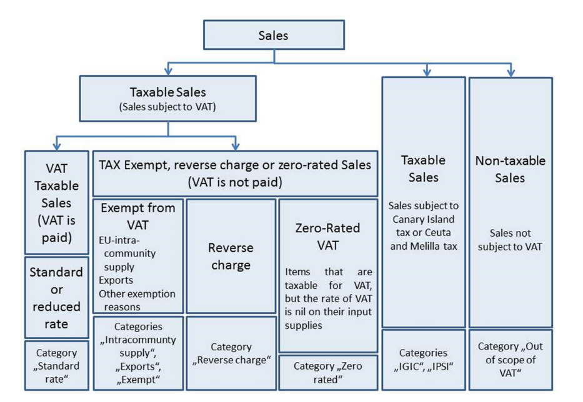

**Figure 17 — Summary of the VAT requirement model**

The required VAT information in an Invoice is dependent on the VAT case as detailed in 6.4.3.2 to

6.4.3.4.8. Below follows an explanation on how each VAT use case, illustrated in the diagram above, is

treated in the Core Semantic Model.

#### Specification of VAT category codes

[SOURCE: EN 16931-1 6.4.3.2]

In the **Table 42** below the meaning of each VAT category code (based on the UNTDID 5305 code list [6]) is explained.

[SOURCE: EN 16931-1 Table 5]

**Table 42 — VAT categories**

|  |  |
| --- | --- |
| Definition of category | Category |
| Standard VAT calculation |  |
| Item is liable for VAT that is calculated in a standard way of applying the VAT percentage to the relevant taxable amount. | Standard rate |
| Item is liable for VAT that is calculated in a standard way of applying the VAT percentage to the relevant taxable amount, but the VAT percentage rate is 0 (zero). | Zero rated |
| VAT is not levied due to trade circumstances |  |
| Item is exempt from VAT. | Exempt |
| The VAT tax is not levied to an item that is liable for VAT due to trade circumstances where the Reverse charge VAT rules apply. | Reverse charge |
| The VAT is not levied to an item that is liable for VAT due to trade circumstances where the rules on Intra-community supply apply. | Intra-community supply |
| The VAT is not levied to an item that is liable for VAT due to trade circumstances where the rules on export outside of the EU apply. | Export |
| Other VAT taxes apply |  |
| Sale is subject to Canary Island (IGIC) tax. | IGIC |
| Sale is subject to Ceuta and Melilla (IPSI) tax. | IPSI |
| Not subject to VAT |  |
| Sale is not subject to VAT. | Not subject to VAT |

### VAT is levied through the Invoice [SOURCE: EN 16931-1 6.4.3.3]

#### Standard rate and reduced rate items

[SOURCE: EN 16931-1 6.4.3.3.1]

For each sale, the VAT information shall be identified as follows:

— The VAT identifier of the Seller shall be stated in the Invoice;

— The VAT category code for the taxable amounts is given as Standard rate;

— The VAT category rate for the taxable amount is given as the relevant percentage rate;

— The VAT category taxable amount is the sum of Invoice line net amount minus the document level allowance amounts and plus the document level charge amounts;

— In the calculation of VAT the Invoice shall show a subtotal of the VAT taxable amount and the VAT tax amount for each VAT rate (i.e. each combination of the category code S and VAT tax rate on line level and for allowance and charges on document level).

#### Business rules statements

[SOURCE: EN 16931-1 6.4.3.3.2]

**Table 43 — Business rules - VAT standard and reduced rate**

|  |  |
| --- | --- |
| ID | Description |
| BR-S-1 | An Invoice that contains an Invoice line (BG-25), a Document level allowance (BG-20) or a Document level charge (BG-21) where the VAT category code (BT-151, BT-95 or BT-102) is “Standard rated” shall contain in the VAT breakdown (BG-23) at least one VAT category code (BT-118) equal with "Standard rated". |
| BR-S-2 | An Invoice that contains an Invoice line (BG-25) where the Invoiced item VAT category code (BT-151) is “Standard rated” shall contain the Seller VAT Identifier (BT-31), the Seller tax registration identifier (BT-32) and/or the Seller tax representative VAT identifier (BT-63). |
| BR-S-3 | An Invoice that contains a Document level allowance (BG-20) where the Document level allowance VAT category code (BT-95) is “Standard rated” shall contain the Seller VAT Identifier (BT-31), the Seller tax registration identifier (BT-32) and/or the Seller tax representative VAT identifier (BT-63). |
| BR-S-4 | An Invoice that contains a Document level charge (BG-21) where the Document level charge VAT category code (BT-102) is “Standard rated” shall contain the Seller VAT Identifier (BT-31), the Seller tax registration identifier (BT-32) and/or the Seller tax representative VAT identifier (BT-63). |
| BR-S-5 | In an Invoice line (BG-25) where the Invoiced item VAT category code (BT-151) is "Standard rated" the Invoiced item VAT rate (BT-152) shall be greater than zero. |
| BR-S-6 | In a Document level allowance (BG-20) where the Document level allowance VAT category code (BT-95) is "Standard rated" the Document level allowance VAT rate (BT-96) shall be greater than zero. |
| BR-S-7 | In a Document level charge (BG-21) where the Document level charge VAT category code (BT-102) is "Standard rated" the Document level charge VAT rate (BT-103) shall be greater than zero. |
| BR-S-8 | For each different value of VAT category rate (BT-119) where the VAT category code (BT-118) is "Standard rated", the VAT category taxable amount (BT-116) in a VAT breakdown (BG-23) shall equal the sum of Invoice line net amounts (BT-131) plus the sum of document level charge amounts (BT-99) minus the sum of document level allowance amounts (BT-92) where the VAT category code (BT-151, BT-102, BT-95) is “Standard rated” and the VAT rate (BT-152, BT-103, BT-96) equals the VAT category rate (BT-119). |
| BR-S-9 | The VAT category tax amount (BT-117) in a VAT breakdown (BG-23) where VAT category code (BT-118) is "Standard rated" shall equal the VAT category taxable amount (BT-116) multiplied by the VAT category rate (BT-119). |
| BR-S-10 | A VAT Breakdown (BG-23) with VAT Category code (BT-118) "Standard rate" shall not have a VAT exemption reason code (BT-121) or VAT exemption reason text (BT-120). |

[EIPA]

EN 16931-1 contains rules specified in the following clauses;

**6.4.3.4 VAT is not levied through the Invoice**

6.4.3.4.1 Zero rated sale

6.4.3.4.2 Business rules statements

BR-Z-1 ~ BR-Z-10

6.4.3.4.3 Exempted from VAT

BR-E-1 ~ BR-E-10

6.4.3.4.4 Reverse Charge

BR-AE-1 ~ BR-AE-10

6.4.3.4.5 Intra-Community Supply

BR-IC-1 ~ BR-IC-12

6.4.3.4.6 Exports

BR-G-1 ~ BR-G-10

6.4.3.4.7 Not subject to VAT

BR-O-1 ~ BR-O-14

6.4.3.4.8 Canary Islands, Ceuta and Melilla tax

BR-IG-1 ~ BR-IG-10

BR-IP-1 ~ BR-IP-10

## Model rule for PINT

[EIPA]

Some elements require cardinality alignment based on the value defined in **8.1.2**. PINT rule specified in **19.2.2** requires rules defined with Schematron.

Nobu: Peppol BIS Billing 3.0 defines Schematron Model rules but Japanese Peppol BIS Documentation has no Model rules. I think we need to define these rules at least for shared elements.

## Rules for BIS Billing 3.0

[SOURCE: Peppol BIS Billing 3.0]

The rules listed in the followingtable are from Poen Peppol BIS 3.0 Billing Rules are defined as specified in ISO/IEC 19757-3 :2020.

**Table 44** lists rules for BIS Billing 3.0.

**Table 44 — Rules for BIS Billing 3.0**

|  |  |  |
| --- | --- | --- |
| **ID** | **Rule** | **Severity** |
| DK-R-002 | Danish suppliers MUST provide legal entity (CVR-number) | fatal |
| DK-R-003 | If ItemClassification is provided from Danish suppliers, UNSPSC version 19.0501 should be used. | warning |
| DK-R-004 | When specifying non-VAT Taxes, Danish suppliers MUST use the AllowanceChargeReasonCode="ZZZ" and the 4-digit Tax category MUST be specified in 'AllowanceChargeReason' | fatal |
| DK-R-005 | For Danish suppliers the following Payment means codes are allowed: 1, 10, 31, 42, 48, 49, 50, 58, 59, 93 and 97 | fatal |
| DK-R-006 | For Danish suppliers bank account and registration account is mandatory if payment means is 31 or 42 | fatal |
| DK-R-007 | For Danish suppliers PaymentMandate/ID and PayerFinancialAccount/ID are mandatory when payment means is 49 | fatal |
| DK-R-008 | For Danish Suppliers PaymentID is mandatory and MUST start with 01#, 04# or 15# (kortartkode), and PayeeFinancialAccount/ID (Giro kontonummer) is mandatory and must be 7 characters long, when payment means equals 50 (Giro) | fatal |
| DK-R-009 | For Danish Suppliers if the PaymentID is prefixed with 04# or 15# the 16 digits instruction Id must be added to the PaymentID eg. "04#1234567890123456" when Payment means equals 50 (Giro) | fatal |
| DK-R-010 | For Danish Suppliers the PaymentID is mandatory and MUST start with 71#, 73# or 75# (kortartkode) and PayeeFinancialAccount/ID (Kreditornummer) is mandatory and must be exactly 8 characters long, when Payment means equals 93 (FIK) | fatal |
| DK-R-011 | For Danish Suppliers if the PaymentID is prefixed with 71# or 75# the 15-16 digits instruction Id must be added to the PaymentID eg. "71#1234567890123456" when payment Method equals 93 (FIK) | fatal |
| DK-R-013 | For Danish Suppliers it is mandatory to use schemeID when PartyIdentification/ID is used for AccountingCustomerParty or AccountingSupplierParty | fatal |
| DK-R-014 | For Danish Suppliers it is mandatory to specify schemeID as "0184" (DK CVR-number) when PartyLegalEntity/CompanyID is used for AccountingSupplierParty | fatal |
| DK-R-015 | For Danish Suppliers, if specified, AccountingSupplierParty/PartyTaxScheme/CompanyID (DK VAT number) must start with DK followed by 8 digits | fatal |
| DK-R-016 | For Danish Suppliers, a Credit note cannot have a negative total (PayableAmount) | fatal |
| GR-R-001-1 | When the Supplier is Greek, the Invoice Id should consist of 6 segments | fatal |
| GR-R-001-2 | When the Supplier is Greek, the Invoice Id first segment must be a valid TIN Number and match either the Supplier's or the Tax Representative's Tin Number | fatal |
| GR-R-001-3 | When the Supplier is Greek, the Invoice Id second segment must be a valid Date that matches the invoice Issue Date | fatal |
| GR-R-001-4 | When Supplier is Greek, the Invoice Id third segment must be a positive integer | fatal |
| GR-R-001-5 | When Supplier is Greek, the Invoice Id in the fourth segment must be a valid greek document type | fatal |
| GR-R-001-6 | When Supplier is Greek, the Invoice Id fifth segment must not be empty | fatal |
| GR-R-001-7 | When Supplier is Greek, the Invoice Id sixth segment must not be empty | fatal |
| GR-R-002 | Greek Suppliers must provide their full name as they are registered in the Greek Business Registry (G.E.MH.) as a legal entity or in the Tax Registry as a natural person | fatal |
| GR-R-003 | For the Greek Suppliers, the VAT must start with 'EL' and must be a valid TIN number | fatal |
| GR-R-004-1 | When Supplier is Greek, there must be one MARK Number | fatal |
| GR-R-004-2 | When Supplier is Greek, the MARK Number must be a positive integer | fatal |
| GR-R-005 | Greek Suppliers must provide the full name of the buyer | fatal |
| GR-R-006 | Greek Suppliers must provide the VAT number of the buyer, if the buyer is Greek | fatal |
| GR-R-007-1 | When greek supplier does not have a VAT number, the tax representative must be present | fatal |
| GR-R-007-2 | If the Greek Suppliers do not have Greek VAT they must provide the full name of their tax representative in Greece | fatal |
| GR-R-007-3 | If the Greek Suppliers do not have Greek VAT, they must provide the VAT number of their tax representative | fatal |
| GR-R-008-2 | When Supplier is Greek, there should be no more than one invoice url | fatal |
| GR-R-008-3 | When Supplier is Greek and the INVOICE URL Document reference exists, the External Reference URI should be present | fatal |
| GR-R-009 | Greek suppliers that send an invoice through the PEPPOL network must use a correct TIN number as an electronic address according to PEPPOL Electronic Address Identifier scheme (schemeID 9933). | fatal |
| GR-R-010 | Greek Suppliers that send an invoice through the PEPPOL network to a greek buyer must use a correct TIN number as an electronic address according to PEPPOL Electronic Address Identifier scheme (SchemeID 9933) | fatal |
| GR-S-008-1 | When Supplier is Greek, there should be one invoice url | warning |
| IS-R-001 | If seller is icelandic then invoice type should be 380 or 381 — Ef seljandi er íslenskur þá ætti gerð reiknings (BT-3) að vera sölureikningur (380) eða kreditreikningur (381). | warning |
| IS-R-002 | If seller is icelandic then it shall contain sellers legal id — Ef seljandi er íslenskur þá skal reikningur innihalda íslenska kennitölu seljanda (BT-30). | fatal |
| IS-R-003 | If seller is icelandic then it shall contain his address with street name and zip code — Ef seljandi er íslenskur þá skal heimilisfang seljanda innihalda götuheiti og póstnúmer (BT-35 og BT-38). | fatal |
| IS-R-004 | If seller and buyer are icelandic then the invoice shall contain the buyers icelandic legal identifier — Ef seljandi og kaupandi eru íslenskir þá skal reikningurinn innihalda íslenska kennitölu kaupanda (BT-47). | fatal |
| IS-R-005 | If seller and buyer are icelandic then the invoice shall contain the buyers address with street name and zip code — Ef seljandi og kaupandi eru íslenskir þá skal heimilisfang kaupanda innihalda götuheiti og póstnúmer (BT-50 og BT-53) | fatal |
| IS-R-006 | If seller is icelandic and payment means code is 9 then a 12 digit account id must exist — Ef seljandi er íslenskur og greiðslumáti (BT-81) er millifærsla (kóti 9) þá skal koma fram 12 stafa reikningnúmer (BT-84) | fatal |
| IS-R-007 | If seller is icelandic and payment means code is 42 then a 12 digit account id must exist — Ef seljandi er íslenskur og greiðslumáti (BT-81) er millifærsla (kóti 42) þá skal koma fram 12 stafa reikningnúmer (BT-84) | fatal |
| IS-R-008 | If seller is icelandic and invoice contains supporting description EINDAGI then the id form must be YYYY-MM-DD — Ef seljandi er íslenskur þá skal eindagi (BT-122, DocumentDescription = EINDAGI) vera á forminu YYYY-MM-DD. | fatal |
| IS-R-009 | If seller is icelandic and invoice contains supporting description EINDAGI invoice must have due date — Ef seljandi er íslenskur þá skal reikningur sem inniheldur eindaga (BT-122, DocumentDescription = EINDAGI) einnig hafa gjalddaga (BT-9). | fatal |
| IS-R-010 | If seller is icelandic and invoice contains supporting description EINDAGI the id date must be same or later than due date — Ef seljandi er íslenskur þá skal eindagi (BT-122, DocumentDescription = EINDAGI) skal vera sami eða síðar en gjalddagi (BT-9) ef eindagi er til staðar. | fatal |
| IT-R-001 | [IT-R-001] BT-32 (Seller tax registration identifier) - For Italian suppliers BT-32 minimum length 11 and maximum length shall be 16. Per i fornitori italiani il BT-32 deve avere una lunghezza tra 11 e 16 caratteri | fatal |
| TT-R-002 | [IT-R-002] BT-35 (Seller address line 1) - Italian suppliers MUST provide the postal address line 1 - I fornitori italiani devono indicare l'indirizzo postale. | fatal |
| TT-R-003 | [IT-R-003] BT-37 (Seller city) - Italian suppliers MUST provide the postal address city - I fornitori italiani devono indicare la città di residenza. | fatal |
| TT-R-004 | [IT-R-004] BT-38 (Seller post code) - Italian suppliers MUST provide the postal address post code - I fornitori italiani devono indicare il CAP di residenza. | fatal |
| NO-R-001 | For Norwegian suppliers, a VAT number MUST be the country code prefix NO followed by a valid Norwegian organization number (nine numbers) followed by the letters MVA. | fatal |
| NO-R-002 | For Norwegian suppliers, most invoice issuers are required to append "Foretaksregisteret" to their invoice. "Dersom selger er aksjeselskap, allmennaksjeselskap eller filial av utenlandsk selskap skal også ordet «Foretaksregisteret» fremgå av salgsdokumentet, jf. foretaksregisterloven § 10-2." | warning |
| PEPPOL-COMMON-R040 | GLN must have a valid format according to GS1 rules. | fatal |
| PEPPOL-COMMON-R041 | Norwegian organization number MUST be stated in the correct format. | fatal |
| PEPPOL-COMMON-R042 | Danish organization number (CVR) MUST be stated in the correct format. | fatal |
| PEPPOL-EN16931-CL001 | Mime code must be according to subset of IANA code list. | fatal |
| PEPPOL-EN16931-CL002 | Reason code MUST be according to subset of UNCL 5189 D.16B. | fatal |
| PEPPOL-EN16931-CL003 | Reason code MUST be according to UNCL 7161 D.16B. | fatal |
| PEPPOL-EN16931-CL006 | Invoice period description code must be according to UNCL 2005 D.16B. | fatal |
| PEPPOL-EN16931-CL007 | Currency code must be according to ISO 4217:2005 | fatal |
| PEPPOL-EN16931-CL008 | Electronic address identifier scheme must be from the codelist "Electronic Address Identifier Scheme" | fatal |
| PEPPOL-EN16931-F001 | A date MUST be formatted YYYY-MM-DD. | fatal |
| PEPPOL-EN16931-P0100 | Invoice type code MUST be set according to the profile. | fatal |
| PEPPOL-EN16931-P0101 | Credit note type code MUST be set according to the profile. | fatal |
| PEPPOL-EN16931-P0104 | Tax Category G MUST be used when exemption reason code is VATEX-EU-G | fatal |
| PEPPOL-EN16931-P0105 | Tax Category O MUST be used when exemption reason code is VATEX-EU-O | fatal |
| PEPPOL-EN16931-P0106 | Tax Category K MUST be used when exemption reason code is VATEX-EU-IC | fatal |
| PEPPOL-EN16931-P0107 | Tax Category AE MUST be used when exemption reason code is VATEX-EU-AE | fatal |
| PEPPOL-EN16931-P0108 | Tax Category E MUST be used when exemption reason code is VATEX-EU-D | fatal |
| PEPPOL-EN16931-P0109 | Tax Category E MUST be used when exemption reason code is VATEX-EU-F | fatal |
| PEPPOL-EN16931-P0110 | Tax Category E MUST be used when exemption reason code is VATEX-EU-I | fatal |
| PEPPOL-EN16931-P0111 | Tax Category E MUST be used when exemption reason code is VATEX-EU-J | fatal |
| PEPPOL-EN16931-R001 | Business process MUST be provided. | fatal |
| PEPPOL-EN16931-R002 | No more than one note is allowed on document level. | fatal |
| PEPPOL-EN16931-R003 | A buyer reference or purchase order reference MUST be provided. | fatal |
| PEPPOL-EN16931-R004 | Specification identifier MUST have the value 'urn:cen.eu:en16931:2017#compliant#urn:fdc:peppol.eu:2017:poacc:billing:3.0'. | fatal |
| PEPPOL-EN16931-R005 | VAT accounting currency code MUST be different from invoice currency code when provided. | fatal |
| PEPPOL-EN16931-R006 | Only one invoiced object is allowed on document level | fatal |
| PEPPOL-EN16931-R007 | Business process MUST be in the format 'urn:fdc:peppol.eu:2017:poacc:billing:NN:1.0' where NN indicates the process number. | fatal |
| PEPPOL-EN16931-R008 | Document MUST not contain empty elements. | fatal |
| PEPPOL-EN16931-R010 | Buyer electronic address MUST be provided | fatal |
| PEPPOL-EN16931-R020 | Seller electronic address MUST be provided | fatal |
| PEPPOL-EN16931-R040 | Allowance/charge amount must equal base amount * percentage/100 if base amount and percentage exists | fatal |
| PEPPOL-EN16931-R041 | Allowance/charge base amount MUST be provided when allowance/charge percentage is provided. | fatal |
| PEPPOL-EN16931-R042 | Allowance/charge percentage MUST be provided when allowance/charge base amount is provided. | fatal |
| PEPPOL-EN16931-R043 | Allowance/charge ChargeIndicator value MUST equal 'true' or 'false' | fatal |
| PEPPOL-EN16931-R044 | Charge on price level is NOT allowed. Only value 'false' allowed. | fatal |
| PEPPOL-EN16931-R046 | Item net price MUST equal (Gross price - Allowance amount) when gross price is provided. | fatal |
| PEPPOL-EN16931-R051 | All currencyID attributes must have the same value as the invoice currency code (BT-5), except for the invoice total VAT amount in accounting currency (BT-111). | fatal |
| PEPPOL-EN16931-R053 | Only one tax total with tax subtotals MUST be provided. | fatal |
| PEPPOL-EN16931-R054 | Only one tax total without tax subtotals MUST be provided when tax currency code is provided. | fatal |
| PEPPOL-EN16931-R055 | Invoice total VAT amount and Invoice total VAT amount in accounting currency MUST have the same operational sign | fatal |
| PEPPOL-EN16931-R061 | Mandate reference MUST be provided for direct debit. | fatal |
| PEPPOL-EN16931-R080 | Only one project reference is allowed on document level | fatal |
| PEPPOL-EN16931-R100 | Only one invoiced object is allowed pr line | fatal |
| PEPPOL-EN16931-R101 | Element Document reference can only be used for Invoice line object | fatal |
| PEPPOL-EN16931-R110 | Start date of line period MUST be within invoice period. | fatal |
| PEPPOL-EN16931-R111 | End date of line period MUST be within invoice period. | fatal |
| PEPPOL-EN16931-R120 | Invoice line net amount MUST equal (Invoiced quantity * (Item net price/item price base quantity) + Sum of invoice line charge amount - sum of invoice line allowance amount | fatal |
| PEPPOL-EN16931-R121 | Base quantity MUST be a positive number above zero. | fatal |
| PEPPOL-EN16931-R130 | Unit code of price base quantity MUST be same as invoiced quantity. | fatal |
| SE-R-001 | For Swedish suppliers, Swedish VAT-numbers must consist of 14 characters. | fatal |
| SE-R-002 | For Swedish suppliers, the Swedish VAT-numbers must have the trailing 12 characters in numeric form | fatal |
| SE-R-003 | Swedish organisation numbers should be numeric. | warning |
| SE-R-004 | Swedish organisation numbers consist of 10 characters. | warning |
| SE-R-005 | For Swedish suppliers, when using Seller tax registration identifier, 'Godkänd för F-skatt' must be stated | fatal |
| SE-R-006 | For Swedish suppliers, only standard VAT rate of 6, 12 or 25 are used | fatal |
| SE-R-007 | For Swedish suppliers using Plusgiro, the Account ID must be numeric | warning |
| SE-R-008 | For Swedish suppliers using Bankgiro, the Account ID must be numeric | warning |
| SE-R-009 | For Swedish suppliers using Bankgiro, the Account ID must have 7-8 characters | warning |
| SE-R-010 | For Swedish suppliers using Plusgiro, the Account ID must have 2-8 characters | warning |
| SE-R-011 | For Swedish suppliers using Swedish Bankgiro or Plusgiro, the proper way to indicate this is to use Code 30 for PaymentMeans and FinancialInstitutionBranch ID with code SE:BANKGIRO or SE:PLUSGIRO | warning |
| SE-R-012 | For domestic transactions between Swedish trading partners, credit transfer should be indicated by PaymentMeansCode="30" | warning |

## Shared rule for PINT

[SOURCE: Japanese Peppol BIS Documentation]

The rules listed in **Table 45** apply to the shared content of the PINT and must be supported by all compliant invoice instances. Rules are defined as specified in ISO/IEC 19757-3 :2020.

**Table 45 — Rules for Peppol PINT (Shared)**

|  |  |  |
| --- | --- | --- |
| **ID** | **Rule** | **Severity** |
| ibr-01 | An Invoice shall have a Specification identifier (ibt-024). | fatal |
| ibr-02 | An Invoice shall have an Invoice number (ibt-001). | fatal |
| ibr-03 | An Invoice shall have an Invoice issue date (ibt-002). | fatal |
| ibr-04 | An Invoice shall have an Invoice type code (ibt-003). | fatal |
| ibr-05 | An Invoice shall have an Invoice currency code (ibt-005). | fatal |
| ibr-06 | An Invoice shall contain the Seller name (ibt-027). | fatal |
| ibr-07 | An Invoice shall contain the Buyer name (ibt-044). | fatal |
| ibr-08 | An Invoice shall contain the Seller postal address (ibg-05). | fatal |
| ibr-09 | The Seller postal address (ibg-05) shall contain a Seller country code (ibt-040). | fatal |
| ibr-10 | An Invoice shall contain the Buyer postal address (ibg-08). | fatal |
| ibr-11 | The Buyer postal address (ibg-089 shall contain a Buyer country code (ibt-055). | fatal |
| ibr-12 | An Invoice shall have the Sum of Invoice line net amount (ibt-106). | fatal |
| ibr-13 | An Invoice shall have the Invoice total amount without Tax (ibt-109). | fatal |
| ibr-14 | An Invoice shall have the Invoice total amount with Tax (ibt-112). | fatal |
| ibr-15 | An Invoice shall have the Amount due for payment (ibt-115). | fatal |
| ibr-16 | An Invoice shall have at least one Invoice line (ibg-25) | fatal |
| ibr-17 | The Payee name (ibt-059) shall be provided in the Invoice, if the Payee (ibg-10) is different from the Seller (ibg-04). | fatal |
| ibr-18 | The Seller tax representative name (ibt-062) shall be provided in the Invoice, if the Seller (ibg-04) has a Seller tax representative party (ibg-11) | fatal |
| ibr-19 | The Seller tax representative postal address (ibg-12) shall be provided in the Invoice, if the Seller (ibg-04) has a Seller tax representative party (ibg-11). | fatal |
| ibr-20 | The Seller tax representative postal address (ibg-12) shall contain a Tax representative country code (ibt-069), if the Seller (ibg-04) has a Seller tax representative party (ibg-11). | fatal |
| ibr-21 | Each Invoice line (ibg-25) shall have an Invoice line identifier (ibt-126). | fatal |
| ibr-22 | Each Invoice line (ibg-25) shall have an Invoiced quantity (ibt-129). | fatal |
| ibr-23 | An Invoice line (ibg-25) shall have an Invoiced quantity unit of measure code (ibt-130). | fatal |
| ibr-24 | Each Invoice line (ibg-25) shall have an Invoice line net amount (ibt-131). | fatal |
| ibr-25 | Each Invoice line (ibg-25) shall contain the Item name (ibt-153). | fatal |
| ibr-26 | Each Invoice line (ibg-25) shall contain the Item net price (ibt-146). | fatal |
| ibr-27 | The Item net price (ibt-146) shall NOT be negative. | fatal |
| ibr-28 | The Item gross price (ibt-148) shall NOT be negative. | fatal |
| ibr-29 | If both Invoicing period start date (ibt-073) and Invoicing period end date (ibt-074) are given then the Invoicing period end date (ibt-074) shall be later or equal to the Invoicing period start date (ibt-073). | fatal |
| ibr-30 | If both Invoice line period start date (ibt-134) and Invoice line period end date (ibt-135) are given then the Invoice line period end date (ibt-135) shall be later or equal to the Invoice line period start date (ibt-134). | fatal |
| ibr-31 | Each Document level allowance (ibg-20) shall have a Document level allowance amount (ibt-092). | fatal |
| ibr-33 | Each Document level allowance (ibg-20) shall have a Document level allowance reason (ibt-907) or a Document level allowance reason code (ibt-098). | fatal |
| ibr-36 | Each Document level charge (ibg-21) shall have a Document level charge amount (ibt-099). | fatal |
| ibr-38 | Each Document level charge (ibg-21) shall have a Document level charge reason (ibt-104) or a Document level charge reason code (ibt-105). | fatal |
| ibr-41 | Each Invoice line allowance (ibg-27) shall have an Invoice line allowance amount (ibt-136). | fatal |
| ibr-42 | Each Invoice line allowance (ibg-27) shall have an Invoice line allowance reason (ibt-139) or an Invoice line allowance reason code (ibt-140). | fatal |
| ibr-43 | Each Invoice line charge (ibg-28) shall have an Invoice line charge amount (ibt-141). | fatal |
| ibr-44 | Each Invoice line charge (ibg-28) shall have an Invoice line charge reason (ibt-144) or an invoice line allowance reason code (ibt-145). | fatal |
| ibr-49 | A Payment instruction (ibg-16) shall specify the Payment means type code (ibt-081). | fatal |
| ibr-52 | Each Additional supporting document (ibg-24) shall contain a Supporting document reference (ibt-122). | fatal |
| ibr-53 | If the Tax accounting currency code (ibt-006) is present, then the Invoice total Tax amount in accounting currency (ibt-111) shall be provided. | fatal |
| ibr-54 | Each Item attribute (ibg-32) shall contain an Item attribute name (ibt-160) and an Item attribute value (ibt-161). | fatal |
| ibr-55 | Each Preceding Invoice reference (ibg-03) shall contain a Preceding Invoice reference (ibt-025). | fatal |
| ibr-56 | Each Seller tax representative party (ibg-11) shall have a Seller tax representative Tax identifier (ibt-063). | fatal |
| ibr-57 | Each Deliver to address (ibg-15) shall contain a Deliver to country code (ibt-080). | fatal |
| ibr-62 | The Seller electronic address (ibt-034) shall have a Scheme identifier. | fatal |
| ibr-63 | The Buyer electronic address (ibt-049) shall have a Scheme identifier. | fatal |
| ibr-64 | The Item standard identifier (ibt-157) shall have a Scheme identifier. | fatal |
| ibr-65 | The Item classification identifier (ibt-158) shall have a Scheme identifier. | fatal |
| ibr-67 | Invoice amount due for payment (ibt-115) shall have no more than 2 decimals. | fatal |
| ibr-cl-01 | The document type code MUST be coded by the invoice and credit note related code lists of UNTDID 1001. | fatal |
| ibr-cl-03 | currencyID MUST be coded using ISO code list 4217 alpha-3. | fatal |
| ibr-cl-04 | Invoice currency code MUST be coded using ISO code list 4217 alpha-3 | fatal |
| ibr-cl-05 | Tax currency code MUST be coded using ISO code list 4217 alpha-3 | fatal |
| ibr-cl-07 | Object identifier identification scheme MUST be coded using a restriction of UNTDID 1153. | fatal |
| ibr-cl-10 | Any identifier identification scheme MUST be coded using one of the ISO 6523 ICD list. | fatal |
| ibr-cl-11 | Any registration identifier identification scheme MUST be coded using one of the ISO 6523 ICD list. | fatal |
| ibr-cl-13 | Item classification identifier identification scheme MUST be coded using one of the UNTDID 7143 list. | fatal |
| ibr-cl-14 | Country codes in an invoice MUST be coded using ISO code list 3166-1 | fatal |
| ibr-cl-15 | Origin country codes in an invoice MUST be coded using ISO code list 3166-1 | fatal |
| ibr-cl-16 | Payment means in an invoice MUST be coded using UNCL4461 code list (adding Z01 and Z02) | fatal |
| ibr-cl-19 | Coded allowance reasons MUST belong to the UNCL 5189 code list | fatal |
| ibr-cl-20 | Coded charge reasons MUST belong to the UNCL 7161 code list | fatal |
| ibr-cl-21 | Item standard identifier scheme identifier MUST belong to the ISO 6523 ICD list. | fatal |
| ibr-cl-23 | Unit code MUST be coded according to the UN/ECE Recommendation 20 with Rec 21 extension | fatal |
| ibr-cl-24 | Mime code must be according to subset of IANA code list. | fatal |
| ibr-cl-25 | Endpoint identifier scheme identifier MUST belong to the CEF EAS code list. | fatal |
| ibr-cl-26 | Delivery location identifier scheme identifier MUST belong to the ISO 6523 ICD code list. | fatal |
| ibr-co-05 | Document level allowance reason code (ibt-098) and Document level allowance reason (ibt-097) shall indicate the same type of allowance. | fatal |
| ibr-co-06 | Document level charge reason code (ibt-105) and Document level charge reason (ibt-104) shall indicate the same type of charge. | fatal |
| ibr-co-07 | When both Invoice line allowance reason code (iibt-140) and Invoice line allowance reason (iibt-139) the definition of the code is normative. | fatal |
| ibr-co-08 | When both Invoice line charge reason code (iibt-145) and Invoice line charge reason (iibt-144) the definition of the code is normative. | fatal |
| ibr-co-10 | Sum of Invoice line net amount (ibt-106) = Σ Invoice line net amount (ibt-131). | fatal |
| ibr-co-11 | Sum of allowances on document level (ibt-107) = Σ Document level allowance amount (ibt-092). | fatal |
| ibr-co-12 | Sum of charges on document level (ibt-108) = Σ Document level charge amount (ibt-099). | fatal |
| ibr-co-13 | Invoice total amount without Tax (ibt-109) = Σ Invoice line net amount (ibt-131) - Sum of allowances on document level (ibt-107) + Sum of charges on document level (ibt-108). | fatal |
| ibr-co-14 | Invoice total Tax amount (ibt-110) = Σ Tax category tax amount (ibt-117). | fatal |
| ibr-co-15 | Invoice total amount with Tax (ibt-112) = Invoice total amount without Tax (ibt-109) + Invoice total Tax amount (ibt-110). | fatal |
| ibr-co-16 | Amount due for payment (ibt-115) = Invoice total amount with Tax (ibt-112) - Paid amount (ibt-113) + Rounding amount (ibt-114). | fatal |
| ibr-co-19 | If Invoicing period (ibg-14) is used, the Invoicing period start date (ibt-073) or the Invoicing period end date (ibt-074) shall be filled, or both. | fatal |
| ibr-co-20 | If Invoice line period (ibg-26) is used, the Invoice line period start date (ibt-134) or the Invoice line period end date (ibt-135) shall be filled, or both. | fatal |
| ibr-co-21 | Each Document level allowance (ibg-20) shall contain a Document level allowance reason (ibt-097) or a Document level allowance reason code (ibt-098), or both | fatal |
| ibr-co-22 | Each Document level charge (ibg-21) shall contain a Document level charge reason (ibt-104) or a Document level charge reason code (ibt-105), or both. | fatal |
| ibr-co-24 | Each Invoice line charge (ibg-28) shall contain an Invoice line charge reason (ibt-144) or an Invoice line charge reason code (ibt-145), or both. | fatal |
| ibr-co-25 | In case the Amount due for payment (ibt-115) is positive, either the Payment due date (ibt-009) or the Payment terms (ibt-020) shall be present. | fatal |
| ibr-co-26 | In order for the buyer to automatically identify a supplier, the Seller identifier (ibt-029), the Seller legal registration identifier (ibt-030) and/or the Seller Tax identifier (ibt-031) shall be present. | fatal |

## Rules for Japanese Standard Commercial Invoice (Aligned)

[SOURCE: Japanese Peppol BIS Documentation]

The rules listed in **Table 46** apply to the aligned content for Japanese Standard Commercial invoice.

**Table 46 — Rules for Japanese Standard Commercial Invoice (Aligned)**

|  |  |  |
| --- | --- | --- |
| **ID** | **Rule** | **Severity** |
| jp-br-01 | For the Japanese Suppliers, the Tax identifier must start with 'T' and must be 13 digits. | fatal |
| jp-br-02 | Amount shall be integer. | fatal |
| jp-br-co-01 | Consumption Tax category tax amount (ibt-117) = Consumption Tax category taxable amount (ibt-116) x (Consumption Tax category rate (ibt-119) / 100), rounded to integer. The rounded result amount SHALL be between the floor and the ceiling. | fatal |
| jp-cl-01 | The document type code MUST be coded by the Japanese invoice and Japanese credit note related code lists of UNTDID 1001. | fatal |
| jp-cl-02 | Payment means in a Japanese invoice MUST be coded using a restricted version of the UNCL4461 code list (adding Z01 and Z02) | fatal |
| jp-cl-03 | Japanese invoice tax categories MUST be coded using UNCL5305 code list | fatal |
| jp-cl-04 | Tax exemption reason code identifier scheme identifier MUST belong to the ???? | fatal |
| jp-s-01 | An Invoice that contains an Invoice line (ibg-25), a Document level allowance (ibg-20) or a Document level charge (ibg-21) where the Consumption Tax category code (ibt-151, ibt-95 or ibt-102) is "Standard rated" shall contain in the Consumption Tax breakdown (ibg-23) at least one Consumption Tax category code (ibt-118) equal with "Standard rated". | fatal |
| jp-s-02 | An Invoice that contains an Invoice line (ibg-25) where the Invoiced item Consumption Tax category code (ibt-151) is "Standard rated" shall contain the Seller Consumption Tax Identifier (ibt-31), the Seller tax registration identifier (ibt-32) and/or the Seller tax representative Consumption Tax identifier (ibt-63). | fatal |
| jp-s-03 | An Invoice that contains a Document level allowance (ibg-20) where the Document level allowance Consumption Tax category code (ibt-95) is "Standard rated" shall contain the Seller Consumption Tax Identifier (ibt-31), the Seller tax registration identifier (ibt-32) and/or the Seller tax representative Consumption Tax identifier (ibt-63). | fatal |
| jp-s-04 | An Invoice that contains a Document level charge (ibg-21) where the Document level charge Consumption Tax category code (ibt-102) is "Standard rated" shall contain the Seller Consumption Tax Identifier (ibt-31), the Seller tax registration identifier (ibt-32) and/or the Seller tax representative Consumption Tax identifier (ibt-63). | fatal |
| jp-s-05 | In an Invoice line (ibg-25) where the Invoiced item Consumption Tax category code (ibt-151) is "Standard rated" the Invoiced item Consumption Tax rate (ibt-152) shall be greater than zero. | fatal |
| jp-s-06 | In a Document level allowance (ibg-20) where the Document level allowance Consumption Tax category code (ibt-95) is "Standard rated" the Document level allowance Consumption Tax rate (ibt-96) shall be greater than zero. | fatal |
| jp-s-07 | In a Document level charge (ibg-21) where the Document level charge Consumption Tax category code (ibt-102) is "Standard rated" the Document level charge Consumption Tax rate (ibt-103) shall be greater than zero. | fatal |
| jp-s-08 | For each different value of Consumption Tax category rate (ibt-119) where the Consumption Tax category code (ibt-118) is "Standard rated", the Consumption Tax category taxable amount (ibt-116) in a Consumption Tax breakdown (ibg-23) shall equal the sum of Invoice line net amounts (ibt-131) plus the sum of document level charge amounts (ibt-99) minus the sum of document level allowance amounts (ibt-92) where the Consumption Tax category code (ibt-151, ibt-102, ibt-95) is "Standard rated" and the Consumption Tax rate (ibt-152, ibt-103, ibt-96) equals the Consumption Tax category rate (ibt-119). | fatal |
| jp-s-09 | The Consumption Tax category tax amount (ibt-117) in a Consumption Tax breakdown (ibg-23) where Consumption Tax category code (ibt-118) is "Standard rated" shall equal the Consumption Tax category taxable amount (ibt-116) multiplied by the Consumption Tax category rate (ibt-119). | fatal |
| jp-s-10 | A Consumption Tax breakdown (ibg-23) with Consumption Tax Category code (ibt-118) "Standard rate" shall not have a Consumption Tax exemption reason code (ibt-121) or Consumption Tax exemption reason text (ibt-120). | fatal |

## Rules requested by Japanese Digital Agency on September 21st

The rules listed in **Table 47** are required and apply to the aligned content for the Japanese Standard Commercial invoice.

**Table 47 — Additional shared rule for PINT**

|  |  |  |  |
| --- | --- | --- | --- |
| **ID** | **Rule** | **Validation in BIS 3.0** | **Severity** |
|  | Each Document level allowance (ibg-20) shall be defined through a Document level allowance Tax Category code (ibt-095). | ibt-095 has a cardinality of 1..1. This means that an element is mandatory.  XML schema validation checks this rule.  We do not need to add a rule by Schematron. |  |
|  | Each Document level allowance (ibg-20) shall have a Document level allowance Tax Rate (ibt-096). | **ibt-095 has a cardinality of 0..1. This means that an element is optional.**  **We need to add a rule by Schematron.** | fatal |
|  | Each Document level charge (ibg-21) shall be defined through a Document level charge Tax Category code (ibt-102). | ibt-102 has a cardinality of 1..1. This means that an element is mandatory.  XML schema validation checks this rule.  We do not need to add a rule by Schematron. |  |
|  | Each Document level charge (ibg-21) shall have a Document level charge Tax Rate (ibt-103). | **ibt-103 has a cardinality of 0..1. This means that an element is optional .**  **We need to add a rule by Schematron.** | fatal |
|  | An Invoice line (ibg-25) shall be categorized with an Invoiced Item Tax Category code (ibt-151). | ibg-25 has an element Line tax information (ibg-30) with cardinality 1..1, meaning this element is mandatory. ibg-30 has an invoiced item tax category code (ibt-151) with cardinality 1..1 meaning this element is mandatory.  XML schema validation checks this rule.  We do not need to add a rule by Schematron. |  |
|  | An Invoice line (ibg-25) shall have an Invoiced Item Tax Rate (ibt-152). | **ibt-152 has a cardinality of 0..1. This means that an element is optional.**  **We need to add a rule by Schematron.** | fatal |
|  | An Invoice line Allowances (ibg-27) shall be categorized by an Invoiced Item Tax Category code(ibt-151), if an Invoice line allowance amount(ibt-136) is presented(ibt-136). | ibg-27 is a child element of an invoice line (ibg-025) and ibg-025 has a mandatory child element Line tax information (ibg-30) and ibg-30 has a mandatory child element invoiced item tax category code (ibt-151).  XML schema validation checks this rule.  We do not need to add a rule by Schematron. |  |
|  | An Invoice line Charges (ibg-28) shall be categorized with an Invoiced Item Tax Category code(ibt-151), if an Invoice line charge amount(ibt-141) is presented. | ditto  We do not need to add a rule by Schematron. |  |
|  | An Invoice line Allowances (ibg-27) shall have an Invoiced Item Tax Rate (ibt-152). | **ibg-25 has an element Line tax information (ibg-30) with cardinality 1..1, meaning this element is mandatory. ibg-30 has an invoiced item tax rate (ibt-152) with cardinality 0..1 meaning this element is optional.**  **We need to add a rule by Schematron.** | fatal |
|  | An Invoice line Charge (ibg-28) shall have an Invoiced Item Tax Rate (ibt-152). | **ditto**  **We need to add a rule by Schematron.** | fatal |
|  | Each Tax Breakdown (ibg-23) shall be defined through a Tax Category code (ibt-118). | ibt-118 has a cardinality of 1..1. This means that an element is mandatory.  XML schema validation checks this rule.  We do not need to add a rule by Schematron. |  |
|  | Each Tax Breakdown (ibg-23) shall have a Tax Scheme (ibt118-1). | **ibt-118-1 has a cardinality of 0..1. This means that an element is optional.**  **We need to add a rule by Schematron.** | fatal |
|  | Each Tax Breakdown (igb-23) shall have a Tax Category Taxable amount (ibt-116). | ibt-116 has a cardinality of 1..1. This means that an element is mandatory.  XML schema validation checks this rule.  We do not need to add a rule by Schematron. |  |
|  | Each Tax Breakdown (ibg-23) shall have a Tax Category rate (ibt-119). | **ibt-119 has a cardinality of 0..1. This means that an element is optional.**  **We need to add a rule by Schematron.** | fatal |

The rules listed in **Table 48** are required and apply to the aligned content for Japanese Standard Commercial invoice.

**Table 48 — Additional rules for Japanese Standard Commercial Invoice (Aligned)**

|  |  |  |  |
| --- | --- | --- | --- |
| **ID** | **Rule** |  | **Severity** |
|  | For the Japanese suppliers, Tax accounting currency (ibt-006) must be coded using JPY in ISO code list 4327-alpha-3. | **We need to add a rule by Schematron** | fatal |
|  | For the Japanese suppliers, Tax Scheme(ibt-118-1) shall be used VAT in the UNECE5153 code list. The VAT shall mean Consumption Tax in Japan. | **We need to add a rule by Schematron** | fatal |
| Tax Scheme(ibt-118-1) shall be used by JCT (Japanese Consumption Tax) in the PINT code list. | **We need to add a rule by Schematron** |
|  | For the Japanese suppliers , Tax Category code (ibt-118) shall be coded based on UN/CEFACT 5305 and shall be used in the following codes.  S: Standard Rate for Consumption Tax  AA: Reduced Rate for Consumption Tax  E: Exemption (Exempt from Consumption Tax)  G: Export (Free from Consumption Tax)  O: Out of scope of Consumption Tax | **We need to add a rule by Schematron** | fatal |
|  | For the Japanese suppliers , Tax Category Rate (ibt-119)　shall be used the followings.  S: 10%  AA: 8% | **We need to add a rule by Schematron.** | fatal |
|  | For the Japanese suppliers , an Invoice shall contain a Seller Tax identifier(ibt-031). | Although following rule exists, we need to add a rule by Schematron.[ibr-co-26](https://www.wuwei.space/jp_pint/billing-japan/rules/ubl-pint/ibr-co-26/en/) (fatal) **In order for the buyer to automatically identify a supplier, the Seller identifier (ibt-029), the Seller legal registration identifier (ibt-030) and/or the Seller Tax identifier (ibt-031) shall be present.** | fatal |
|  | For the Japanese suppliers , a Seller Tax identifier(ibt-031) must be a registration number for Consumption Tax purposes and consists of fourteen letters starting with “T”followed by a 13-digit number.. | **It is necessary to clarify the rule defined as jp-br-01.** | fatal |
|  | An Invoice shall contain an Invoice Period(ibg-14). | **ibg-14 has cardinality 0..1 and is a child element of Delivery information (ibg-13) which is also an optional element.**  **We need to add a rule by Schematron.** | fatal |
|  | The date shall be formatted YYYY-MM-DD. | **XML schema validation checks datatype Date allows time zone such as 2002-09-24+09:00.**  **PEPPOL-EN16931-P0100(fatal) checks this rule. in BIS Billing 3.0.**  **A date MUST be formatted YYYY-MM-DD.**  **Needs definition in**  **PEPPOL-EN16931-UBL.sch** | fatal |
|  | An Invoice Period(ibg-14)shall have both an Invoice period start date(ibt-073)and an Invoice period end date(ibt-074). | **We need to add a rule by Schematron.** | fatal |
|  | if an Invoice line Period(ibg-26) is present, an Invoice Period(ibg-14)shall not be provided. | **We need to add a rule by Schematron.** | fatal |
|  | An Invoice line Period(ibg-26)shall have both an Invoice line Period start date(ibt-134)and an Invoice line Period end date (ibt-135). | **We need to add a rule by Schematron.** | fatal |
|  | An Item net price(ibt-146) = an Item gross price (ibt-148) – an Item price discount(ibt-147). | **Following rule by BIS Billing 3.0 is needed.**  **PEPPOL-EN16931-R046 Item net price MUST equal (Gross price - DISCOUNT amount) when gross price is provided.** | fatal |
|  | an Invoice line net amount(ibt-131) = an Item net price (ibt-146) x an Invoiced quantity (ibt-129) ÷ an Item price base quantity (ibt-149) + an Invoice line charge amount (ibt-141). | **Following rule by BIS Billing 3.0 is needed.**  **PEPPOL-EN16931-R120 Invoice line net amount MUST equal (Invoiced quantity * (Item net price/item price base quantity) + Sum of invoice line charge amount - sum of invoice line allowance amount** | fatal |
|  | a Tax Category Taxable amount (ibt-116) = an Invoice line net amount (ibt-131) – a Document level Allowance amount (ibt-092) + a Document level Charge amount (ibt-099). | **Consider adding rule for AA or make following rule more general.**  BR-S-08 For each different value of VAT category rate (BT-119) where the VAT category code (BT-118) is "Standard rated", the VAT category taxable amount (BT-116) in a VAT breakdown (BG-23) shall equal the sum of Invoice line net amounts (BT-131) plus the sum of document level charge amounts (BT-99) minus the sum of document level allowance amounts (BT-92) where the VAT category code (BT-151, BT-102, BT-95) is "Standard rated" and the VAT rate (BT-152, BT-103, BT-96) equals the VAT category rate (BT-119).  BR-Z-08 In a VAT breakdown (BG-23) where VAT category code (BT-118) is "Zero rated" the VAT category taxable amount (BT-116) shall equal the sum of Invoice line net amount (BT-131) minus the sum of Document level allowance amounts (BT-92) plus the sum of Document level charge amounts (BT-99) where the VAT category codes (BT-151, BT-95, BT-102) are "Zero rated".  BR-AE-08 In a VAT breakdown (BG-23) where the VAT category code (BT-118) is "Reverse charge" the VAT category taxable amount (BT-116) shall equal the sum of Invoice line net amounts (BT-131) minus the sum of Document level allowance amounts (BT-92) plus the sum of Document level charge amounts (BT-99) where the VAT category codes (BT-151, BT-95, BT-102) are "Reverse charge". | fatal |
|  | a Tax Category Tax amount (ibt-117) = a Tax Category Taxable amount (ibt-116) ｘ a Tax Category Rate (ibt-119) ÷ 100. | EN 16931 transaction business rule defines this rule.  BR-CO-17  VAT category tax amount (BT-117) = VAT category taxable amount (BT-116) x (VAT category rate (BT-119) / 100), rounded to two decimals.  **Clarify requirement**  **jp-br-co-01 Consumption Tax category tax amount (ibt-117) = Consumption Tax category taxable amount (ibt-116) x (Consumption Tax category rate (ibt-119) / 100), rounded to integer. The rounded result amount SHALL be between the floor and the ceiling.** | fatal |
| a Tax Category Tax amount (ibt-117) shall be between the amount rounded down to integer values as floor and the amount rounded up to integer value as ceiling. | fatal |

## Basic idea of our proposal on October 5th

[SOURCE: October 5, 2021 Japan Peppol Project Team (Digital Agency and EIPA)]

《 Key Points 》

○ A basic idea of our proposal is to comply with a Qualified Invoice in Japan and Japanese Consumption Tax

law.

○ To comply with those,

・ Tax amount on a Qualified Invoice should be shown in JPY

・ Taxable amount and Tax amount should be shown per tax rate

○ Under the Qualified Invoice Based method, there are some kinds of a Qualified Invoice to be supported.

・ a Qualified Invoice

・ a Qualified Invoice issued to correct an error or a mistake on the preceding Qualified Invoice

・ a Qualified Invoice for return

　・ a Self Billing

○ In addition to the above, in the next stage, Document in the current system, issued by an exempt business

or a taxable business without the Registration number for Qualified Invoice purpose, and a Self Billing should

be supported.

## Our proposals

[SOURCE: October 5, 2021 Japan Peppol Project Team (Digital Agency and EIPA)]

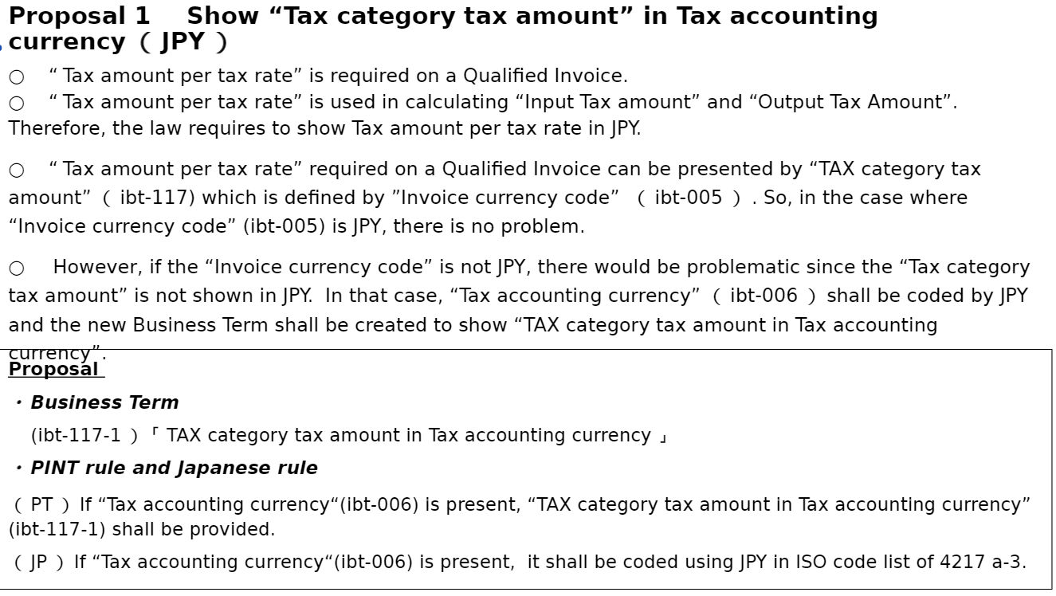

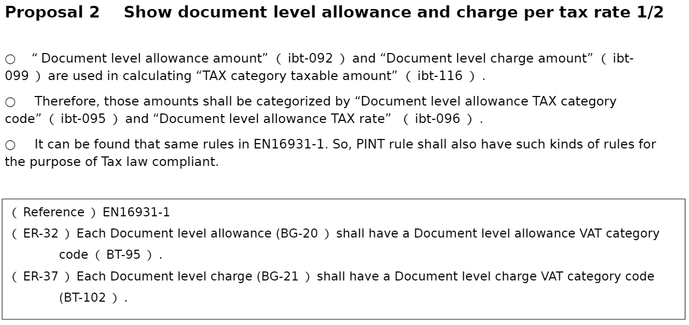

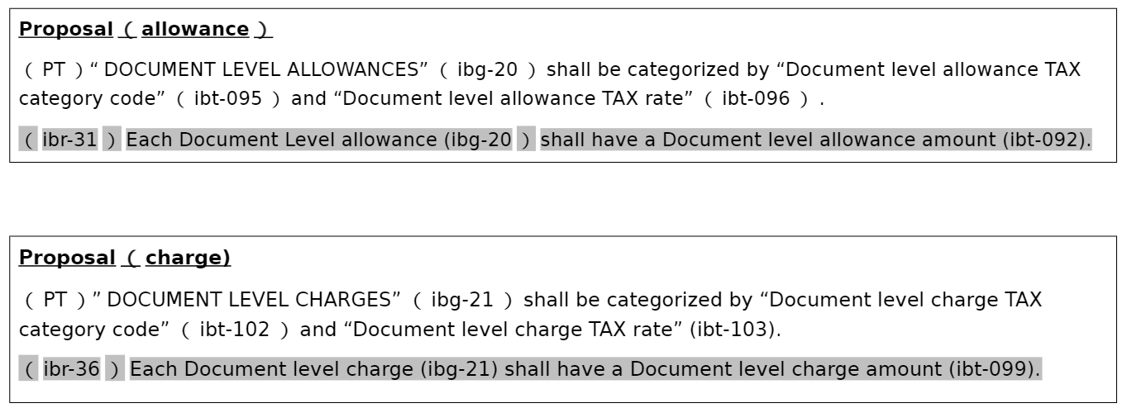

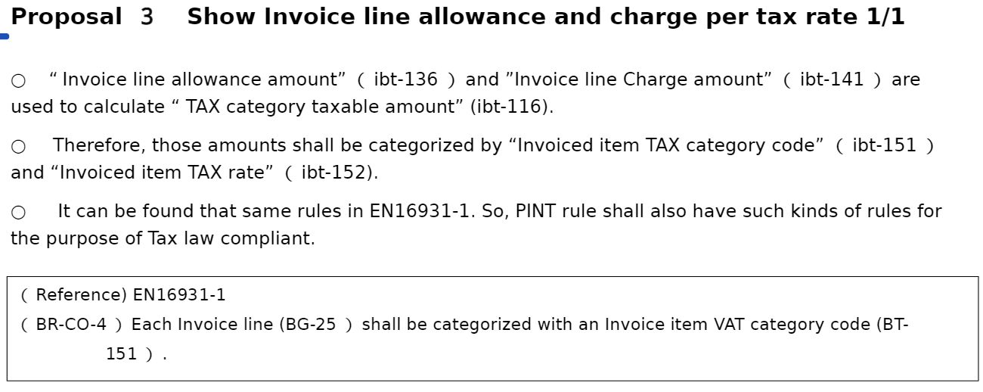

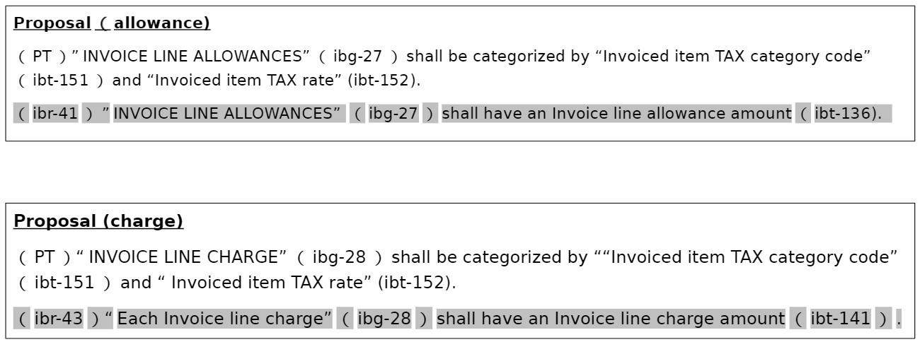

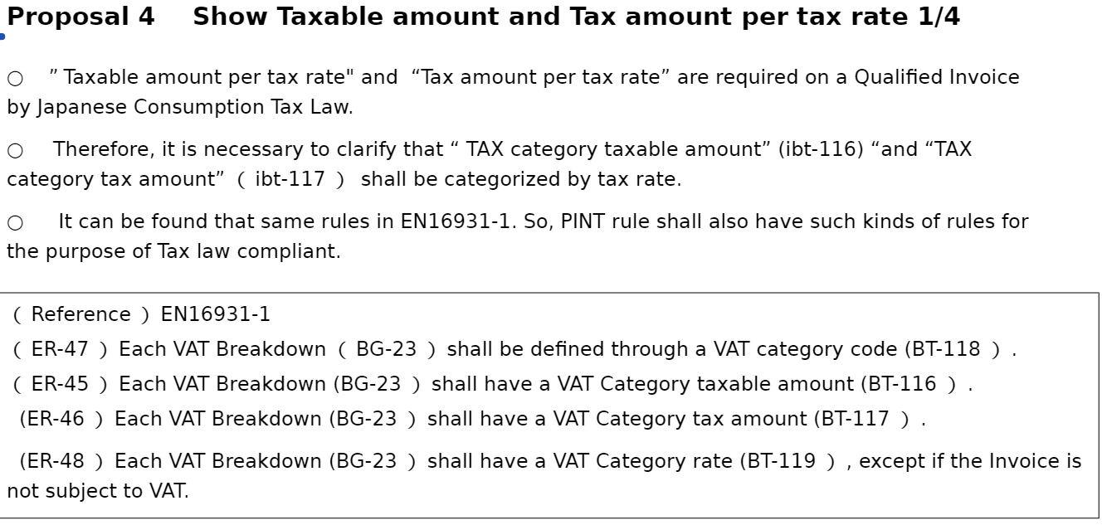

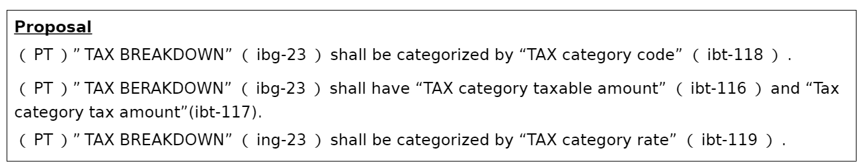

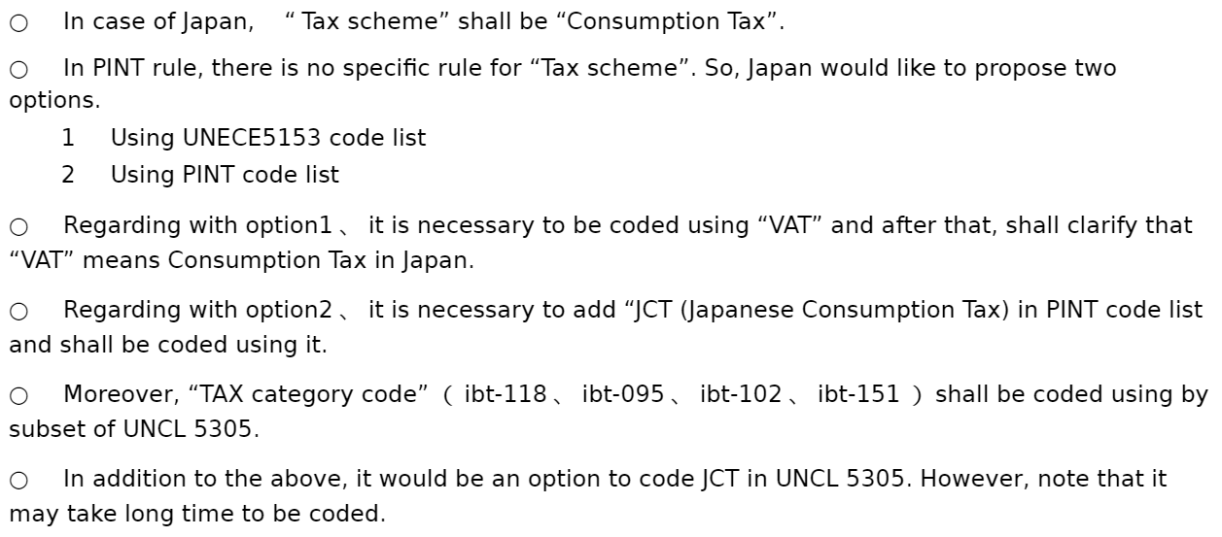

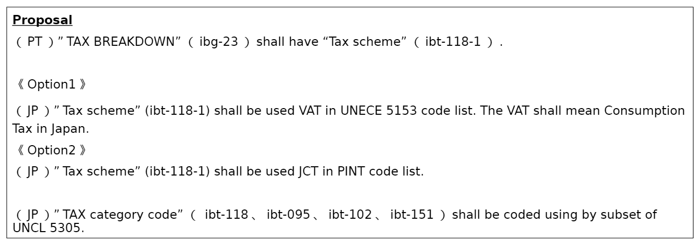

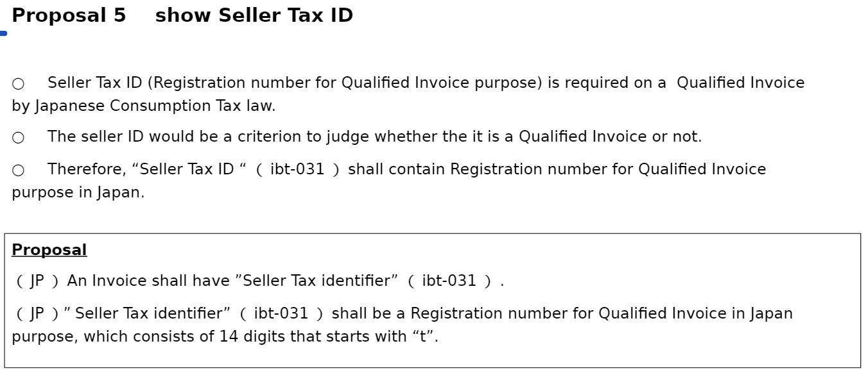

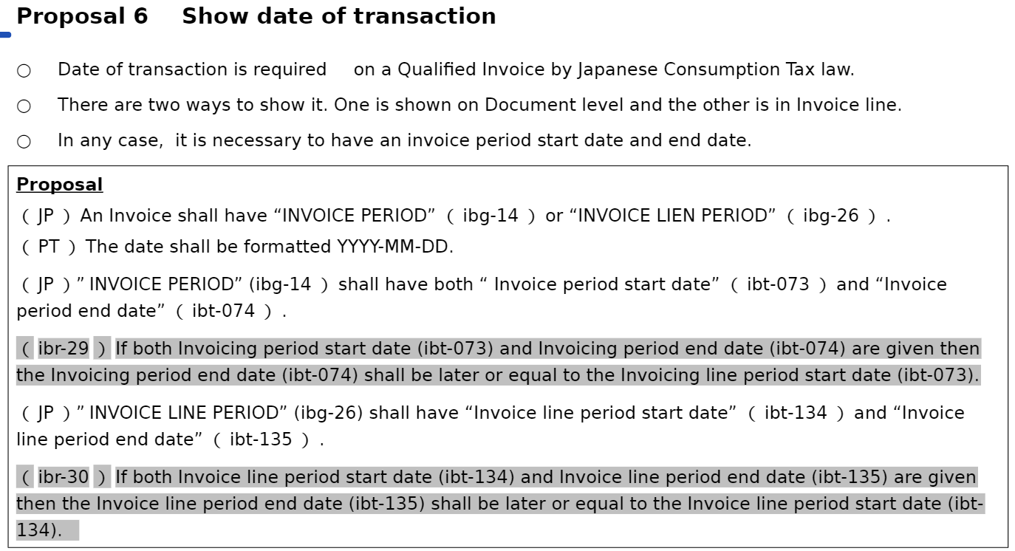

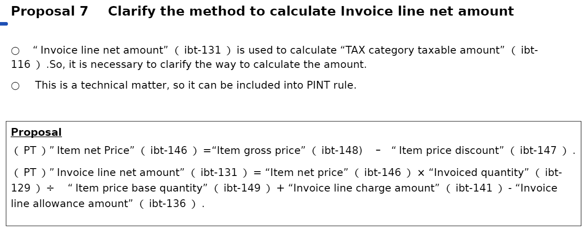

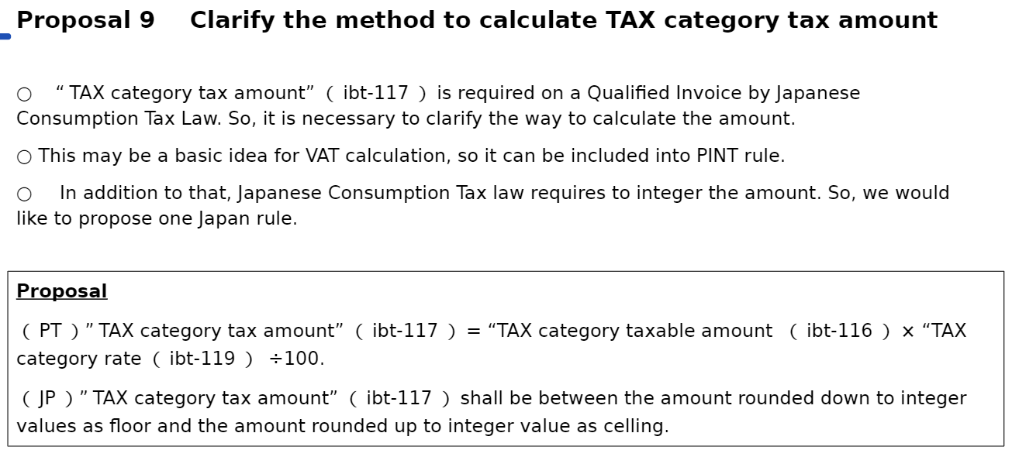

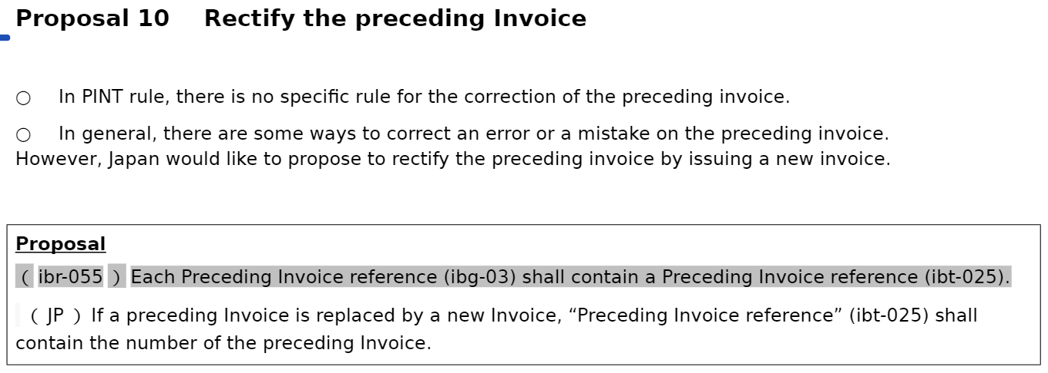

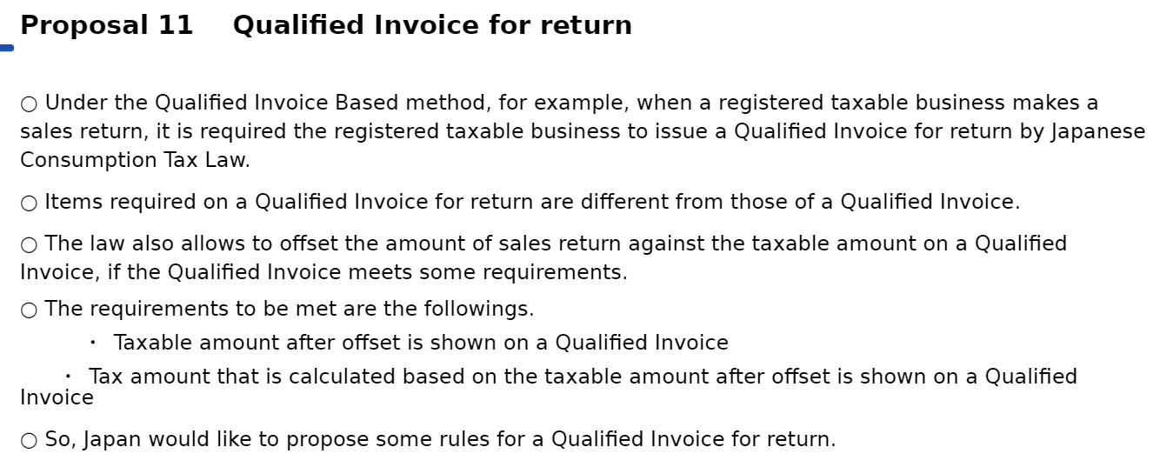

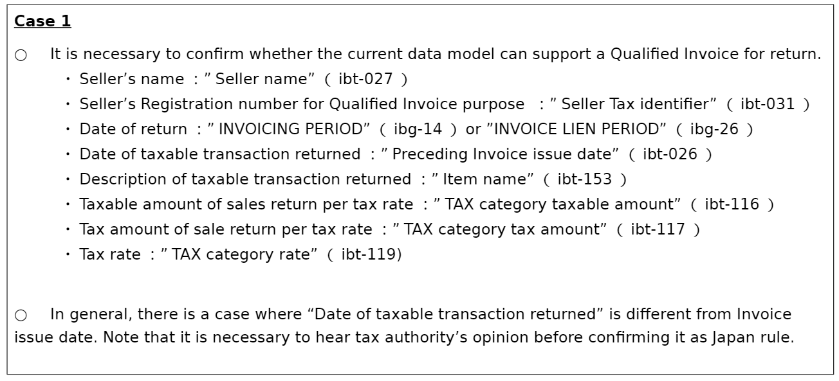

# Code list and identifier

[SOURCE: PINT DRAFT 0.08]

## Overview

The following chapters give an overview of the restricted set of codes that is used in this PEPPOL BIS. For most codes, the restriction is only to add a dated reference of the code list, but for the Invoice Type Code a subset of valid values has been established.

The list of values that are allowed for each code list at each time shall be as published or referenced on the peppol.eu (or peppol.org) website.

Aligned code list is code list that can be restricted in domain specific implementation of the PINT.

## Shared code list

Shared code list must be used in the same way by all compliant specifications of the international invoicing model and cannot be restricted. Addition or modification to the code shall be by amending the code lists through their managing authorities.

### Document type

The following sub-chapters give an overview of the restricted set of invoice type codes (BT-3) that is used in this PEPPOL BIS Billing.

**Table 49** and **Table 50** indicates the name and description of each code, as well as a column "Synonym with" to indicate how this invoice type can be processed if the recipient does not have a separate process/work flow for this code, and as you will see, all invoice types valid in this profile can be processed as a commercial invoice (380) and all credit note types as Commercial credit note (381). Some recipients might have separate processes or work flows for some of these types, and can then use these processes.

The table also gives information on what message type is to be used in the UBL syntax for the different codes.

UNTDID 1001 — Document type.

Document location cbc:InvoiceTypeCode

Source code list Subset of UN/CEFACT code list 1001, D.16B

Codes for invoices.

* 380 Commercial invoices.

The following invoice related document type codes may also be used in an invoice but shall be processed as code 380 unless otherwise agreed between the trading partners.

**Table 49 — Invoice related document type codes**

|  |  |  |  |  |
| --- | --- | --- | --- | --- |
| **Code** | **Name** | **Description** | **Synonym with** | **UBL message type** |
| 380 | Commercial invoice | Document/message claiming payment for goods or services supplied under conditions agreed between seller and buyer. |  | Invoice |
| 393 | Factored invoice | Invoice assigned to a third party for collection. | 380 | Invoice |
| 82 | Metered services invoice | Document/message claiming payment for the supply of metered services (e.g., gas, electricity, etc.) supplied to a fixed meter whose consumption is measured over a period of time. | 380 | Invoice |
| 80 | Delivery Note related to goods or services | Debit information related to a transaction for goods or services to the relevant party. | 380 | Invoice |
| 84 | Delivery Note related to financial adjustments | Document/message for providing debit information related to financial adjustments to the relevant party. | 380 | Invoice |
| 395 | Consignment invoice | Commercial invoice that covers a transaction other than one involving a sale. | 380 | Invoice |
| 575 | Insurer’s invoice | Document/message issued by an insurer specifying the cost of an insurance which has been effected and claiming payment therefore | 380 | Invoice |
| 623 | Forwarder’s invoice | Invoice issued by a freight forwarder specifying services rendered and costs incurred and claiming payment therefore. | 380 | Invoice |
| 780 | Freight invoice | Document/message issued by a transport operation specifying freight costs and charges incurred for a transport operation and stating conditions of payment. | 380 | Invoice |
| 383 | Debit Note | Document/message for providing debit information to the relevant party. | 380 | Invoice |
| 386 | Prepayment invoice | An invoice to pay amounts for goods and services in advance; these amounts will be subtracted from the final invoice. | 380 | Invoice |

Document location cbc:CreditNoteTypeCode

Source code list Subset of UN/CEFACT code list 1001, D.16B

Specific code lists for the credit note

* 381 Commercial credit notes.

The following credit note related document type codes may also be used in an invoice but shall be processed as code 381 unless otherwise agreed between the trading partners.

**Table 50 — Credit note related document type codes**

|  |  |  |  |  |
| --- | --- | --- | --- | --- |
| **Code** | **Name** | **Description** | **Synonym with** | **UBL message type** |
| 381 | Credit note | Document/message for providing credit information to the relevant party. |  | CreditNote |
| 396 | Factored credit note | Credit note related to assigned invoice(s). | 381 | CreditNote |
| 81 | Credit note related to goods or services | Document message used to provide credit information related to a transaction for goods or services to the relevant party. | 381 | CreditNote |
| 83 | Credit note related to financial adjustments | Document message for providing credit information related to financial adjustments to the relevant party, e.g., bonuses. | 381 | CreditNote |
| 532 | Forwarder’s credit note | Document/message for providing credit information to the relevant party. | 381 | CreditNote |

### Country code

All country codes in an invoice or credit note shall be the alpha-2 code from ISO 3166-1

Document location cac:Country/cbc:IdentificationCode

cac:OriginCountry/cbc:IdentificationCode

Source code list ISO 3166-1

### Currency code

All currencies in an invoice or credit note shall be the alphabetic code from ISO 4217:2015

Document location cbc:*/@currencyID

Source code list ISO 4217:2015

### Unit of measure

Valid unit codes shall be from UN/ECE Recommendation 20, Revision 11 (2015). Unless codes for unit of measure are not in common daily use, implementers should as necessarily provide a function for clarification of codes when invoices are visualised.

Codes for unit of packaging from UNECE Recommendation # 21 can be used in accordance with the descriptions in the "Intro" section of UN/ECE Recommendation 20, Revision 11 (2015):

The 2-character alphanumeric code values in UNECE Recommendation 21 shall be used. To avoid duplication with existing code values in UNECE Recommendation # 20, each code value from UNECE Recommendation 21 shall be prefixed with an “X”, resulting in a 3 alphanumeric code when used as a unit of measure.

Document location cbc:*/@unitCode

Source code list UN/ECE Recommendation 20, Revision 11 (2015)

Unit of measure in an invoice allows the use of codes from UNECE Recommendation # 20 (version 11e), as well as codes from UNECE Recommendation # 21 prefixed with an X. Please

EXAMPLE 1: unit of measure from Recommendation # 20

Code Name

C62 One (Synonym: Unit)

EA Each

H87 Piece

KGM Kilogram

MTR Meter

LTR Litre

MTK Square metre

MTQ Cubic metre

KTM Kilometre

TNE Tonne (metric ton)

KWH Kilowatt hour

DAY Day

HUR Hour

MIN Minute

EXAMPLE 2: unit of measure from Recommendation # 21, prefixed with an X

Code Name

XBG Bag

XBX Box

XCA Case

XCT Carton

XCY Cylinder

XBA Barrel

XPK Package

XPX Pallet

XRL Reel

XSA Sack

XST Sheet

EXAMPLE 3: UBL example of unit of measure

<cbc:InvoicedQuantity unitCode="H87">**10**</cbc:InvoicedQuantity>

<cbc:InvoicedQuantity unitCode="XPX">**10**</cbc:InvoicedQuantity>

Code H87 from Recommendation # 20

Code PX, prefixed with an X from Recommendation # 21

### Allowance reason codes

Any allowance reason codes shall be from UN/CEFACT code list 5189, D.16B

Document location cbc:AllowanceChargeReasonCode[../cbc:ChargeIndicator = false()]

Source code list Subset of UN/CEFACT code list 5189, D.16B

Valid values are listed in the list below:

Code Description

41 Bonus for works ahead of schedule

42 Other bonus

60 Manufacturer’s consumer discount

62 Due to military status

63 Due to work accident

64 Special agreement

65 Production error discount

66 New outlet discount

67 Sample discount

68 End-of-range discount

70 Incoterm discount

71 Point of sales threshold allowance

88 Material surcharge/deduction

95 Discount

100 Special rebates

102 Fixed long term

103 Temporary

104 Standard

105 Yearly turnovers

### Charge reason codes

Any charge reason code shall be from UN/CEFACT code list 7161, D.16B

Document location cbc:AllowanceChargeReasonCode[../cbc:ChargeIndicator = true()]

Source code list UN/CEFACT code list 7161, D.16B

### Mime codes

Mime type codes — Mime codes, shared as restricted in PINT

Subset of IANA Media Types.

Document location cbc:EmbeddedDocumentBinaryObject/@mimeCode

Source code list Subset of IANA

Documents application/pdf

Images image/png

image/jpeg

Text text/csv

Spreadsheet application/vnd.openxmlformats-officedocument.spreadsheetml.sheet

application/vnd.oasis.opendocument.spreadsheet

### Code lists for identifier schemes

#### General

Following code lists are used for identifier elements to specify what identifier scheme an identifier is based on.

#### Electronic address identifier scheme

For Sellers and Buyers Electronic address identifiers (Endpoint identification, ibt-49 and ibt-34) the allowed identifier schemes is specified by the Electronic address scheme code list, EAS.

Business Term Electronic address identifiers (Endpoint)

Applicable XPath cbc:EndpointID/@schemeID

Code list (link or subset values)

Code list for electronic addresses.

#### Party identifiers and party legal registration identifier scheme

All party identifiers and party legal registration identifier has an optional scheme attribute. If used, the value shall be chosen from the ICD list from ISO/IEC 6523

Business Term Party identifiers (Buyer, Seller, Payee)

Applicable XPath cac:PartyIdentification/cbc:ID/@schemeID

Code list ICD list from ISO/IEC 6523

Legal registration identifiers (Buyer, Seller, Payee)

cac:PartyLegalEntity/cbc:CompanyID/@schemeID

Deliver to location identifier

cac:Delivery/cac:DeliveryLocation/cbc:ID/@schemeID

#### Invoiced object identifier scheme

The invoiced object identifier scheme shall be from UN/CEFACT code list 1153, D.16B

Business Term Invoiced object identifier

Applicable XPath

cac:AdditionalDocumentReference[cbc:DocumentTypeCode= '130']/cbc:ID/@schemeID

Code list UN/CEFACT code list 1153, D.16B

#### Item standard identifier scheme

An item standard identifier has a mandatory scheme attribute. The value shall be chosen from the ICD list from ISO/IEC 6523

Business Term Item Standard identifier

Applicable XPath cac:InvoiceLine/cac:Item/cac:StandardItemIdentification/cbc:ID/@schemeID

Code list ICD list from ISO/IEC 6523

#### Item classification identifier

An item classification identifier has a mandatory scheme attribute. The value shall be chosen from UN/CEFACT code list 7143, D.16B.

Business Term Item Classification identifier

Applicable XPath

cac:InvoiceLine/cac:Item/cac:CommodityClassification/cbc:ItemClassificationCode/@listID

Code list UN/CEFACT code list 7143, D.16B

#### Peppol Identifiers

PEPPOL has defined a PEPPOL Policy for identifiers, policy 8 that specifies how to use identifiers in both its transport infrastructure and within the documents exchanged across that infrastructure. It also introduces principles for any identifiers used in the PEPPOL environment.

## Aligned code list

### Payment means type code

Payment means type code shall be from UN/CEFACT code list 4461, with extensions. The extended part of the code list is not supported in EN 16931 and consequently not in the European implementation of PINT, the BIS Billing 3.0.

Document location cac:PaymentMeans/cbc:PaymentMeansCode

Source code list UN/CEFACT code list 4461

The payment means type code list is extended in the PINT by adding codes that begin with the letter Z and followed with a number with minimum 2 digits. As example Z01.

### TAX category codes

Although EN 16931 mandate use of a source code list UN/CEFACT code list 5305, tax category codes (ib-095, ibt-102, ibt-118, ibt-151) are not shared but defined by different specializations. Consequently, there is not a shared understanding of what they mean, and their meaning can be ignored by those who are processing invoices as pint compliant.

Further details on tax category codes may be found in the PINT guideline.

Document location cac:TaxCategory/cbc:ID

Followings are Tax category codes in Japan.

S tandard rate(tax rate 10％)

AA Lower rate (tax rate8％) Tax rate is lower than standard rate.

AE Consumption Tax Reverse Charge

E Exempt from Consumption Tax. Consumption Tax is not applicable.

G Free export item, tax not charged, free export and Consumption Tax is not charged.

O Outside scope of Consumption Tax

### TAX type

Tax types allowed in the PINT are limited to the following subset of the UNECE 5153 Duty or tax or fee type name codes. Invoice domain specification may restrict the allowed tax type, but additional tax types can be allowed by adding to the PINT code list subset.

Document location cac:TaxCategory/cac:TaxScheme/cbc:ID

**VAT**

**Value added tax**

A tax on domestic or imported goods applied to the value added at each stage in the production/distribution cycle.

**GST**

**Goods and services tax**A tax on domestic or imported goods applied to the value added at each stage in the production/distribution cycle.

**LOC**

**Sales tax**Assessment charges on sale of goods or services by city borough country or other taxing authorities below state or provincial level.

**STT**

**State/provincial sales tax**

All applicable sale taxes by authorities at the state or level, below national level.

**AAG**

**Harmonised sales tax, Canadian**

A harmonized sales tax consisting of a goods and service, a Canadian provincial sales tax and, as applicable, Quebec sales tax which is recoverable.

**AAH**

**Quebec sales tax**

A sales tax charged within the Canadian province of Quebec which is recoverable.

**AAI**

**Canadian provincial sales tax**

A sales tax charged within Canadian provinces which is recoverable.

### TAX exemption reason code

Although EN 16931 mandate use of a code list maintained by Connecting Europe Facility (CEF), tax exemption reason code can be any and is not shared.

Document location cac:TaxCategory/cbc:TaxExemptionReasonCode

[EIPA]

The invoices issued by unregistered seller who has no TAX identifier (registration number "T"+13digits) is not applicable for Japanese Consumption Tax. These type of invoices has no tax amount.

### Value added tax point date code

Although EN 16931 mandate use of a code list subset of UN/CEFACT code list 2005.D.16B , value added tax point date code (ibt-008) code can be any and is not shared.

Document location cac:InvoicePeriod/cbc:DescriptionCode

# 

# Peppol Identifiers

[SOURCE: Japanese Peppol BIS Documentation]

## Overview

Peppol has defined a PEPPOL Policy for identifiers, policy 8 that specifies how to use identifiers in both its transport infrastructure and within the documents exchanged across that infrastructure. It also introduces principles for any identifiers used in the Peppol environment. The policies that apply to this BIS are the following:

## Profiles and messages

All messages contains ProfileID and CustomizationID. ProfileID identifies what business process a given message is part of, and CustomizationID identifies the kind of message and the rules applied.

Profiles are connected to one business process, and may contain multiple document types. Valid document instances shall contain corresponding ProfileID and CustomizationID.

NOTE: CustomizationID is a string without spaces. The list below contains spaces in CustomizationID to make them easier to read. Make sure to remove any spaces before use.

## Japanese standard invoice

**Table 51** lists the values to be used as the specification identifier (ibt-024 ) and the business process type (ibt-023) for this profile.

**Table 51 — Values to be used for billing**

|  |  |  |  |
| --- | --- | --- | --- |
| **Type** | **ID** | **Element** | **Value** |
| JP standard invoice and credit note | ibt-024 | cbc:CustomizationID | urn:peppol:pint:billing-3.0@jp:peppol-1 |
| ibt-023 | cbc:ProfileID | urn:peppol:bis:billing |
| Debit Note | ibt-024 | cbc:CustomizationID | urn:peppol:pint:debitnote-3.0@jp:peppol-1 |
| ibt-023 | cbc:ProfileID | urn:peppol:bis:suminvpt1 |

## Japanese summarised invoice

**Table 52** lists the values to be used as the specification identifier (ibt-024 ) and the business process type (ibt-023) for this profile.

**Table 52 — Values tio be used for summarised invoice pattern 1**

|  |  |  |  |
| --- | --- | --- | --- |
| **Type** | **ID** | **Element** | **Value** |
| JP summarised invoice and credit note | ibt-024 | cbc:CustomizationID | urn:peppol:pint:billing-3.0@jp:peppol-1@jp:suminvpt1-1 |
| ibt-023 | cbc:ProfileID | urn:peppol:bis:suminvpt1 |
| Debit Note | ibt-024 | cbc:CustomizationID | urn:peppol:pint:debitnote-3.0@jp:peppol-1 |
| ibt-023 | cbc:ProfileID | urn:peppol:bis:suminvpt1 |

# Applying the PINT: Examples of selected parts of the transaction (informative)

[SOURCE: PINT DRAFT 0.08]

## General

CEN/TS 16931-3-2 Annex B provides examples. First, there is a table specifying the semantic elements of the example and afterwards, the corresponding XML UBL instance file is provided. In the subchapters below you find examples of selected parts of the transaction. First, the semantic elements ot the example is provides in the table and the snippet of corresponding XML UBL instance file is listed.

## Party

### Overview

The following roles may be specified. The same actor may play more than one role depending on the handling routine.

### Seller

Seller is mandatory information and provided in element cac:AccountingSupplierParty

### Buyer

Buyer is mandatory information and provided in element cac:AccountingCustomerParty

### Payee

Payee is optional information. If this information is not supplied, the seller is the payment receiver. When payee information is sent this is indicating that a factoring situation is being documented.

### UBL example for party information

Following is an example of party information for a seller. Party information for other parties is identically structured but the details and mandatory element differ as defined in the data model.

**Table 53** lists example contents of semantic elements of Seller. [EIPA]

NOTE: In the table below, the leading "/(Invoice | CreditNote)/" in the XPath has been removed and the XPath now contains spaces for readability. Be sure to add the leading "/(Invoice | CreditNote)/" and remove the spaces before using it.

**Table 53 — Example contents of semantic elements of Seller [EIPA]**

|  |  |  |  |  |
| --- | --- | --- | --- | --- |
| **ID** | **Level** | **Business Term** | **Content** | **UBL syntax XPath** |
| ibg-04 | 1 | SELLER |  | cac:AccountingSupplierParty |
| ibt-027 | 2 | Seller name | SupplierOfficialName Ltd | cac:AccountingSupplierParty/ cac:Party/ cac:PartyLegalEntity/ cbc:RegistrationName |
| ibt-028 | 2 | Seller trading name | SupplierTradingName Ltd. | cac:AccountingSupplierParty/ cac:Party/ cac:PartyName/ cbc:Name |
| ibt-029 | 2 | Seller identifier | 7300010000001 | cac:AccountingSupplierParty/ cac:Party/ cac:PartyIdentification/ cbc:ID |
| ibt-029-1 | 3 | Scheme identifier | 0088 | cac:AccountingSupplierParty/ cac:Party/ cac:PartyIdentification/ cbc:ID/ @schemeID |
| ibt-030 | 2 | Seller legal registration identifier | GB983294 | cac:AccountingSupplierParty/ cac:Party/ cac:PartyLegalEntity/ cbc:CompanyID |
| ibt-031 | 2 | Seller TAX identifier | GB76576657 | cac:AccountingSupplierParty/ cac:Party/ cac:PartyTaxScheme/ cbc:CompanyID |
| ibt-031-1 | 2 | Tax Scheme | VAT | cac:AccountingSupplierParty/ cac:Party/ cac:PartyTaxScheme/ cac:TaxScheme/ cbc:ID |
| ibt-032 | 2 | Seller TAX registration identifier | TaxRegistrationID | cac:AccountingSupplierParty/ cac:Party/ cac:PartyTaxScheme/ cbc:CompanyID |
| ibt-032-1 | 2 | Tax Scheme | TAX | cac:AccountingSupplierParty/ cac:Party/ cac:PartyTaxScheme/ cac:TaxScheme/ cbc:ID |
| ibt-033 | 2 | Seller additional legal information | Private Limited Company | cac:AccountingSupplierParty/ cac:Party/ cac:PartyLegalEntity/ cbc:CompanyLegalForm |
| ibt-034 | 2 | Seller electronic address | 7300010000001 | cac:AccountingSupplierParty/ cac:Party/ cbc:EndpointID |
| ibt-034-1 | 3 | Scheme identifier | 0088 | cac:AccountingSupplierParty/ cac:Party/ cbc:EndpointID/ @schemeID |
| ibg-05 | 2 | SELLER POSTAL ADDRESS |  | cac:AccountingSupplierParty/ cac:Party/ cac:PostalAddress |
| ibt-035 | 3 | Seller address line 1 | Main street 1 | cac:AccountingSupplierParty/ cac:Party/ cac:PostalAddress/ cbc:StreetName |
| ibt-036 | 3 | Seller address line 2 | Postbox 123 | cac:AccountingSupplierParty/ cac:Party/ cac:PostalAddress/ cbc:AdditionalStreetName |
| ibt-162 | 3 | Seller address line 3 | Third address line | cac:AccountingSupplierParty/ cac:Party/ cac:PostalAddress/ cac:AddressLine/ cbc:Line |
| ibt-037 | 3 | Seller city | London | cac:AccountingSupplierParty/ cac:Party/ cac:PostalAddress/ cbc:CityName |
| ibt-038 | 3 | Seller post code | GB 123 EW | cac:AccountingSupplierParty/ cac:Party/ cac:PostalAddress/ cbc:PostalZone |
| ibt-039 | 3 | Seller country subdivision | West London district | cac:AccountingSupplierParty/ cac:Party/ cac:PostalAddress/ cbc:CountrySubentity |
| ibt-040 | 3 | Seller country code | GB | cac:AccountingSupplierParty/ cac:Party/ cac:PostalAddress/ cac:Country/ cbc:IdentificationCode |
| ibg-06 | 2 | SELLER CONTACT |  | cac:AccountingSupplierParty/ cac:Party/ cac:Contact |
| ibt-041 | 3 | Seller contact point | John Doe | cac:AccountingSupplierParty/ cac:Party/ cac:Contact/ cbc:Name |
| ibt-042 | 3 | Seller contact telephone number | 9384203984 | cac:AccountingSupplierParty/ cac:Party/ cac:Contact/ cbc:Telephone |
| ibt-043 | 3 | Seller contact email address | john.doe@foo.bar | cac:AccountingSupplierParty/ cac:Party/ cac:Contact/ cbc:ElectronicMail |

EXAMPLE UBL Example of seller

<cac:AccountingSupplierParty>

<cac:Party>

<cbc:EndpointID schemeID="0088">**7300010000001**</cbc:EndpointID>

<cac:PartyIdentification>

<cbc:ID schemeID="0088">**7300010000001**</cbc:ID>

</cac:PartyIdentification>

<cac:PartyName>

<cbc:Name>**SupplierTradingName Ltd.**</cbc:Name>

</cac:PartyName>

<cac:PostalAddress>

<cbc:StreetName>**Main street 1**</cbc:StreetName>

<cbc:AdditionalStreetName>**Postbox 123**</cbc:AdditionalStreetName>

<cbc:CityName>**London**</cbc:CityName>

<cbc:PostalZone>**GB 123 EW**</cbc:PostalZone>

<cbc:CountrySubentity>**West London district**</cbc:CountrySubentity>

<cac:AddressLine>

<cbc:Line>**Third address line**</cbc:Line>

</cac:AddressLine>

<cac:Country>

<cbc:IdentificationCode>**GB**</cbc:IdentificationCode>

</cac:Country>

</cac:PostalAddress>

<cac:PartyTaxScheme>

<cbc:CompanyID>**GB76576657**</cbc:CompanyID>

<cac:TaxScheme>

<cbc:ID>**VAT**</cbc:ID>

</cac:TaxScheme>

</cac:PartyTaxScheme>

<cac:PartyTaxScheme>

<cbc:CompanyID>**TaxRegistrationID**</cbc:CompanyID>

<cac:TaxScheme>

<cbc:ID>**TAX**</cbc:ID>

</cac:TaxScheme>

</cac:PartyTaxScheme>

<cac:PartyLegalEntity>

<cbc:RegistrationName>**SupplierOfficialName Ltd**</cbc:RegistrationName>

<cbc:CompanyID>**GB983294**</cbc:CompanyID>

<cbc:CompanyLegalForm>**Private Limited Company**</cbc:CompanyLegalForm>

</cac:PartyLegalEntity>

<cac:Contact>

<cbc:Name>**John Doe**</cbc:Name>

<cbc:Telephone>**9384203984**</cbc:Telephone>

<cbc:ElectronicMail>**john.doe@foo.bar**</cbc:ElectronicMail>

</cac:Contact>

</cac:Party>

## Delivery Details (Date and Location)

Delivery details may be given at document level.

Place and date of delivery is recommended and should be sent unless this does not affect the ability to ensure the correctness of the invoice.

The delivery element contains information on name, address and delivery location identifier (cac:Delivery/cac:DeliveryLocation/cbc:ID) which may be used if the place of delivery is defined through an identifier. Examples are GLN (Global Location Number) or GSRN (Global Service Relationship Number) both issued by GS1.

**Table 54** lists example contents of semantic elements of delivery information. [EIPA]

NOTE: In the table below, the leading "/(Invoice | CreditNote)/" in the XPath has been removed and the XPath now contains spaces for readability. Be sure to add the leading "/(Invoice | CreditNote)/" and remove the spaces before using it.

**Table 54 — Example contents of semantic elements of delivery information [EIPA]**

|  |  |  |  |  |
| --- | --- | --- | --- | --- |
| **ID** | **Level** | **Business Term** | **Content** | **UBL syntax XPath** |
| ibg-13 | 1 | DELIVERY INFORMATION |  | cac:Delivery |
| ibt-070 | 2 | Deliver to party name | Delivery party Name | cac:Delivery/ cac:DeliveryParty/ cac:PartyName/ cbc:Name |
| ibt-071 | 2 | Deliver to location identifier | 7300010000001 | cac:Delivery/ cac:DeliveryLocation/ cbc:ID |
| ibt-071-1 | 3 | Scheme identifier | 0088 | cac:Delivery/ cac:DeliveryLocation/ cbc:ID/ @schemeID |
| ibt-072 | 2 | Actual delivery date | 2017-11-01 | cac:Delivery/ cbc:ActualDeliveryDate |
| ibg-15 | 2 | DELIVER TO ADDRESS |  | cac:Delivery/ cac:DeliveryLocation/ cac:Address |
| ibt-075 | 3 | Deliver to address line 1 | Delivery street 2 | cac:Delivery/ cac:DeliveryLocation/ cac:Address/ cbc:StreetName |
| ibt-076 | 3 | Deliver to address line 2 | Building 56 | cac:Delivery/ cac:DeliveryLocation/ cac:Address/ cbc:AdditionalStreetName |
| ibt-165 | 3 | Deliver to address line 3 | Gate 15 | cac:Delivery/ cac:DeliveryLocation/ cac:Address/ cac:AddressLine/ cbc:Line |
| ibt-077 | 3 | Deliver to city | Stockholm | cac:Delivery/ cac:DeliveryLocation/ cac:Address/ cbc:CityName |
| ibt-078 | 3 | Deliver to post code | 21234 | cac:Delivery/ cac:DeliveryLocation/ cac:Address/ cbc:PostalZone |
| ibt-080 | 3 | Deliver to country code | SE | cac:Delivery/ cac:DeliveryLocation/ cac:Address/ cac:Country/ cbc:IdentificationCode |

EXAMPLE UBL example of delivery information

<cac:Delivery>

<cbc:ActualDeliveryDate>**2017-11-01**</cbc:ActualDeliveryDate>

<cac:DeliveryLocation>

<cbc:ID schemeID="0088">**7300010000001**</cbc:ID>

<cac:Address>

<cbc:StreetName>**Delivery street 2**</cbc:StreetName>

<cbc:AdditionalStreetName>**Building 56**</cbc:AdditionalStreetName>

<cbc:CityName>**Stockholm**</cbc:CityName>

<cbc:PostalZone>**21234**</cbc:PostalZone>

<cac:AddressLine>

<cbc:Line>**Gate 15**</cbc:Line>

</cac:AddressLine>

<cac:Country>

<cbc:IdentificationCode>**SE**</cbc:IdentificationCode>

</cac:Country>

</cac:Address>

</cac:DeliveryLocation>

<cac:DeliveryParty>

<cac:PartyName>

<cbc:Name>**Delivery party Name**</cbc:Name>

</cac:PartyName>

</cac:DeliveryParty>

</cac:Delivery>

## References

[SOURCE: PINT DRAFT 0.08]

### Overview

[EIPA]

Support for invoice verification is a key function of an invoice. The invoice should provide sufficient information to look up relevant existing documentation, electronic or paper.

Any reference element should contain valid information, if you do not have a reference, the element should not be present in the instance document.

The relationships between the invoice and the other document and events are depicted in **Figure 17**, which is Figure 14 of EN 16931-1.

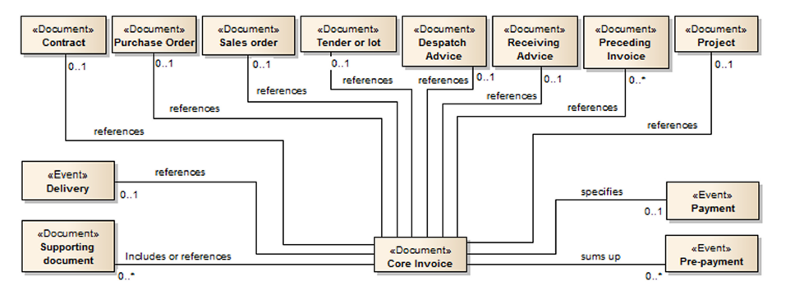

**Figure 18 — Invoice relations [SOURCE: EN 16931-1]**

The invoice and credit note transactions supports the following references to existing documentation:

### Purchase order and sales order reference

The purchase order is conditional. If purchase order reference exists then provide that, else provide Buyer reference (see Buyer reference). If both exist, they can both be provided.

The customer will issue an order with a unique order number. This unique purchase order number should be supplied as the order reference on the invoice.

If order reference is stated at header level, the order reference element on line level can be used to state the order line numbers.

A sales order is issued by the seller, confirming the sale of specified products.

In the invoice, both a purchase order and a sales order reference can be given but be aware that an invoice instance cannot have a sales order reference, without the corresponding purchase order reference.

**Table 55** lists example contents of semantic elements of purchase order and sales order reference. [EIPA]

NOTE: In the table below, the leading "/(Invoice | CreditNote)/" in the XPath has been removed and the XPath now contains spaces for readability. Be sure to add the leading "/(Invoice | CreditNote)/" and remove the spaces before using it.

**Table 55 — Example contents of semantic elements of purchase order and sales order reference [EIPA]**

|  |  |  |  |  |
| --- | --- | --- | --- | --- |
| **ID** | **Level** | **Business Term** | **Content** | **UBL syntax XPath** |
| ibt-013 | 1 | Purchase order reference | o-998877 | cac:OrderReference/ cbc:ID |
| ibt-014 | 1 | Sales order reference | so-12343 | cac:OrderReference/ cbc:SalesOrderID |

EXAMPLE UBL example or order and sales order and sales order reference.

<cac:OrderReference>

<cbc:ID>**o-998877**</cbc:ID>

<cbc:SalesOrderID>**so-12343**</cbc:SalesOrderID>

</cac:OrderReference>

### Buyer reference

The buyer reference, known as Your ref, is conditional. An invoice shall have either or both, the buyer reference or the order reference (see Purchase order and sales order reference)

The element is used for the reference of who ordered the products/services. Example being the name of the person ordering, employee number or a code identifying this person or department/group. Your ref is often used for internal routing at recipient, and hence it is important to fill this element with the correct values according to the need of the recipient.

If neither buyer reference nor a reference to an order is supplied by the customer, the name of the person ordering or appointed for the customer can be supplied in buyer reference if known by the supplier.

When reference is provided by the customer, the correct element shall contain the provided reference.

**Table 56** lists example contents of semantic elements of buyer reference. [EIPA]

NOTE: In the table below, the leading "/(Invoice | CreditNote)/" in the XPath has been removed and the XPath now contains spaces for readability. Be sure to add the leading "/(Invoice | CreditNote)/" and remove the spaces before using it.

**Table 56 — Example contents of semantic elements of buyer reference [EIPA]**

|  |  |  |  |  |
| --- | --- | --- | --- | --- |
| **ID** | **Level** | **Business Term** | **Content** | **UBL syntax XPath** |
| ibt-010 | 1 | Buyer reference | 0150abc | cbc:BuyerReference |

EXAMPLE: UBL example of buyer reference

<cbc:BuyerReference>**0150abc**</cbc:BuyerReference>

### Invoiced object identifier

The invoiced object identifier is the identifier for an object on which the invoice is based, given by the Seller. Examples may be a subscription number, telephone number, meter point, vehicle, person etc., as applicable.

If it is not clear to the receiver what scheme is used for the identifier, a conditional scheme identifier should be used, that shall be chosen from the Invoiced object identifier scheme.

The invoiced object reference is provided by using the element cac:AdditionalDocumentReference with the document type code = 130

**Table 57** lists example contents of semantic elements of invoiced object identifier. [EIPA]

NOTE: In the table below, the leading "/(Invoice | CreditNote)/" in the XPath has been removed and the XPath now contains spaces for readability. Be sure to add the leading "/(Invoice | CreditNote)/" and remove the spaces before using it.

**Table 57 — Example contents of semantic elements of invoiced object identifier [EIPA]**

|  |  |  |  |  |
| --- | --- | --- | --- | --- |
| **ID** | **Level** | **Business Term** | **Content** | **UBL syntax XPath** |
| ibt-018 | 1 | Invoiced object identifier | DR35141 | cac:AdditionalDocumentReference[ cbc:DocumentTypeCode='130' ]/ cbc:ID |
| ibt-018-1 | 2 | The identification scheme identifier of the Invoiced object identifier | ABT | cac:AdditionalDocumentReference[ cbc:DocumentTypeCode='130' ]/ cbc:ID/ @schemeID |

EXAMPLE: UBL example of invoiced object identifier

<cac:AdditionalDocumentReference>

<cbc:ID schemeID="ABT">**DR35141**</cbc:ID>

<cbc:DocumentTypeCode>**130**</cbc:DocumentTypeCode>

</cac:AdditionalDocumentReference>

Scheme identifier from UN/CEFACT 1153 code list

Document type code shall be ´130´ to indicate Invoiced object

### Contract reference

To reference or match an invoice to a purchase contract, the contract number could be specified like this:

**Table 58** lists example contents of semantic elements of contract reference. [EIPA]

NOTE: In the table below, the leading "/(Invoice | CreditNote)/" in the XPath has been removed and the XPath now contains spaces for readability. Be sure to add the leading "/(Invoice | CreditNote)/" and remove the spaces before using it.

**Table 58 — Example contents of semantic elements of contract reference [EIPA]**

|  |  |  |  |  |
| --- | --- | --- | --- | --- |
| **ID** | **Level** | **Business Term** | **Content** | **UBL syntax XPath** |
| ibt-012 | 1 | Contract reference | framework no 1 | cac:ContractDocumentReference/ cbc:ID |

EXAMPLE: UBL example of contract reference

<cac:ContractDocumentReference>

<cbc:ID>**framework no 1**</cbc:ID>

</cac:ContractDocumentReference>

### Despatch and receipt advice references

To reference or match an invoice to a despatch or receipt advice use the following elements:

**Table 59** lists example contents of semantic elements of despatch and receipt advice reference. [EIPA]

NOTE: In the table below, the leading "/(Invoice | CreditNote)/" in the XPath has been removed and the XPath now contains spaces for readability. Be sure to add the leading "/(Invoice | CreditNote)/" and remove the spaces before using it.

**Table 59 — Example contents of semantic elements of despatch and receipt advice reference [EIPA]**

|  |  |  |  |  |
| --- | --- | --- | --- | --- |
| **ID** | **Level** | **Business Term** | **Content** | **UBL syntax XPath** |
| ibt-016 | 1 | Despatch advice reference | despadv-3 | cac:DespatchDocumentReference/ cbc:ID |
| ibt-015 | 1 | Receiving advice reference | resadv-1 | cac:ReceiptDocumentReference/ cbc:ID |

EXAMPLE: UBL example of despatch and receipt advice

<cac:DespatchDocumentReference>

<cbc:ID>**despadv-3**</cbc:ID>

</cac:DespatchDocumentReference>

<cac:ReceiptDocumentReference>

<cbc:ID>**resadv-1**</cbc:ID>

</cac:ReceiptDocumentReference>

### Tender reference

To identify the call for tender or lot the invoice relates to, use the 'OriginatorDocumentReference'. The identifier is, in most cases, the Procurement Procedure Identifier.

**Table 60** lists example contents of semantic elements of tender reference. [EIPA]

NOTE: In the table below, the leading "/(Invoice | CreditNote)/" in the XPath has been removed and the XPath now contains spaces for readability. Be sure to add the leading "/(Invoice | CreditNote)/" and remove the spaces before using it.

**Table 60 — Example contents of semantic elements of tender reference [EIPA]**

|  |  |  |  |  |
| --- | --- | --- | --- | --- |
| **ID** | **Level** | **Business Term** | **Content** | **UBL syntax XPath** |
| ibt-017 | 1 | Tender or lot reference | ppid-123 | cac:OriginatorDocumentReference/ cbc:ID |

EXAMPLE: UBL example of tender reference

<cac:OriginatorDocumentReference>

<cbc:ID>**ppid-123**</cbc:ID>

</cac:OriginatorDocumentReference>

### Project reference

The project reference is optional to use, and is sent in an invoice in the element cac:ProjectReference/cbc:ID. In a credit note, this element does not exist, and project reference is sent by using the element cac:AdditionalDocumentReference[cbc:DocumentTypeCode='50']/cbc:ID.

NOTE 1: When sending the project reference, only the cbc:ID and the cbc:DocumentTypeCode are allowed in the cac:AdditionalDocumentReference element.

**Table 61** lists example contents of semantic elements of project reference. [EIPA]

NOTE 2: In the table below, the leading "/(Invoice | CreditNote)/" in the XPath has been removed and the XPath now contains spaces for readability. Be sure to add the leading "/(Invoice | CreditNote)/" and remove the spaces before using it.

**Table 61 — Example contents of semantic elements of project reference [EIPA]**

|  |  |  |  |  |
| --- | --- | --- | --- | --- |
| **ID** | **Level** | **Business Term** | **Content** | **UBL syntax XPath** |
| ibt-011 | 1 | Project reference | project333 | cac:ProjectReference/ cbc:ID |

EXAMPLE: UBL example of project reference in an invoice

<cac:ProjectReference>

<cbc:ID>**project333**</cbc:ID>

</cac:ProjectReference>

|  |  |  |  |
| --- | --- | --- | --- |
| ibg-24 | 1 | ADDITIONAL SUPPORTING DOCUMENTS | cac:AdditionalDocumentReference |
| ibt-122 | 2 | Supporting document reference | cac:AdditionalDocumentReference/ cbc:ID |
| ibt-123 | 2 | Supporting document description | cac:AdditionalDocumentReference/ cbc:DocumentDescription |
| ibt-124 | 2 | External document location | cac:AdditionalDocumentReference/ cac:Attachment/ cac:ExternalReference/ cbc:URI |
| ibt-125 | 2 | Attached document | cac:AdditionalDocumentReference/ cac:Attachment/ cbc:EmbeddedDocumentBinaryObject |
| ibt-125-1 | 3 | Attached document Mime code | cac:AdditionalDocumentReference/ cac:Attachment/ cbc:EmbeddedDocumentBinaryObject/ @mimeCode |
| ibt-125-2 | 3 | Attached document Filename | cac:AdditionalDocumentReference/ cac:Attachment/ cbc:EmbeddedDocumentBinaryObject/ @filename |

EXAMPLE: UBL example of project reference in a credit note

<cac:AdditionalDocumentReference>

<cbc:ID>**p-2347234**</cbc:ID>

<cbc:DocumentTypeCode>**50**</cbc:DocumentTypeCode>

</cac:AdditionalDocumentReference>

Code 50 indicating this is a project reference. The project reference identifier

Nobu: Although ISO/IEC 19845:2015 (UBL 2.1) has cbc:DocumentTypeCode under cac:AdditionalDocumentReference, this element is not defined in 3.4.2. Allowed value for cbc:DocumentTypeCode='130'.

### Preceding invoice references

A credit note or negative invoice can refer to one or more initial invoice(s). This is done in the business group ibg-03 Preceding invoice reference, providing the invoice number and issue date. The issue date shall be provided in case the preceding invoice reference is not unique.

In case correction applies to a large number of invoices, the invoicing period (ibg-014), as necessary combined with a clarifying invoice note (ibt-022), may instead be given at document level.

**Table 62** lists example contents of semantic elements of preceding invoice reference. [EIPA]

NOTE: In the table below, the leading "/(Invoice | CreditNote)/" in the XPath has been removed and the XPath now contains spaces for readability. Be sure to add the leading "/(Invoice | CreditNote)/" and remove the spaces before using it.

**Table 62 — Example contents of semantic elements of preceding invoice reference [EIPA]**

|  |  |  |  |  |  |
| --- | --- | --- | --- | --- | --- |
| **ID** | **Level** | **Business Term** | **Content** | | **UBL syntax XPath** |
| ibg-03 | 1 | PRECEDING INVOICE REFERENCE |  |  | cac:BillingReference |
| ibt-025 | 2 | Preceding Invoice reference | 123 | 124 | cac:BillingReference/ cac:InvoiceDocumentReference/ cbc:ID |
| ibt-026 | 2 | Preceding Invoice issue date | 2017-10-20 |  | cac:BillingReference/ cac:InvoiceDocumentReference/ cbc:IssueDate |

EXAMPLE: UBL example of preceding invoice information

<cac:BillingReference>

<cac:InvoiceDocumentReference>

<cbc:ID>123</cbc:ID>

<cbc:IssueDate>2017-10-20</cbc:IssueDate>

</cac:InvoiceDocumentReference>

</cac:BillingReference>

<cac:BillingReference>

<cac:InvoiceDocumentReference>

<cbc:ID>124</cbc:ID>

</cac:InvoiceDocumentReference>

</cac:BillingReference>

The identifier is mandatory if cac:BillingReference is provided. Issue date shall be filled if the invoice reference is not unique. Repeat the cac:BillingReference to add several preceding invoice references

## Allowances and Charges

### The document level

[SOURCE: Japanese Peppol BIS Docmentation]

Applies to the whole invoice and is included in the calculation of the invoice total amount.

Several allowances and charges may be supplied.

Specification of tax for allowances and charges, cac:TaxCategory with sub elements, shall be supplied

The sum of all allowances and charges on the header level shall be specified in cbc:AllowanceTotalAmount and cbc:ChargeTotalAmount respectively. See UBL syntax calculation formulas.

**Table 63** lists example contents of semantic elements of document level allowance and charge. [EIPA]

NOTE: In the table below, the leading "/(Invoice | CreditNote)/" in the XPath has been removed and the XPath now contains spaces for readability. Be sure to add the leading "/(Invoice | CreditNote)/" and remove the spaces before using it.

**Table 63 — Example of document level allowance and charge [EIPA]**

|  |  |  |  |  |  |
| --- | --- | --- | --- | --- | --- |
| **ID** | **Level** | **Card** | **Business Term** | **Content** | **UBL syntax XPath** |
| ibg-20 | 1 | 0..n | DOCUMENT LEVEL ALLOWANCES |  | cac:AllowanceCharge[cbc:ChargeIndicator = false()] |
| ibt-092 | 2 | 1..1 | Document level allowance amount | 10.00 | cac:AllowanceCharge[cbc:ChargeIndicator = false()]/ cbc:Amount |
| ibt-093 | 2 | 0..1 | Document level allowance base amount |  | cac:AllowanceCharge[cbc:ChargeIndicator = false()]/ cbc:BaseAmount |
| ibt-094 | 2 | 0..1 | Document level allowance percentage |  | cac:AllowanceCharge[cbc:ChargeIndicator = false()]/ cbc:MultiplierFactorNumeric |
| ibt-095 | 2 | 1..1 | Document level allowance TAX category code | S | cac:AllowanceCharge[cbc:ChargeIndicator = false()]/ cac:TaxCategory/ cbc:ID |
| ibt-096 | 2 | 0..1 | Document level allowance TAX rate | 25 | cac:AllowanceCharge[cbc:ChargeIndicator = false()]/ cac:TaxCategory/ cbc:Percent |
| ibt-096-1 | 3 | 0..1 | Tax Scheme | VAT | cac:AllowanceCharge[cbc:ChargeIndicator = false()]/ cac:TaxCategory/ cac:TaxScheme/ cbc:ID |
| ibt-097 | 2 | 0..1 | Document level allowance reason | Production error discoun | cac:AllowanceCharge[cbc:ChargeIndicator = false()]/ cbc:AllowanceChargeReason |
| ibt-098 | 2 | 0..1 | Document level allowance reason code | 65 | cac:AllowanceCharge[cbc:ChargeIndicator = false()]/ cbc:AllowanceChargeReasonCode |
| ibg-21 | 1 | 0..n | DOCUMENT LEVEL CHARGES |  | cac:AllowanceCharge[cbc:ChargeIndicator = true()] |
| ibt-099 | 2 | 1..1 | Document level charge amount | 20.00 | cac:AllowanceCharge[cbc:ChargeIndicator = true()]/ cbc:Amount |
| ibt-100 | 2 | 0..1 | Document level charge base amount | 1000.00 | cac:AllowanceCharge[cbc:ChargeIndicator = true()]/ cbc:BaseAmount |
| ibt-101 | 2 | 0..1 | Document level charge percentage | 2 | cac:AllowanceCharge[cbc:ChargeIndicator = true()]/ cbc:MultiplierFactorNumeric |
| ibt-102 | 2 | 1..1 | Document level charge TAX category code | S | cac:AllowanceCharge[cbc:ChargeIndicator = true()]/ cac:TaxCategory/ cbc:ID |
| ibt-103 | 2 | 0..1 | Document level charge TAX rate | 25 | cac:AllowanceCharge[cbc:ChargeIndicator = true()]/ cac:TaxCategory/ cbc:Percent |
| ibt-103-1 | 3 | 0..1 | Tax Scheme | VAT | cac:AllowanceCharge[cbc:ChargeIndicator = true()]/ cac:TaxCategory/ cac:TaxScheme/ cbc:ID |
| ibt-104 | 2 |  | Document level charge reason | Freight service | cac:AllowanceCharge[cbc:ChargeIndicator = true()]/ cbc:AllowanceChargeReason |
| ibt-105 | 2 |  | Document level charge reason code | FC | cac:AllowanceCharge[cbc:ChargeIndicator = true()]/ cbc:AllowanceChargeReasonCode |

EXAMPLE: UBL example of Allowances and Charges on the document level

<cac:AllowanceCharge>

<cbc:ChargeIndicator>**false**</cbc:ChargeIndicator>

<cbc:AllowanceChargeReasonCode>**65**</cbc:AllowanceChargeReasonCode>

<cbc:AllowanceChargeReason>**Production error discount**</cbc:AllowanceChargeReason>

<cbc:Amount currencyID="EUR">**10**</cbc:Amount>

<cac:TaxCategory>

<cbc:ID>**S**</cbc:ID>

<cbc:Percent>**25**</cbc:Percent>

<cac:TaxScheme>

<cbc:ID>**VAT**</cbc:ID>

</cac:TaxScheme>

</cac:TaxCategory>

</cac:AllowanceCharge>

<cac:AllowanceCharge>

<cbc:ChargeIndicator>**true**</cbc:ChargeIndicator>

<cbc:AllowanceChargeReasonCode>**FC**</cbc:AllowanceChargeReasonCode>

<cbc:AllowanceChargeReason>**Freight service**</cbc:AllowanceChargeReason>

<cbc:MultiplierFactorNumeric>**2**</cbc:MultiplierFactorNumeric>

<cbc:Amount currencyID="EUR">**20**</cbc:Amount>

<cbc:BaseAmount currencyID="EUR">**1000**</cbc:BaseAmount>

<cac:TaxCategory>

<cbc:ID>**S**</cbc:ID>

<cbc:Percent>**25**</cbc:Percent>

<cac:TaxScheme>

<cbc:ID>**VAT**</cbc:ID>

</cac:TaxScheme>

</cac:TaxCategory>

</cac:AllowanceCharge>

cbc:ChargeIndicator = true to indicate a charge

cbc:ChargeIndicator = false to indicate an allowance

cbc:BaseAmount, to be used with the percentage to calculate the amount

cbc:Amount = cbc:BaseAmount×( cbc:MultiplierFactorNumeric ÷ 100)

### The line level

[SOURCE: Japanese Peppol BIS Docmentation]

Applies to the line level and is included in the calculation of the line amount.

* Several allowances and charges may be supplied.
* Specification of tax for allowances and charges shall not be specified, as the tax category stated for the invoice line itself, applies also to the allowances or charges of that line.
* The sum of all allowances and charges on the line level shall be considered, subtracted, or added, when calculating the line extension amount. These line level allowances and charges shall not be calculated into the header level elements.

**Table 64** lists example contents of semantic elements of line level allowance and charge.[EIPA]

NOTE 1: In the table below, the leading "/(Invoice | CreditNote)/cac:InvoiceLine/" in the XPath has been removed and the XPath now contains spaces for readability. Be sure to add the leading "/(Invoice | CreditNote)/cac:InvoiceLine/" and remove the spaces before using it.

**Table 64 — Example of line level allowance and charge [EIPA]**

|  |  |  |  |  |  |
| --- | --- | --- | --- | --- | --- |
| **ID** | **Level** | **Card** | **Business Term** | **Content** | **UBL syntax XPath** |
| ibg-27 | 2 | 0..n | INVOICE LINE ALLOWANCES |  | cac:AllowanceCharge[cbc:ChargeIndicator = false()] |
| ibt-136 | 3 | 1..1 | Invoice line allowance amount | 101 | cac:AllowanceCharge[cbc:ChargeIndicator = false()]/ cbc:Amount |
| ibt-137 | 3 | 0..1 | Invoice line allowance base amount |  | cac:AllowanceCharge[cbc:ChargeIndicator = false()]/ cbc:BaseAmount |
| ibt-138 | 3 | 0..1 | Invoice line allowance percentage |  | cac:AllowanceCharge[cbc:ChargeIndicator = false()]/ cbc:MultiplierFactorNumeric |
| ibt-139 | 3 | 0..1 | Invoice line allowance reason | Discount | cac:AllowanceCharge[cbc:ChargeIndicator = false()]/ cbc:AllowanceChargeReason |
| ibt-140 | 3 | 0..1 | Invoice line allowance reason code | 95 | cac:AllowanceCharge[cbc:ChargeIndicator = false()]/ cbc:AllowanceChargeReasonCode |
| ibg-28 | 2 | 0..n | INVOICE LINE CHARGES |  | cac:AllowanceCharge[cbc:ChargeIndicator = true()] |
| ibt-141 | 3 | 1..1 | Invoice line charge amount | 1 | cac:AllowanceCharge[cbc:ChargeIndicator = true()]/ cbc:Amount |
| ibt-142 | 3 | 0..1 | Invoice line charge base amount | 10 | cac:AllowanceCharge[cbc:ChargeIndicator = true()]/ cbc:BaseAmount |
| ibt-143 | 3 | 0..1 | Invoice line charge percentage | 10 | cac:AllowanceCharge[cbc:ChargeIndicator = true()]/ cbc:MultiplierFactorNumeric |
| ibt-144 | 3 | 0..1 | Invoice line charge reason | Cleaning | cac:AllowanceCharge[cbc:ChargeIndicator = true()]/ cbc:AllowanceChargeReason |
| ibt-145 | 3 | 0..1 | Invoice line charge reason code | CG | cac:AllowanceCharge[cbc:ChargeIndicator = true()]/ cbc:AllowanceChargeReasonCode |

EXAMPE: UBL example of Allowance and Charge on invoice line

<cac:AllowanceCharge>

<cbc:ChargeIndicator>**false**</cbc:ChargeIndicator>

<cbc:AllowanceChargeReasonCode>**95**</cbc:AllowanceChargeReasonCode>

<cbc:AllowanceChargeReason>**Discount**</cbc:AllowanceChargeReason>

<cbc:Amount currencyID="EUR">**101**</cbc:Amount>

</cac:AllowanceCharge>

<cac:AllowanceCharge>

<cbc:ChargeIndicator>**true**</cbc:ChargeIndicator>

<cbc:AllowanceChargeReasonCode>**CG**</cbc:AllowanceChargeReasonCode>

<cbc:AllowanceChargeReason>**Cleaning**</cbc:AllowanceChargeReason>

<cbc:MultiplierFactorNumeric>**10**</cbc:MultiplierFactorNumeric>

<cbc:Amount currencyID="EUR">**1**</cbc:Amount>

<cbc:BaseAmount currencyID="EUR">**10**</cbc:BaseAmount>

</cac:AllowanceCharge>

NOTE 2: cac:TaxCategory is not specified for allowance and charge on invoice line. cac:TaxCategory is specified for each invoice line independently. [EIPA]

### The line level Price information

[SOURCE: Japanese Peppol BIS Docmentation]

A way to inform the buyer how the price is set. Is also relevant if the seller or buyer want to post the allowance in their accounting systems. The price itself shall always be the net price, i.e., the base amount reduced with a discount (allowance).

* Only one occurrence of allowance (discount) is allowed.
* Specification of tax for allowance shall not be specified.
* Allowance related to Price shall not be part of any other calculations.
* Allowance related to Price may specify amount and the base amount.

Further details of the calculation of allowance/charge amount, can be found in Calculation of allowance/charge amount.

An invoice line must contain information about the item net price and additional information such as gross price, item price base quantity and price discount may be added.

For details on calculating price see Item net price (ibt-146).

**Table 65** lists example contents of semantic elements of line level price and tax. [EIPA]

NOTE: In the table below, the leading "/(Invoice | CreditNote)/cac:InvoiceLine/" in the XPath has been removed and the XPath now contains spaces for readability. Be sure to add the leading "/(Invoice | CreditNote)/cac: InvoiceLine/" and remove the spaces before using it.

**Table 65 — Example of line level price [EIPA]**

|  |  |  |  |  |  |  |
| --- | --- | --- | --- | --- | --- | --- |
| **ID** | **Level** | **Card** | **Business Term** | **EXAMPLE 1 with price discount** | **EXAMPLE 2 without price discount** | **UBL syntax XPath** |
| ibg-29 | 2 | 1..1 | PRICE DETAILS |  |  | cac:Price |
| ibt-146 | 3 | 1..1 | Item net price | 410 | 200 | cac:Price/ cbc:PriceAmount |
| ibt-147 | 3 | 0..1 | Item price discount | 40 |  | cac:Price/ cac:AllowanceCharge[cbc:ChargeIndicator = false()]/ cbc:Amount |
| ibt-148 | 3 | 0..1 | Item gross price | 450 |  | cac:Price/ cac:AllowanceCharge[cbc:ChargeIndicator = false()]/ cbc:BaseAmount |
| ibt-149 | 3 | 0..1 | Item price base quantity | 1 | 2 | cac:Price/ cbc:BaseQuantity |
| ibt-150 | 3 | 0..1 | Item price base quantity unit of measure code | XBX | C62 | cac:Price/ cbc:BaseQuantity/ @unitCode |

EXAMPLE 1: UBL example of price with price discount

<cac:Price>

<cbc:PriceAmount currencyID="EUR">**410**</cbc:PriceAmount>

<cbc:BaseQuantity unitCode="XBX">**1**</cbc:BaseQuantity>

<cac:AllowanceCharge>

<cbc:ChargeIndicator>**false**</cbc:ChargeIndicator>

<cbc:Amount currencyID="EUR">**40**</cbc:Amount>

<cbc:BaseAmount currencyID="EUR">**450**</cbc:BaseAmount>

</cac:AllowanceCharge>

</cac:Price>

EXAMPLE 2: UBL example of price without price discount

<cac:Price>

<cbc:PriceAmount currencyID="EUR">**200**</cbc:PriceAmount>

<cbc:BaseQuantity unitCode="C62">**2**</cbc:BaseQuantity>

</cac:Price>

## Item information

### Item identifiers

[SOURCE: Japanese Peppol BIS Docmentation]

In an invoice line the seller item identifier, the buyer item identifier and the standard item identifier can be provided. For sellers and buyers item identifiers, no scheme attribute is used, whilst the schemeID is mandatory for the standard item identification and must be from the ISO 6523 ICD list.

**Table 66** lists example contents of semantic elements of item information. [EIPA]

NOTE: In the table below, the leading "/(Invoice | CreditNote)/cac:InvoiceLine/" in the XPath has been removed and the XPath now contains spaces for readability. Be sure to add the leading "/(Invoice | CreditNote)/cac: InvoiceLine/" and remove the spaces before using it.

**Table 66 — Example of item information [EIPA]**

|  |  |  |  |  |  |
| --- | --- | --- | --- | --- | --- |
| **ID** | **Level** | **Card** | **Business Term** | **EXAMPLE 1 with CPV classification** | **UBL syntax XPath** |
| ibg-31 | 2 | 1..1 | ITEM INFORMATION |  | cac:Item |
| ibt-153 | 3 | 1..1 | Item name | item 1 | cac:Item/ cbc:Name |
| ibt-154 | 3 | 0..n | Item description |  | cac:Item/ cbc:Description |
| ibt-155 | 3 | 0..1 | Item Seller's identifier | 97iugug876 | cac:Item/ cac:SellersItemIdentification/ cbc:ID |
| ibt-156 | 3 | 0..1 | Item Buyer's identifier | b-13214 | cac:Item/ cac:BuyersItemIdentification/ cbc:ID |
| ibt-157 | 3 | 0..1 | Item standard identifier | 97iugug876 | cac:Item/ cac:StandardItemIdentification/ cbc:ID |
| ibt-157-1 | 4 | 1..1 | Scheme identifier | 0160 | cac:Item/ cac:StandardItemIdentification/ cbc:ID/ @schemeID |
| ibt-158 | 3 | 0..n | Item classification identifier |  | cac:Item/ cac:CommodityClassification/ cbc:ItemClassificationCode |
| ibt-158-1 | 4 | 1..1 | Scheme identifier |  | cac:Item/ cac:CommodityClassification/ cbc:ItemClassificationCode/ @listID |
| ibt-158-2 | 4 | 0..1 | Scheme version identifier |  | cac:Item/ cac:CommodityClassification/ cbc:ItemClassificationCode/ @listVersionID |
| ibt-159 | 3 | 0..1 | Item country of origin |  | cac:Item/ cac:OriginCountry/ cbc:IdentificationCode |

EXAMPLE: UBL example of item identifiers

<cac:Item>

<cbc:Name>item 1</cbc:Name>

<cac:BuyersItemIdentification>

<cbc:ID>b-13214</cbc:ID>

</cac:BuyersItemIdentification>

<cac:SellersItemIdentification>

<cbc:ID>97iugug876</cbc:ID>

</cac:SellersItemIdentification>

<cac:StandardItemIdentification>

<cbc:ID schemeID="0160">97iugug876</cbc:ID>

</cac:StandardItemIdentification>

<!-- Code omitted for clarity -->

<cac:Item>

### Item classification

Several different item classification codes can be provided per invoice line, and the codes must be from one of the classification schemes in code list UNCL7143.

**Table 67** lists example contents of semantic elements of item information. [EIPA]

NOTE: In the table below, the leading "/(Invoice | CreditNote)/cac:InvoiceLine/" in the XPath has been removed and the XPath now contains spaces for readability. Be sure to add the leading "/(Invoice | CreditNote)/cac: InvoiceLine/" and remove the spaces before using it.

**Table 67 — Example of item information [EIPA]**

|  |  |  |  |  |  |  |
| --- | --- | --- | --- | --- | --- | --- |
| **ID** | **Level** | **Card** | **Business Term** | **EXAMPLE 1 with CPV classification** | **EXAMPLE 2 with UNSPSC classification** | **UBL syntax XPath** |
| ibg-31 | 2 | 1..1 | ITEM INFORMATION |  |  | cac:Item |
| ibt-153 | 3 | 1..1 | Item name | item 1 | item 2 | cac:Item/ cbc:Name |
| ibt-154 | 3 | 0..n | Item description |  |  | cac:Item/ cbc:Description |
| ibt-155 | 3 | 0..1 | Item Seller's identifier |  |  | cac:Item/ cac:SellersItemIdentification/ cbc:ID |
| ibt-156 | 3 | 0..1 | Item Buyer's identifier |  |  | cac:Item/ cac:BuyersItemIdentification/ cbc:ID |
| ibt-157 | 3 | 0..1 | Item standard identifier |  |  | cac:Item/ cac:StandardItemIdentification/ cbc:ID |
| ibt-157-1 | 4 | 1..1 | Scheme identifier |  |  | cac:Item/ cac:StandardItemIdentification/ cbc:ID/ @schemeID |
| ibt-158 | 3 | 0..n | Item classification identifier | 09348023 | 86776 | cac:Item/ cac:CommodityClassification/ cbc:ItemClassificationCode |
| ibt-158-1 | 4 | 1..1 | Scheme identifier | STI | TST | cac:Item/ cac:CommodityClassification/ cbc:ItemClassificationCode/ @listID |
| ibt-158-2 | 4 | 0..1 | Scheme version identifier |  | 19.05.01 | cac:Item/ cac:CommodityClassification/ cbc:ItemClassificationCode/ @listVersionID |
| ibt-159 | 3 | 0..1 | Item country of origin |  |  | cac:Item/ cac:OriginCountry/ cbc:IdentificationCode |

* CPV

listID must be from UNCL7143 code list, and code STI indicates this is a CPV classification.

EXAMPLE 1: UBL example of using CPV

<cac:Item>

<cbc:Name>item 1</cbc:Name>

<cac:CommodityClassification>

<cbc:ItemClassificationCode listID="STI">09348023</cbc:ItemClassificationCode>

</cac:CommodityClassification>

</cac:Item>

* UNSPSC

listID must be from UNCL7143 code list, and code TST indicates this is a UNSPSC classification, listVersionID is optional, but can be used to specify the version of UNSPSC.

EXAMPLE 2: UBL example of UNSPSC

<cac:Item>

<cbc:Name>item 2</cbc:Name>

<cac:CommodityClassification>

<cbc:ItemClassificationCode listID="TST" listVersionID="19.05.01">86776</cbc:ItemClassificationCode>

</cac:CommodityClassification>

</cac:Item>

* Intrastat

When EU member states buy from other EU members, traders commonly require some statistical information in the invoice, normally a classification code as the Combined Nomenclature.

It is recommended to use the Item classification identifier (ibt-158) for this purpose, with the code "HS" as list identifier.

EXAMPLE 3: UBL example of Combined nomenclature information

<cac:Item>

<cbc:Name>item 3</cbc:Name>

<!-- Code omitted for clarity -->

<cac:CommodityClassification>

<cbc:ItemClassificationCode listID="HS">080110</cbc:ItemClassificationCode>

</cac:CommodityClassification>

</cac:Item>

# 

**Annex A  
(informative)  
  
Example of Japanese standard invoice**

**Table A.1** lists example contents of semantic elements of Japanese standard invoice.

1. **Example of Japanese standard invoice**

|  |  |  |  |  |  |  |  |  |
| --- | --- | --- | --- | --- | --- | --- | --- | --- |
| **ID** | **Level** | **Card.** | **Business Term** | **Content** | **VAT S 10%** | **Line 1** | **Line 2** | **Section** |
| ibt-001 | 1 | 1..1 | Invoice number | 000016 |  |  |  | S |
| ibt-002 | 1 | 1..1 | Invoice issue date | 2022-03-20 |  |  |  | S |
| ibt-003 | 1 | 1..1 | Invoice type code | 380 |  |  |  | S |
| ibt-005 | 1 | 1..1 | Invoice currency code | JPY |  |  |  | S |
| ibt-009 | 1 | 0..1 | Payment due date | 2022-04-20 |  |  |  | S |
| ibg-33 | 1 | 0..n | INVOICE TERMS |  |  |  |  |  |
| ibt-020 | 2 | 0..1 | Payment terms | 振込手数料控除 |  |  |  |  |
| ibt-187 | 2 | 0..1 | Terms payment instruction ID | 1a2b3c |  |  |  |  |
| ibg-02 | 1 | 1..1 | PROCESS CONTROL |  |  |  |  |  |
| ibt-023 | 2 | 0..1 | Business process type | urn:peppol:bis:billing |  |  |  | S |
| ibt-024 | 2 | 1..1 | Specification identifier | urn:peppol:pint:billing-3.0@jp:peppol-1 |  |  |  | S |
| ibg-04 | 1 |  | SELLER |  |  |  |  |  |
| ibt-027 | 2 | 1..1 | Seller name | 株式会社 ○○商事 |  |  |  | S |
| ibt-031 | 2 | 0..1 | Seller TAX identifier | T1234567890123 |  |  |  | A |
| ibt-032-1 | 2 | 0..1 | Tax Scheme | VAT |  |  |  |
| ibt-034 | 2 | 0..1 | Seller electronic address | JP1234567890123 |  |  |  | S |
| ibt-034-1 | 3 | 1..1 | Scheme identifier | 0188 |  |  |  | S |
| ibg-05 | 2 | 1..1 | SELLER POSTAL ADDRESS |  |  |  |  |  |
| ibt-035 | 3 | 0..1 | Seller address line 1 | 四谷4-29-X |  |  |  | S |
| ibt-036 | 3 | 0..1 | Seller address line 2 | 〇〇商事ビル |  |  |  | S |
| ibt-037 | 3 | 0..1 | Seller city | 新宿区 |  |  |  | S |
| ibt-038 | 3 | 0..1 | Seller post code | 160-0044 |  |  |  | S |
| ibt-039 | 3 | 0..1 | Seller country subdivision | 東京都 |  |  |  | S |
| ibt-040 | 3 | 1..1 | Seller country code | JP |  |  |  | S |
| ibg-06 | 2 | 0..1 | SELLER CONTACT |  |  |  |  |  |
| ibt-041 | 3 | 0..1 | Seller contact point | 青木　志郎 |  |  |  | S |
| ibt-042 | 3 | 0..1 | Seller contact telephone number | 03-3xxx-0001 |  |  |  | S |
| ibt-043 | 3 | 0..1 | Seller contact email address | shirou_aoki@〇〇co.jp |  |  |  | S |
| ibg-07 | 1 | 1..1 | BUYER |  |  |  |  |  |
| ibt-044 | 2 | 1..1 | Buyer name | 株式会社 藤山物産 札幌支社 |  |  |  | S |
| ibt-045 | 2 | 0..1 | Buyer trading name | 株式会社 藤山物産 |  |  |  | S |
| ibt-046 | 2 | 0..n | Buyer identifier | 0000001020 |  |  |  | S |
| ibt-047 | 2 | 0..1 | Buyer legal registration identifier | 654321:000321:0147:1 |  |  |  | A |
| ibt-047-1 | 3 | 0..1 | Scheme identifier | 0147 |  |  |  |
| ibt-049 | 2 | 0..1 | Buyer electronic address | JP3210987654321 |  |  |  | S |
| ibt-049-1 | 3 | 1..1 | Scheme identifier | 0188 |  |  |  | S |
| ibg-08 | 2 | 1..1 | BUYER POSTAL ADDRESS |  |  |  |  |  |
| ibt-050 | 3 | 0..1 | Buyer address line 1 | 北区 |  |  |  | S |
| ibt-051 | 3 | 0..1 | Buyer address line 2 | 北十二条西76-X |  |  |  | S |
| ibt-052 | 3 | 0..1 | Buyer city | 札幌市 |  |  |  | S |
| ibt-053 | 3 | 0..1 | Buyer post code | 001-0012 |  |  |  | S |
| ibt-054 | 3 | 0..1 | Buyer country subdivision | 北海道 |  |  |  | S |
| ibt-055 | 3 | 1..1 | Buyer country code | JP |  |  |  | S |
| ibg-09 | 2 | 0..1 | BUYER CONTACT |  |  |  |  |  |
| ibt-056 | 3 | 0..1 | Buyer contact point | 株式会社 藤山物産 札幌支社 |  |  |  | S |
| ibt-058 | 3 | 0..1 | Buyer contact email address | purchaser@fujiyamabsn.co.jp |  |  |  | S |
| ibg-13 | 1 | 0..1 | DELIVERY INFORMATION |  |  |  |  |  |
| ibt-070 | 2 | 0..1 | Deliver to party name | 株式会社 藤山物産 札幌支社 |  |  |  | S |
| ibt-072 | 2 | 0..1 | Actual delivery date | 2022-03-04 |  |  |  | S |
| ibg-15 | 2 | 0..1 | DELIVER TO ADDRESS |  |  |  |  |  |
| ibt-075 | 3 | 0..1 | Deliver to address line 1 | 北区 |  |  |  | S |
| ibt-076 | 3 | 0..1 | Deliver to address line 2 | 北十二条西76-X |  |  |  | S |
| ibt-077 | 3 | 0..1 | Deliver to city | 札幌市 |  |  |  | S |
| ibt-078 | 3 | 0..1 | Deliver to post code | 001-0012 |  |  |  | S |
| ibt-079 | 3 | 0..1 | Deliver to country subdivision | 北海道 |  |  |  | S |
| ibt-080 | 3 | 1..1 | Deliver to country code | JP |  |  |  | S |
| ibg-16 | 1 | 0..n | PAYMENT INSTRUCTIONS |  |  |  |  |  |
| ibt-178 | 2 | 0..1 | Payment Instructions ID | 1a2b3c |  |  |  | A |
| ibt-081 | 2 | 1..1 | Payment means type code | 30 |  |  |  | A |
| ibt-082 | 2 | 0..1 | Payment means text | Credit transfer |  |  |  | S |
| ibt-083 | 2 | 0..n | Remittance information | Snippet1 |  |  |  | A |
| ibt-083-1 | 3 | 0..1 | Scheme identifier |  |  |  |  | A |
| ibg-17 | 2 | 0..n | CREDIT TRANSFER |  |  |  |  |  |
| ibt-084 | 3 | 1..1 | Payment account identifier | 1234:12:1:123456789 |  |  |  | S |
| ibt-084-1 | 3 | 0..1 | Scheme identifier |  |  |  |  | A |
| ibt-085 | 3 | 0..1 | Payment account name | 株式会社 ○○商事 |  |  |  | S |
| ibt-086 | 3 | 0..1 | Payment service provider identifier |  |  |  |  | S |
| ibg-20 | 1 | 0..n | DOCUMENT LEVEL ALLOWANCES |  |  |  |  |  |
| ibt-092 | 2 | 1..1 | Document level allowance amount | 700 |  |  |  | S |
| ibt-095 | 2 | 1..1 | Document level allowance TAX category code | S |  |  |  | A |
| ibt-096 | 2 | 0..1 | Document level allowance TAX rate | 10 |  |  |  | A |
| ibt-096-1 | 3 | 0..1 | Tax Scheme | VAT |  |  |  |
| ibt-097 | 2 | 0..1 | Document level allowance reason | 値引き |  |  |  | S |
| ibg-21 | 1 | 0..n | DOCUMENT LEVEL CHARGES |  |  |  |  |  |
| ibt-099 | 2 | 1..1 | Document level charge amount | 17700 |  |  |  | S |
| ibt-102 | 2 | 1..1 | Document level charge TAX category code | S |  |  |  | A |
| ibt-103 | 2 | 0..1 | Document level charge TAX rate | 10 |  |  |  | A |
| ibt-103-1 | 3 | 0..1 | Tax Scheme | VAT |  |  |  |
| ibt-104 | 2 | 0..1 | Document level charge reason | 諸係り |  |  |  | S |
| ibg-22 | 1 | 1..1 | DOCUMENT TOTALS |  |  |  |  |  |
| ibt-106 | 2 | 1..1 | Sum of Invoice line net amount | 105000 |  |  |  | S |
| ibt-107 | 2 | 0..1 | Sum of allowances on document level | 700 |  |  |  | S |
| ibt-108 | 2 | 0..1 | Sum of charges on document level | 17700 |  |  |  | S |
| ibt-109 | 2 | 1..1 | Invoice total amount without TAX | 122000 |  |  |  | S |
| ibt-110 | 2 | 0..1 | Invoice total TAX amount | 12200 |  |  |  | S |
| ibt-112 | 2 | 1..1 | Invoice total amount with TAX | 134200 |  |  |  | S |
| ibt-115 | 2 | 1..1 | Amount due for payment | 134200 |  |  |  | S |
| ibg-23 | 1 | 1..n | TAX BREAKDOWN |  |  |  |  |  |
| ibt-116 | 2 | 1..1 | TAX category taxable amount |  | 122000 |  |  | A |
| ibt-117 | 2 | 1..1 | TAX category tax amount |  | 12200 |  |  | A |
| ibt-118 | 2 | 1..1 | TAX category code |  | S |  |  | A |
| ibt-118-1 | 3 | 0..1 | Tax Scheme |  | VAT |  |  |
| ibt-119 | 2 | 0..1 | TAX category rate |  | 10 |  |  | A |
| ibg-25 | 1 | 1..n | INVOICE LINE |  |  |  |  |  |
| ibt-126 | 2 | 1..1 | Invoice line identifier |  |  | 1 | 2 | S |
| ibt-127 | 2 | 0..1 | Invoice line note |  |  |  |  | S |
| ibt-129 | 2 | 1..1 | Invoiced quantity |  |  | 1000 | 2 | S |
| ibt-130 | 2 | 1..1 | Invoiced quantity unit of measure code |  |  | XST | EA | S |
| ibt-131 | 2 | 1..1 | Invoice line net amount |  |  | 25000 | 80000 | S |
| ibg-27 | 2 | 0..n | INVOICE LINE ALLOWANCES |  |  |  |  |  |
| ibt-136 | 3 | 1..1 | Invoice line allowance amount |  |  | 5000 |  | S |
| ibt-137 | 3 | 1..1 | Invoice line allowance base amount |  |  | 30000 |  | S |
| ibt-139 | 3 | 0..1 | Invoice line allowance reason |  |  | 値引き |  | S |
| ibg-29 | 2 | 1..1 | PRICE DETAILS |  |  |  |  |  |
| ibt-146 | 3 | 1..1 | Item net price |  |  | 30 | 40000 | S |
| ibt-147 | 3 | 0..1 | Item price discount |  |  |  | 10000 | S |
| ibt-148 | 3 | 0..1 | Item gross price |  |  |  | 50000 | S |
| ibt-149 | 3 | 0..1 | Item price base quantity |  |  | 1 | 1 | S |
| ibt-150 | 3 | 0..1 | Item price base quantity unit of measure code |  |  | XST | EA | S |
| ibg-30 | 2 | 1..n | LINE TAX INFORMATION |  |  |  |  | A |
| ibt-151 | 3 | 1..1 | Invoiced item TAX category code |  |  | S | S | A |
| ibt-152 | 3 | 0..1 | Invoiced item TAX rate |  |  | 10 | 10 | A |
| ibt-167 | 3 | 0..1 | Tax Scheme |  |  | VAT | VAT | A |
| ibg-31 | 2 | 1..1 | ITEM INFORMATION |  |  |  |  |  |
| ibt-153 | 3 | 1..1 | Item name |  |  | 原稿用紙 | 回転椅子 | S |
| ibg-32 | 3 | 0..n | ITEM ATTRIBUTES |  |  |  |  |  |
| ibt-160 | 4 | 1..1 | Item attribute name |  |  | 数量単位 | 数量単位 | S |
| ibt-161 | 4 | 1..1 | Item attribute value |  |  | 枚 | 脚 | S |

EXAMPLE: UBL example of Japanese standard invoice

<?xml version="1.0" encoding="UTF-8"?>

<Invoice xmlns="urn:oasis:names:specification:ubl:schema:xsd:Invoice-2"

xmlns:cac="urn:oasis:names:specification:ubl:schema:xsd:CommonAggregateComponents-2"

xmlns:cbc="urn:oasis:names:specification:ubl:schema:xsd:CommonBasicComponents-2"

xmlns:xsi="http://www.w3.org/2001/XMLSchema-instance" xsi:schemaLocation="urn:oasis:names:specification:ubl:schema:xsd:Invoice-2 http://docs.oasis-open.org/ubl/os-UBL-2.1/xsd/maindoc/UBL-Invoice-2.1.xsd">

<cbc:CustomizationID>urn:peppol:pint:billing-3.0@jp:peppol-1</cbc:CustomizationID>

<cbc:ProfileID>urn:peppol:bis:billing</cbc:ProfileID>

<cbc:ID>000016</cbc:ID>

<cbc:IssueDate>2022-03-04</cbc:IssueDate>

<cbc:DueDate>2022-04-20</cbc:DueDate>

<cbc:InvoiceTypeCode>380</cbc:InvoiceTypeCode>

<cbc:DocumentCurrencyCode>JPY</cbc:DocumentCurrencyCode>

<cac:InvoicePeriod>

<cbc:DescriptionCode>3</cbc:DescriptionCode>

</cac:InvoicePeriod>

<cac:OrderReference>

<cbc:ID>AA-123-AA</cbc:ID>

</cac:OrderReference>

<cac:AccountingSupplierParty>

<cac:Party>

<cbc:EndpointID schemeID="0188">JP1234567890123</cbc:EndpointID>

<cac:PostalAddress>

<cbc:StreetName>四谷4-29-X</cbc:StreetName>

<cbc:AdditionalStreetName>〇〇商事ビル</cbc:AdditionalStreetName>

<cbc:CityName>新宿区</cbc:CityName>

<cbc:PostalZone>160-0044</cbc:PostalZone>

<cbc:CountrySubentity>東京都</cbc:CountrySubentity>

<cac:Country>

<cbc:IdentificationCode>JP</cbc:IdentificationCode>

</cac:Country>

</cac:PostalAddress>

<cac:PartyTaxScheme>

<cbc:CompanyID>T1234567890123</cbc:CompanyID>

<cac:TaxScheme>

<cbc:ID>VAT</cbc:ID>

</cac:TaxScheme>

</cac:PartyTaxScheme>

<cac:PartyLegalEntity>

<cbc:RegistrationName>株式会社〇〇商事</cbc:RegistrationName>

</cac:PartyLegalEntity>

<cac:Contact>

<cbc:Name>青木 志郎</cbc:Name>

<cbc:Telephone>03-3xxx-0001</cbc:Telephone>

<cbc:ElectronicMail>shirou_aoki@zxc.co.jp</cbc:ElectronicMail>

</cac:Contact>

</cac:Party>

</cac:AccountingSupplierParty>

<cac:AccountingCustomerParty>

<cac:Party>

<cbc:EndpointID schemeID="0188">JP3210987654321</cbc:EndpointID>

<cac:PartyIdentification>

<cbc:ID>0000001020</cbc:ID>

</cac:PartyIdentification>

<cac:PartyName>

<cbc:Name>株式会社 藤山物産</cbc:Name>

</cac:PartyName>

<cac:PostalAddress>

<cbc:StreetName>北区</cbc:StreetName>

<cbc:AdditionalStreetName>北十二条西76-5</cbc:AdditionalStreetName>

<cbc:CityName>札幌市</cbc:CityName>

<cbc:PostalZone>001-0012</cbc:PostalZone>

<cbc:CountrySubentity>北海道</cbc:CountrySubentity>

<cac:Country>

<cbc:IdentificationCode>JP</cbc:IdentificationCode>

</cac:Country>

</cac:PostalAddress>

<cac:PartyLegalEntity>

<cbc:RegistrationName>株式会社 藤山物産 札幌支社</cbc:RegistrationName>

<cbc:CompanyID schemeID="0147">654321:000321:0147:1</cbc:CompanyID>

</cac:PartyLegalEntity>

<cac:Contact>

<cbc:Name>株式会社 藤山物産 札幌支社</cbc:Name>

<cbc:ElectronicMail>purchaser@fujiyamabussan.co.jp</cbc:ElectronicMail>

</cac:Contact>

</cac:Party>

</cac:AccountingCustomerParty>

<cac:Delivery>

<cbc:ActualDeliveryDate>2022-03-04</cbc:ActualDeliveryDate>

<cac:DeliveryLocation>

<cac:Address>

<cbc:StreetName>北海道札幌市北区</cbc:StreetName>

<cbc:AdditionalStreetName>北十二条西76-X</cbc:AdditionalStreetName>

<cbc:CityName>北海道札幌市</cbc:CityName>

<cbc:PostalZone>001-0012</cbc:PostalZone>

<cac:Country>

<cbc:IdentificationCode>JP</cbc:IdentificationCode>

</cac:Country>

</cac:Address>

</cac:DeliveryLocation>

<cac:DeliveryParty>

<cac:PartyName>

<cbc:Name>株式会社 藤山物産 札幌支社</cbc:Name>

</cac:PartyName>

</cac:DeliveryParty>

</cac:Delivery>

<cac:PaymentMeans>

<cbc:ID>1a2b3c</cbc:ID>

<cbc:PaymentMeansCode name="Credit transfer">30</cbc:PaymentMeansCode>

<cbc:PaymentID>Snippet1</cbc:PaymentID>

<cac:PayeeFinancialAccount>

<cbc:ID>1234:12:1:123456789</cbc:ID>

<cbc:Name>株式会社〇〇商事</cbc:Name>

</cac:PayeeFinancialAccount>

</cac:PaymentMeans>

<cac:PaymentTerms>

<cbc:PaymentMeansID>1a2b3c</cbc:PaymentMeansID>

<cbc:Note>振込手数料控除</cbc:Note>

</cac:PaymentTerms>

<cac:AllowanceCharge>

<cbc:ChargeIndicator>false</cbc:ChargeIndicator>

<cbc:AllowanceChargeReason>値引き</cbc:AllowanceChargeReason>

<cbc:Amount currencyID="JPY">700</cbc:Amount>

<cac:TaxCategory>

<cbc:ID>S</cbc:ID>

<cbc:Percent>10</cbc:Percent>

<cac:TaxScheme>

<cbc:ID>VAT</cbc:ID>

</cac:TaxScheme>

</cac:TaxCategory>

</cac:AllowanceCharge>

<cac:AllowanceCharge>

<cbc:ChargeIndicator>true</cbc:ChargeIndicator>

<cbc:AllowanceChargeReason>諸掛り</cbc:AllowanceChargeReason>

<cbc:Amount currencyID="JPY">17700</cbc:Amount>

<cac:TaxCategory>

<cbc:ID>S</cbc:ID>

<cbc:Percent>10</cbc:Percent>

<cac:TaxScheme>

<cbc:ID>VAT</cbc:ID>

</cac:TaxScheme>

</cac:TaxCategory>

</cac:AllowanceCharge>

<cac:TaxTotal>

<cbc:TaxAmount currencyID="JPY">12200</cbc:TaxAmount>

<cac:TaxSubtotal>

<cbc:TaxableAmount currencyID="JPY">122000</cbc:TaxableAmount>

<cbc:TaxAmount currencyID="JPY">12200</cbc:TaxAmount>

<cac:TaxCategory>

<cbc:ID>S</cbc:ID>

<cbc:Percent>10</cbc:Percent>

<cac:TaxScheme>

<cbc:ID>VAT</cbc:ID>

</cac:TaxScheme>

</cac:TaxCategory>

</cac:TaxSubtotal>

</cac:TaxTotal>

<cac:LegalMonetaryTotal>

<cbc:LineExtensionAmount currencyID="JPY">105000</cbc:LineExtensionAmount>

<cbc:TaxExclusiveAmount currencyID="JPY">122000</cbc:TaxExclusiveAmount>

<cbc:TaxInclusiveAmount currencyID="JPY">134200</cbc:TaxInclusiveAmount>

<cbc:AllowanceTotalAmount currencyID="JPY">700</cbc:AllowanceTotalAmount>

<cbc:ChargeTotalAmount currencyID="JPY">17700</cbc:ChargeTotalAmount>

<cbc:PayableAmount currencyID="JPY">134200</cbc:PayableAmount>

</cac:LegalMonetaryTotal>

<cac:InvoiceLine>

<cbc:ID>1</cbc:ID>

<cbc:InvoicedQuantity unitCode="XST">1000</cbc:InvoicedQuantity>

<cbc:LineExtensionAmount currencyID="JPY">25000</cbc:LineExtensionAmount>

<cac:AllowanceCharge>

<cbc:ChargeIndicator>false</cbc:ChargeIndicator>

<cbc:AllowanceChargeReason>値引き</cbc:AllowanceChargeReason>

<cbc:Amount currencyID="JPY">5000</cbc:Amount>

<cbc:BaseAmount currencyID="JPY">30000</cbc:BaseAmount>

</cac:AllowanceCharge>

<cac:Item>

<cbc:Name>原稿用紙(A4)</cbc:Name>

<cac:ClassifiedTaxCategory>

<cbc:ID>S</cbc:ID>

<cbc:Percent>10</cbc:Percent>

<cac:TaxScheme>

<cbc:ID>VAT</cbc:ID>

</cac:TaxScheme>

</cac:ClassifiedTaxCategory>

<cac:AdditionalItemProperty>

<cbc:Name>数量単位</cbc:Name>

<cbc:Value>枚</cbc:Value>

</cac:AdditionalItemProperty>

</cac:Item>

<cac:Price>

<cbc:PriceAmount currencyID="JPY">30</cbc:PriceAmount>

<cbc:BaseQuantity unitCode="XST">1</cbc:BaseQuantity>

</cac:Price>

</cac:InvoiceLine>

<cac:InvoiceLine>

<cbc:ID>2</cbc:ID>

<cbc:InvoicedQuantity unitCode="EA">2</cbc:InvoicedQuantity>

<cbc:LineExtensionAmount currencyID="JPY">80000</cbc:LineExtensionAmount>

<cac:Item>

<cbc:Name>回転椅子K</cbc:Name>

<cac:ClassifiedTaxCategory>

<cbc:ID>S</cbc:ID>

<cbc:Percent>10</cbc:Percent>

<cac:TaxScheme>

<cbc:ID>VAT</cbc:ID>

</cac:TaxScheme>

</cac:ClassifiedTaxCategory>

<cac:AdditionalItemProperty>

<cbc:Name>数量単位</cbc:Name>

<cbc:Value>個</cbc:Value>

</cac:AdditionalItemProperty>

</cac:Item>

<cac:Price>

<cbc:PriceAmount currencyID="JPY">40000</cbc:PriceAmount>

<cbc:BaseQuantity unitCode="EA">1</cbc:BaseQuantity>

<cac:AllowanceCharge>

<cbc:ChargeIndicator>false</cbc:ChargeIndicator>

<cbc:Amount currencyID="JPY">10000</cbc:Amount>

<cbc:BaseAmount currencyID="JPY">50000</cbc:BaseAmount>

</cac:AllowanceCharge>

</cac:Price>

</cac:InvoiceLine>

</Invoice>

EXAMPLE: XSLT output html

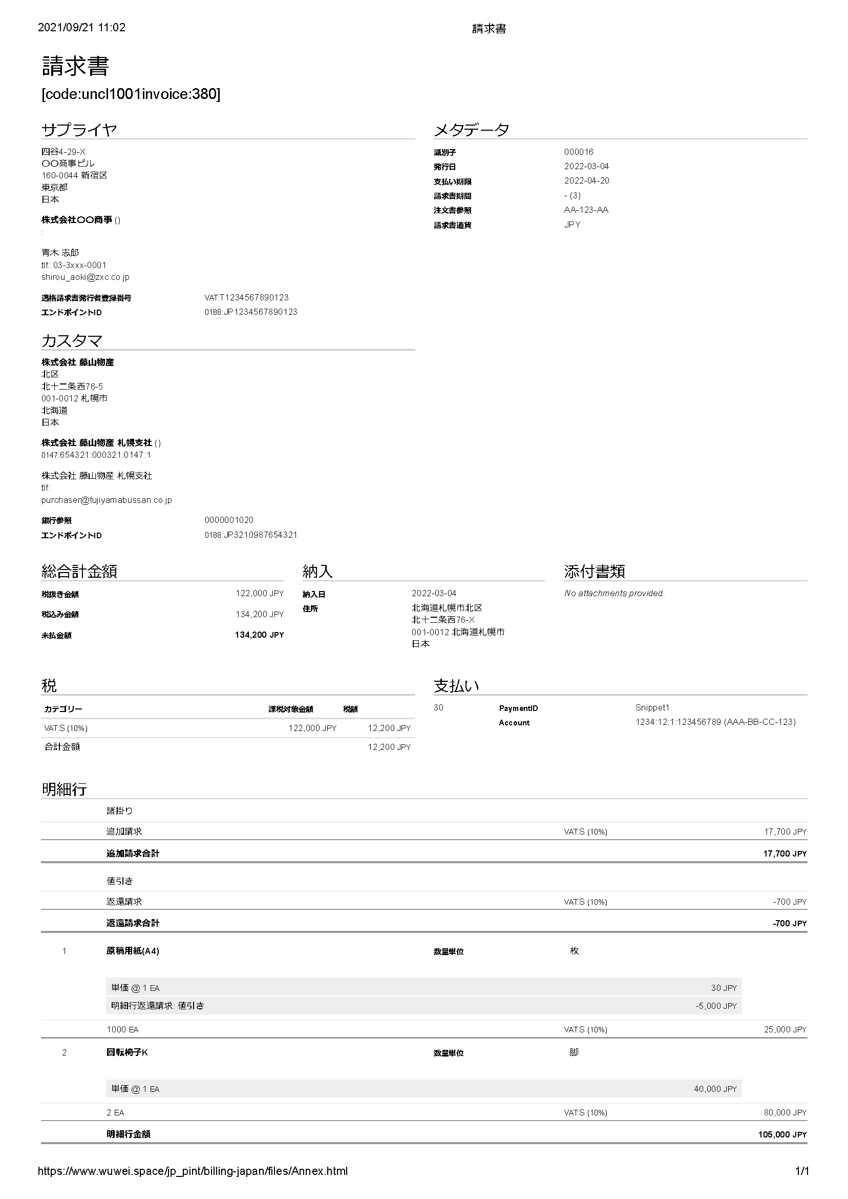

**Annex B  
(informative)  
  
Example of UBL Invoice**

CEN/TS 16931-3-2 Annex B provides example files. This document also use this example as sample invoice document.

<?xml version="1.0" encoding="UTF-8"?>

<Invoice xmlns:cac="urn:oasis:names:specification:ubl:schema:xsd:CommonAggregateComponents-2"

xmlns:cbc="urn:oasis:names:specification:ubl:schema:xsd:CommonBasicComponents-2"

xmlns:qdt="urn:oasis:names:specification:ubl:schema:xsd:QualifiedDataTypes-2"

xmlns:udt="urn:oasis:names:specification:ubl:schema:xsd:UnqualifiedDataTypes-2"

xmlns:ccts="urn:un:unece:uncefact:documentation:2"

xmlns="urn:oasis:names:specification:ubl:schema:xsd:Invoice-2">

<cbc:CustomizationID>urn:cen.eu:en16931:2017</cbc:CustomizationID>

<cbc:ProfileID>1</cbc:ProfileID>

<cbc:ID>TOSL110</cbc:ID>

<cbc:IssueDate>2013-04-10</cbc:IssueDate>

<cbc:DueDate>2013-05-10</cbc:DueDate>

<cbc:InvoiceTypeCode>380</cbc:InvoiceTypeCode>

<cbc:Note>Ordered through our website#Ordering information</cbc:Note>

<cbc:DocumentCurrencyCode>DKK</cbc:DocumentCurrencyCode>

<cbc:TaxCurrencyCode>EUR</cbc:TaxCurrencyCode>

<cbc:AccountingCost>67543</cbc:AccountingCost>

<cbc:BuyerReference>qwerty</cbc:BuyerReference>

<cac:InvoicePeriod>

<cbc:StartDate>2013-03-10</cbc:StartDate>

<cbc:EndDate>2013-04-10</cbc:EndDate>

</cac:InvoicePeriod>

<cac:OrderReference>

<cbc:ID>PO4711</cbc:ID>

<cbc:SalesOrderID>123</cbc:SalesOrderID>

</cac:OrderReference>

<cac:BillingReference>

<cac:InvoiceDocumentReference>

<cbc:ID>TOSL109</cbc:ID>

<cbc:IssueDate>2013-03-10</cbc:IssueDate>

</cac:InvoiceDocumentReference>

</cac:BillingReference>

<cac:DespatchDocumentReference>

<cbc:ID>5433</cbc:ID>

</cac:DespatchDocumentReference>

<cac:ReceiptDocumentReference>

<cbc:ID>3544</cbc:ID>

</cac:ReceiptDocumentReference>

<cac:OriginatorDocumentReference>

<cbc:ID>Lot567</cbc:ID>

</cac:OriginatorDocumentReference>

<cac:ContractDocumentReference>

<cbc:ID>2013-05</cbc:ID>

</cac:ContractDocumentReference>

<cac:AdditionalDocumentReference>

<cbc:ID>OBJ999</cbc:ID>

<cbc:DocumentType>ATS</cbc:DocumentType>

</cac:AdditionalDocumentReference>

<cac:AdditionalDocumentReference>

<cbc:ID>sales slip</cbc:ID>

<cbc:DocumentType>your sales slip</cbc:DocumentType>

<cac:Attachment>

<cbc:EmbeddedDocumentBinaryObject mimeCode="application/pdf" filename="EHF.pdf">VGVzdGluZyBCYXNlNjQgZW5jb2Rpbmc=</cbc:EmbeddedDocumentBinaryObject>

</cac:Attachment>

</cac:AdditionalDocumentReference>

<cac:ProjectReference>

<cbc:ID>Project345</cbc:ID>

</cac:ProjectReference>

<cac:AccountingSupplierParty>

<cac:Party>

<cbc:EndpointID schemeID="EMAIL">info@selco.nl</cbc:EndpointID>

<cac:PartyIdentification>

<cbc:ID schemeID="0088">5790000436101</cbc:ID>

</cac:PartyIdentification>

<cac:PartyName>

<cbc:Name>SelCo</cbc:Name>

</cac:PartyName>

<cac:PostalAddress>

<cbc:StreetName>Hoofdstraat 4</cbc:StreetName>

<cbc:AdditionalStreetName>Om de hoek</cbc:AdditionalStreetName>

<cbc:CityName>Grootstad</cbc:CityName>

<cbc:PostalZone>54321</cbc:PostalZone>

<cbc:CountrySubentity>Overijssel</cbc:CountrySubentity>

<cac:Country>

<cbc:IdentificationCode>NL</cbc:IdentificationCode>

</cac:Country>

</cac:PostalAddress>

<cac:PartyTaxScheme>

<cbc:CompanyID>NL16356706</cbc:CompanyID>

<cac:TaxScheme>

<cbc:ID>VAT</cbc:ID>

</cac:TaxScheme>

</cac:PartyTaxScheme>

<cac:PartyTaxScheme>

<cbc:CompanyID>NL16356706</cbc:CompanyID>

<cac:TaxScheme>

<cbc:ID>LOC</cbc:ID>

</cac:TaxScheme>

</cac:PartyTaxScheme>

<cac:PartyLegalEntity>

<cbc:RegistrationName>SellerCompany</cbc:RegistrationName>

<cbc:CompanyID>NL16356706</cbc:CompanyID>

<cbc:CompanyLegalForm>Export</cbc:CompanyLegalForm>

</cac:PartyLegalEntity>

<cac:Contact>

<cbc:Name>Anthon Larsen</cbc:Name>

<cbc:Telephone>+3198989898</cbc:Telephone>

<cbc:ElectronicMail>Anthon@Selco.nl</cbc:ElectronicMail>

</cac:Contact>

</cac:Party>

</cac:AccountingSupplierParty>

<cac:AccountingCustomerParty>

<cac:Party>

<cbc:EndpointID schemeID="MAIL">info@buyercompany.dk</cbc:EndpointID>

<cac:PartyIdentification>

<cbc:ID schemeID="0088">5790000436057</cbc:ID>

</cac:PartyIdentification>

<cac:PartyName>

<cbc:Name>Buyco</cbc:Name>

</cac:PartyName>

<cac:PostalAddress>

<cbc:StreetName>Anystreet, Building 1</cbc:StreetName>

<cbc:AdditionalStreetName>5th floor</cbc:AdditionalStreetName>

<cbc:CityName>Anytown</cbc:CityName>

<cbc:PostalZone>101</cbc:PostalZone>

<cbc:CountrySubentity>Jutland</cbc:CountrySubentity>

<cac:Country>

<cbc:IdentificationCode>DK</cbc:IdentificationCode>

</cac:Country>

</cac:PostalAddress>

<cac:PartyTaxScheme>

<cbc:CompanyID>DK16356607</cbc:CompanyID>

<cac:TaxScheme>

<cbc:ID>VAT</cbc:ID>

</cac:TaxScheme>

</cac:PartyTaxScheme>

<cac:PartyLegalEntity>

<cbc:RegistrationName>Buyercompany ltd</cbc:RegistrationName>

<cbc:CompanyID>DK16356607</cbc:CompanyID>

</cac:PartyLegalEntity>

<cac:Contact>

<cbc:Name>John Hansen</cbc:Name>

<cbc:Telephone>+4598989898</cbc:Telephone>

<cbc:ElectronicMail>john.hansen@buyercompany.dk</cbc:ElectronicMail>

</cac:Contact>

</cac:Party>

</cac:AccountingCustomerParty>

<cac:PayeeParty>

<cac:PartyIdentification>

<cbc:ID>DK16356608</cbc:ID>

</cac:PartyIdentification>

<cac:PartyName>

<cbc:Name>Dagobert Duck</cbc:Name>

</cac:PartyName>

<cac:PartyLegalEntity>

<cbc:CompanyID>DK16356608</cbc:CompanyID>

</cac:PartyLegalEntity>

</cac:PayeeParty>

<cac:TaxRepresentativeParty>

<cac:PartyName>

<cbc:Name>Dick Panama</cbc:Name>

</cac:PartyName>

<cac:PostalAddress>

<cbc:StreetName>Anystreet, Building 1</cbc:StreetName>

<cbc:AdditionalStreetName>6th floor</cbc:AdditionalStreetName>

<cbc:CityName>Anytown</cbc:CityName>

<cbc:PostalZone>101</cbc:PostalZone>

<cbc:CountrySubentity>Jutland</cbc:CountrySubentity>

<cac:Country>

<cbc:IdentificationCode>DK</cbc:IdentificationCode>

</cac:Country>

</cac:PostalAddress>

<cac:PartyTaxScheme>

<cbc:CompanyID>DK16356609</cbc:CompanyID>

<cac:TaxScheme>

<cbc:ID>VAT</cbc:ID>

</cac:TaxScheme>

</cac:PartyTaxScheme>

</cac:TaxRepresentativeParty>

<cac:Delivery>

<cbc:ActualDeliveryDate>2013-04-15</cbc:ActualDeliveryDate>

<cac:DeliveryLocation>

<cbc:ID>5790000436068</cbc:ID>

<cac:Address>

<cbc:StreetName>Deliverystreet</cbc:StreetName>

<cbc:AdditionalStreetName>Gate 15</cbc:AdditionalStreetName>

<cbc:CityName>Deliverycity</cbc:CityName>

<cbc:PostalZone>9000</cbc:PostalZone>

<cbc:CountrySubentity>Jutland</cbc:CountrySubentity>

<cac:Country>

<cbc:IdentificationCode>DK</cbc:IdentificationCode>

</cac:Country>

</cac:Address>

</cac:DeliveryLocation>

<cac:DeliveryParty>

<cac:PartyName>

<cbc:Name>Logistic service Ltd</cbc:Name>

</cac:PartyName>

</cac:DeliveryParty>

</cac:Delivery>

<cac:PaymentMeans>

<cbc:PaymentMeansCode>49</cbc:PaymentMeansCode>

<cbc:InstructionNote>Half prepaid</cbc:InstructionNote>

<cbc:PaymentID>Payref1</cbc:PaymentID>

<cac:PaymentMandate>

<cbc:ID>123456</cbc:ID>

<cac:PayerFinancialAccount>

<cbc:ID>DK1212341234123412</cbc:ID>

</cac:PayerFinancialAccount>

</cac:PaymentMandate>

</cac:PaymentMeans>

<cac:PaymentTerms>

<cbc:Note>50% prepaid, 50% within one month</cbc:Note>

</cac:PaymentTerms>

<cac:AllowanceCharge>

<cbc:ChargeIndicator>false</cbc:ChargeIndicator>

<cbc:AllowanceChargeReasonCode>100</cbc:AllowanceChargeReasonCode>

<cbc:AllowanceChargeReason>Loyal customer</cbc:AllowanceChargeReason>

<cbc:MultiplierFactorNumeric>10</cbc:MultiplierFactorNumeric>

<cbc:Amount currencyID="DKK">150.00</cbc:Amount>

<cbc:BaseAmount currencyID="DKK">1500.00</cbc:BaseAmount>

<cac:TaxCategory>

<cbc:ID>S</cbc:ID>

<cbc:Percent>25</cbc:Percent>

<cac:TaxScheme>

<cbc:ID>VAT</cbc:ID>

</cac:TaxScheme>

</cac:TaxCategory>

</cac:AllowanceCharge>

<cac:AllowanceCharge>

<cbc:ChargeIndicator>true</cbc:ChargeIndicator>

<cbc:AllowanceChargeReasonCode>ABL</cbc:AllowanceChargeReasonCode>

<cbc:AllowanceChargeReason>Packaging</cbc:AllowanceChargeReason>

<cbc:MultiplierFactorNumeric>10</cbc:MultiplierFactorNumeric>

<cbc:Amount currencyID="DKK">150.00</cbc:Amount>

<cbc:BaseAmount currencyID="DKK">1500.00</cbc:BaseAmount>

<cac:TaxCategory>

<cbc:ID>S</cbc:ID>

<cbc:Percent>25</cbc:Percent>

<cac:TaxScheme>

<cbc:ID>VAT</cbc:ID>

</cac:TaxScheme>

</cac:TaxCategory>

</cac:AllowanceCharge>

<cac:TaxTotal>

<cbc:TaxAmount currencyID="DKK">675.00</cbc:TaxAmount>

<cac:TaxSubtotal>

<cbc:TaxableAmount currencyID="DKK">1500.00</cbc:TaxableAmount>

<cbc:TaxAmount currencyID="DKK">375.00</cbc:TaxAmount>

<cac:TaxCategory>

<cbc:ID>S</cbc:ID>

<cbc:Percent>25</cbc:Percent>

<cac:TaxScheme>

<cbc:ID>VAT</cbc:ID>

</cac:TaxScheme>

</cac:TaxCategory>

</cac:TaxSubtotal>

<cac:TaxSubtotal>

<cbc:TaxableAmount currencyID="DKK">2500.00</cbc:TaxableAmount>

<cbc:TaxAmount currencyID="DKK">300.00</cbc:TaxAmount>

<cac:TaxCategory>

<cbc:ID>S</cbc:ID>

<cbc:Percent>12</cbc:Percent>

<cac:TaxScheme>

<cbc:ID>VAT</cbc:ID>

</cac:TaxScheme>

</cac:TaxCategory>

</cac:TaxSubtotal>

</cac:TaxTotal>

<cac:TaxTotal>

<cbc:TaxAmount currencyID="EUR">628.62</cbc:TaxAmount>

</cac:TaxTotal>

<cac:LegalMonetaryTotal>

<cbc:LineExtensionAmount currencyID="DKK">4000.00</cbc:LineExtensionAmount>

<cbc:TaxExclusiveAmount currencyID="DKK">4000.00</cbc:TaxExclusiveAmount>

<cbc:TaxInclusiveAmount currencyID="DKK">4675.00</cbc:TaxInclusiveAmount>

<cbc:AllowanceTotalAmount currencyID="DKK">150.00</cbc:AllowanceTotalAmount>

<cbc:ChargeTotalAmount currencyID="DKK">150.00</cbc:ChargeTotalAmount>

<cbc:PrepaidAmount currencyID="DKK">2337.50</cbc:PrepaidAmount>

<cbc:PayableAmount currencyID="DKK">2337.50</cbc:PayableAmount>

</cac:LegalMonetaryTotal>

<cac:InvoiceLine>

<cbc:ID>1</cbc:ID>

<cbc:Note>first line</cbc:Note>

<cbc:InvoicedQuantity unitCode="EA">1000</cbc:InvoicedQuantity>

<cbc:LineExtensionAmount currencyID="DKK">1000.00</cbc:LineExtensionAmount>

<cbc:AccountingCost>ACC7654</cbc:AccountingCost>

<cac:InvoicePeriod>

<cbc:StartDate>2013-03-10</cbc:StartDate>

<cbc:EndDate>2013-04-10</cbc:EndDate>

</cac:InvoicePeriod>

<cac:OrderLineReference>

<cbc:LineID>1</cbc:LineID>

</cac:OrderLineReference>

<cac:DocumentReference>

<cbc:ID>Object2</cbc:ID>

</cac:DocumentReference>

<cac:AllowanceCharge>

<cbc:ChargeIndicator>false</cbc:ChargeIndicator>

<cbc:AllowanceChargeReasonCode>100</cbc:AllowanceChargeReasonCode>

<cbc:AllowanceChargeReason>Loyal customer</cbc:AllowanceChargeReason>

<cbc:MultiplierFactorNumeric>10</cbc:MultiplierFactorNumeric>

<cbc:Amount currencyID="DKK">100.00</cbc:Amount>

<cbc:BaseAmount currencyID="DKK">1000.00</cbc:BaseAmount>

</cac:AllowanceCharge>

<cac:AllowanceCharge>

<cbc:ChargeIndicator>true</cbc:ChargeIndicator>

<cbc:AllowanceChargeReasonCode>ABL</cbc:AllowanceChargeReasonCode>

<cbc:AllowanceChargeReason>Packaging</cbc:AllowanceChargeReason>

<cbc:MultiplierFactorNumeric>10</cbc:MultiplierFactorNumeric>

<cbc:Amount currencyID="DKK">100.00</cbc:Amount>

<cbc:BaseAmount currencyID="DKK">1000.00</cbc:BaseAmount>

</cac:AllowanceCharge>

<cac:Item>

<cbc:Description>Printing paper, 2mm</cbc:Description>

<cbc:Name>Printing paper</cbc:Name>

<cac:BuyersItemIdentification>

<cbc:ID>BUY123</cbc:ID>

</cac:BuyersItemIdentification>

<cac:SellersItemIdentification>

<cbc:ID>JB007</cbc:ID>

</cac:SellersItemIdentification>

<cac:StandardItemIdentification>

<cbc:ID schemeID="0088">1234567890128</cbc:ID>

</cac:StandardItemIdentification>

<cac:OriginCountry>

<cbc:IdentificationCode>NL</cbc:IdentificationCode>

</cac:OriginCountry>

<cac:CommodityClassification>

<cbc:ItemClassificationCode listID="ZZZ">12344321</cbc:ItemClassificationCode>

</cac:CommodityClassification>

<cac:ClassifiedTaxCategory>

<cbc:ID>S</cbc:ID>

<cbc:Percent>25</cbc:Percent>

<cac:TaxScheme>

<cbc:ID>VAT</cbc:ID>

</cac:TaxScheme>

</cac:ClassifiedTaxCategory>

<cac:AdditionalItemProperty>

<cbc:Name>Thickness</cbc:Name>

<cbc:Value>2 mm</cbc:Value>

</cac:AdditionalItemProperty>

</cac:Item>

<cac:Price>

<cbc:PriceAmount currencyID="DKK">1.00</cbc:PriceAmount>

<cbc:BaseQuantity unitCode="EA">1</cbc:BaseQuantity>

<cac:AllowanceCharge>

<cbc:ChargeIndicator>false</cbc:ChargeIndicator>

<cbc:Amount currencyID="DKK">0.10</cbc:Amount>

<cbc:BaseAmount currencyID="DKK">1.10</cbc:BaseAmount>

</cac:AllowanceCharge>

</cac:Price>

</cac:InvoiceLine>

<cac:InvoiceLine>

<cbc:ID>2</cbc:ID>

<cbc:Note>second line</cbc:Note>

<cbc:InvoicedQuantity unitCode="EA">100</cbc:InvoicedQuantity>

<cbc:LineExtensionAmount currencyID="DKK">500.00</cbc:LineExtensionAmount>

<cbc:AccountingCost>ACC7654</cbc:AccountingCost>

<cac:InvoicePeriod>

<cbc:StartDate>2013-03-10</cbc:StartDate>

<cbc:EndDate>2013-04-10</cbc:EndDate>

</cac:InvoicePeriod>

<cac:OrderLineReference>

<cbc:LineID>2</cbc:LineID>

</cac:OrderLineReference>

<cac:DocumentReference>

<cbc:ID>Object2</cbc:ID>

</cac:DocumentReference>

<cac:Item>

<cbc:Description>Parker Pen, Black, model Sansa</cbc:Description>

<cbc:Name>Parker Pen</cbc:Name>

<cac:SellersItemIdentification>

<cbc:ID>JB008</cbc:ID>

</cac:SellersItemIdentification>

<cac:OriginCountry>

<cbc:IdentificationCode>NL</cbc:IdentificationCode>

</cac:OriginCountry>

<cac:ClassifiedTaxCategory>

<cbc:ID>S</cbc:ID>

<cbc:Percent>25</cbc:Percent>

<cac:TaxScheme>

<cbc:ID>VAT</cbc:ID>

</cac:TaxScheme>

</cac:ClassifiedTaxCategory>

</cac:Item>

<cac:Price>

<cbc:PriceAmount currencyID="DKK">5.00</cbc:PriceAmount>

</cac:Price>

</cac:InvoiceLine>

<cac:InvoiceLine>

<cbc:ID>3</cbc:ID>

<cbc:InvoicedQuantity unitCode="EA">500</cbc:InvoicedQuantity>

<cbc:LineExtensionAmount currencyID="DKK">2500.00</cbc:LineExtensionAmount>

<cac:Item>

<cbc:Name>American Cookies</cbc:Name>

<cac:SellersItemIdentification>

<cbc:ID>JB009</cbc:ID>

</cac:SellersItemIdentification>

<cac:ClassifiedTaxCategory>

<cbc:ID>S</cbc:ID>

<cbc:Percent>12</cbc:Percent>

<cac:TaxScheme>

<cbc:ID>VAT</cbc:ID>

</cac:TaxScheme>

</cac:ClassifiedTaxCategory>

</cac:Item>

<cac:Price>

<cbc:PriceAmount currencyID="DKK">5.00</cbc:PriceAmount>

</cac:Price>

</cac:InvoiceLine>

</Invoice>

**Bibliography**

[1] ISO #####-#, *General title — Part #: Title of part*

[2] ISO #####-##:20##, *General title — Part ##: Title of part*

1. Businesses that are allowed to issue “eligible invoices” are limited to taxable businesses that have been registered after applying with the District Director of the tax office (businesses allowed to issue eligible invoice). Registration will begin on October 1, 2021.